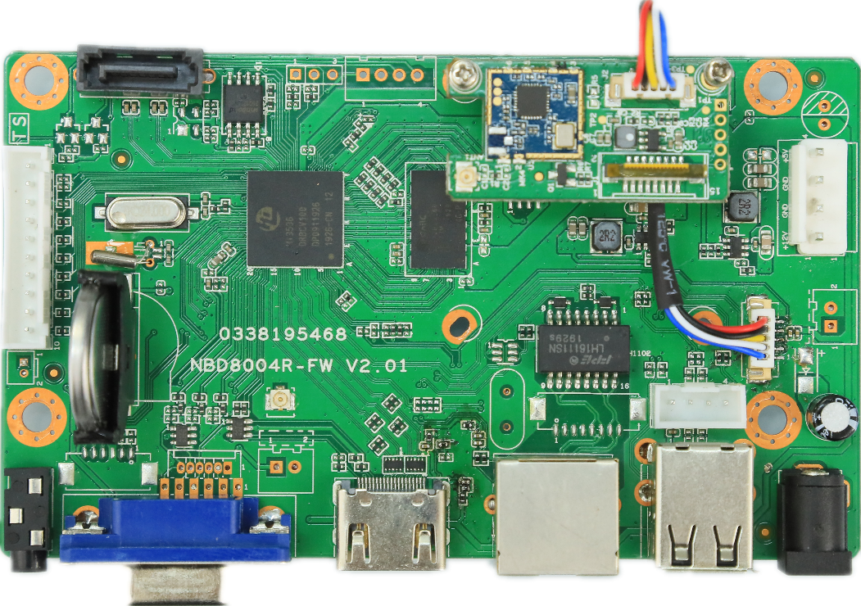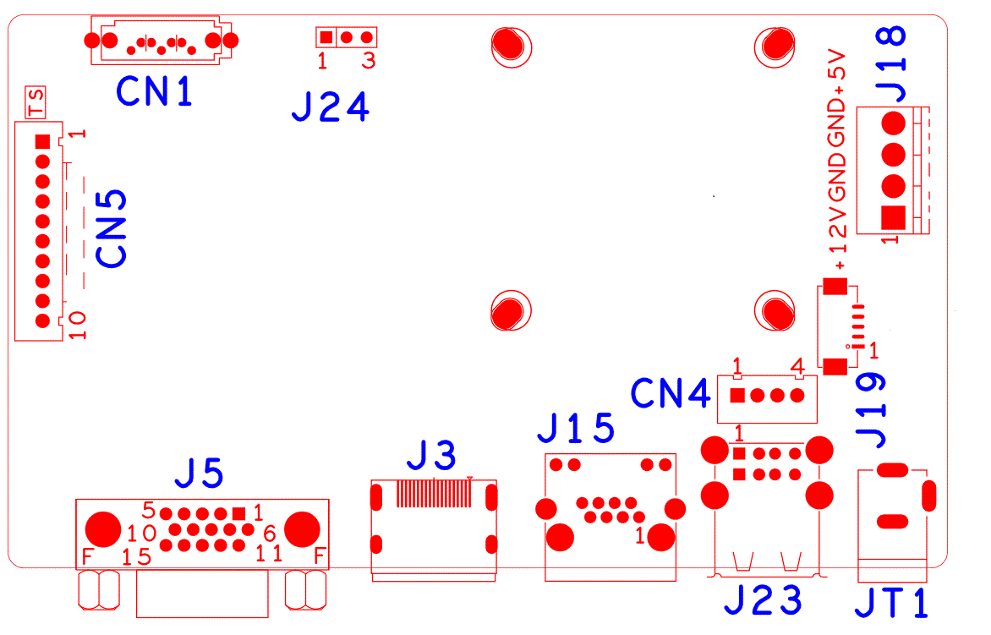

sign | Function | Interface Description
CN5 | Expansion seat without front panel of MCU | 1:+3.3 | 2:GND | 3:IR | 4:COL2
 |  | 5:COL1 | 6:ROW2 | 7:COL3 | 8:ROW1
 |  | 9:ALARM | 10:REC
CN1 | SATA
J24 | RS232
J18 | Hard Disk Power Seat | 1:+12 | 2:GND | 3:GND | 4:+5
J19 | WIFI | 1:GND | 2: USBDP_WIFI | 3: USBDM_WIFI | 4: +5
 |  | 5: USB_CTRL
JT1 | 12V Power switch
J23 | 2USB
CN4 | USB
J15 | RJ45
J3 | HDMI
J5 | VGA

PS: This interface description corresponds to 800 Kit WIFI package NVR products, WIFI module is mounted on 38 holes in the right upper foot of the motherboard.

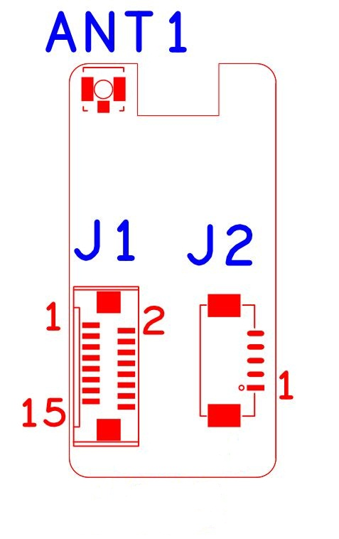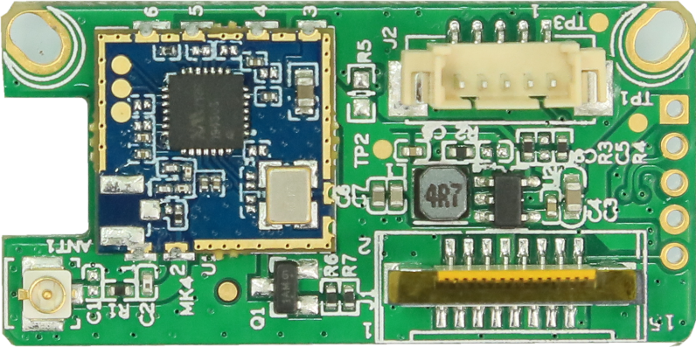

Socket | Function | Interface Description
J2 | 5P1.25mm WIFI Expansion seat | 1:GND | 2:USB_DP | 3:USB_DM | 4:+5V
 |  | 5:USB_CTRL
J1 | 16P FPC WIFI Expansion seat | 1:NC | 2:NC | 3:NC | 4:NC
 |  | 5:NC | 6:NC | 7:NC | 8:GND
 |  | 9:NC | 10:NC | 11:GND | 12:NC
 |  | 13:USB_DM | 14:USB_DP | 15:+5V | 16:USB_CTRL
ANT1 | IPEXAntenna interface

PS: USB_CTRL is the power supply control pin of the WIFI module. Low level enables power supply.

