J5
1 2

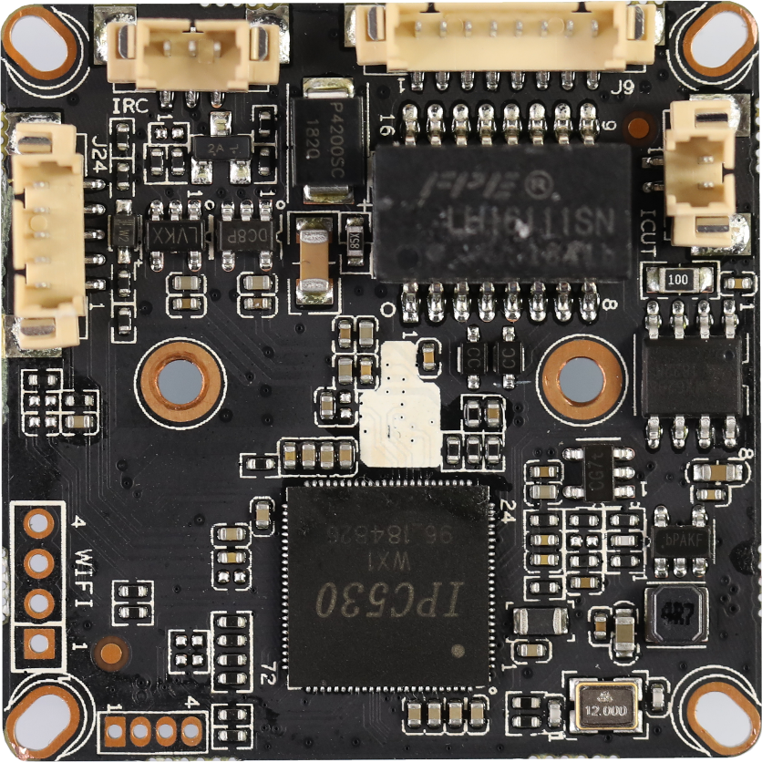
J9

8
7
...
2
1
J6
3
2
1
5 4 3 2 1
J24
4 3 2 1
J1

BLK530WX1-0307D-38X38-S-V1_01 Interface Description
Socket | Specific No | Interface Description | Function
J9 | 1 | LED0 | LED/PHY_AD0 | Connect the tail line of the camera module
 | 2 | LED1 | LED/PHY_AD1
 | 3 | ETHTX+ | Ethernet signal+
 | 4 | ETHTX- | Ethernet signal-
 | 5 | ETHRX+ | Ethernet signal+
 | 6 | ETHRX- | Ethernet signal-
 | 7 | GND | GND
 | 8 | 12V | 12V DC input
J5 | 1 | IR-CUTA | BOUT | IR_CUT
 | 2 | IR-CUTA | AOUT
J6 | 1 | IR-IN | Infrared input | Connect the camera lamp board
 | 2 | GND | GND
 | 3 | PWM-OUT | +3.3V
J24 | 1 | AC_OUT | AC_OUT | audio
 | 2 | AC_IN | AC_IN
 | 3 | GND | GND
 | 4 | ALARM-IN | ALARM_GPIO
 | 5 | ALARM-OUT | ALARM_GPIO（Reserve）
J1 | 1 | 3.3V | WIFI Module power supply | Connect the USB WIFI Module
 | 2 | USB_DN | USB
 | 3 | USB_DP | USB
 | 4 | GND | GND

