P7 power&NET
P6
Alarm Audio
P3 Infrared
P2
IRcut
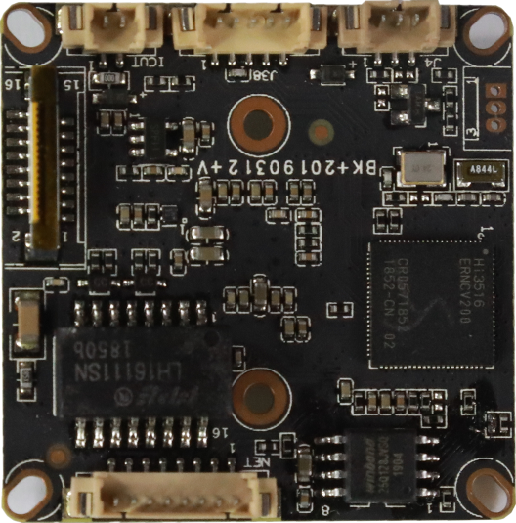
not welded

sign | Socket | Specific No | Interface Description | Function
P2 | J4 | 1 | IC-CUT | IRCUT output
 |  | 2 | IC-CUT | IRCUT output
P3 | J2 | 1 | IRIN_GPIO1_7 | IRIN
 |  | 2 | GND | GND
 |  | 3 | GPIO2_0 | GPIO/PWM
P6 | J9 | 1 | AC_OUTL | AC_OUT
 |  | 2 | AC_LINEL | MIC_P
 |  | 3 | GND | GND
 |  | 4 | ALARM_IN1 | ALARM_IN
 |  | 5 | GND | GND
P1 | J3 | 1 | LED/PHY_AD0 | LED
 |  | 2 | LED/PHY_AD1 | LED
 |  | 3 | ETHTX+ | Ethernet signal
 |  | 4 | ETHTX- | Ethernet signal
 |  | 5 | ETHRX+ | Ethernet signal
 |  | 6 | ETHRX- | Ethernet signal
 |  | 7 | GND | GND
 |  | 8 | 12V | 12V DC input

