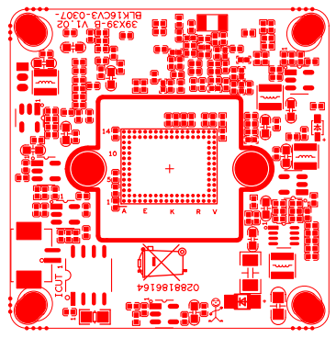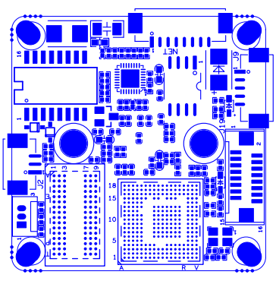
P1 Power&NET

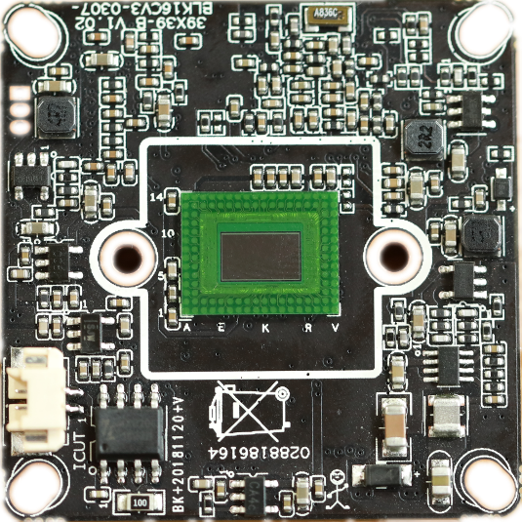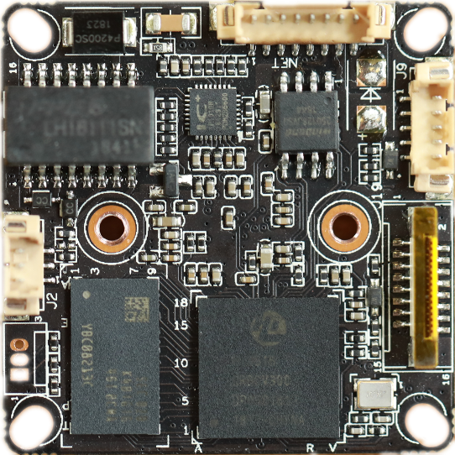
P7 Extension
P6 Alarm Audio
P3 Infrared
P2 IRcut

sign | Socket | Specific No | Interface Description | Function
P2 | J4 | 1 | IC-CUT | IRCUT output
 |  | 2 | IC-CUT | IRCUT output
 | J1 | 1 | UATRO_RXD
 |  | 2 | UATRO_TXD
 |  | 3 | GND | GND
P3 | J2 | 1 | GPIO6_6/PWM2 | GPIO/PWM
 |  | 2 | GND | GND
 |  | 3 | IRC_GPIO80 | IRIN
P7 | J19 | 1 | SDIO1_CCLK_OUT | SD_CLK
 |  | 2 | SDIO1_CCMD | SD_CMD
 |  | 3 | SDIO1_CDATA0 | SD_DATA0
 |  | 4 | SDIA1_CDATA1 | SD_DATA1
 |  | 5 | SDIA1_CDATA2 | SD_DATA2
 |  | 6 | SDIA1_CDATA3 | SD_DATA3
 |  | 7 | ALARM_IN2 | LED_CTRL
 |  | 8 | GND | GND
 |  | 9 | KEY_GPIO8_4 | Key-set
 |  | 10 | VBAT | RTC RTC battery input
 |  | 11 | GND | GND
 |  | 12 | ALARM_OUT | ALARM_OUT
 |  | 13 | USB_DM | USB_DM
 |  | 14 | USB_DP | USB_DP
 |  | 15 | VCC | +5V
 |  | 16 | USB_CONTROL | USB_CONTRL
P6 | J9 | 1 | AC_OUTL | AC_OUT
 |  | 2 | AC_LINEL | MIC_P
 |  | 3 | GND | GND
 |  | 4 | ALARM_IN1 | ALARM_IN
 |  | 5 | GND | GND
P1 | J3 | 1 | ETHRX- | Ethernet signal
 |  | 2 | ETHRX+ | Ethernet signal
 |  | 3 | LED3/PHY_AD3 | LED
 |  | 4 | ETHTX- | Ethernet signal
 |  | 5 | ETHTX+ | Ethernet signal
 |  | 6 | LED0/PHY_AD0 | LED
 |  | 7 | GND | GND
 |  | 8 | 12V | 12V DC input

