BLK19V101-38X38-B V1_01 Interface Description

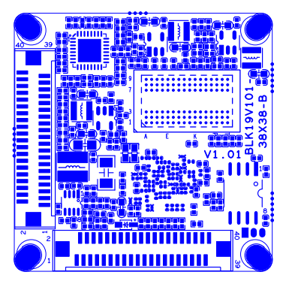
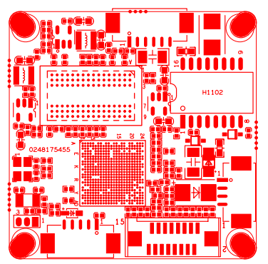
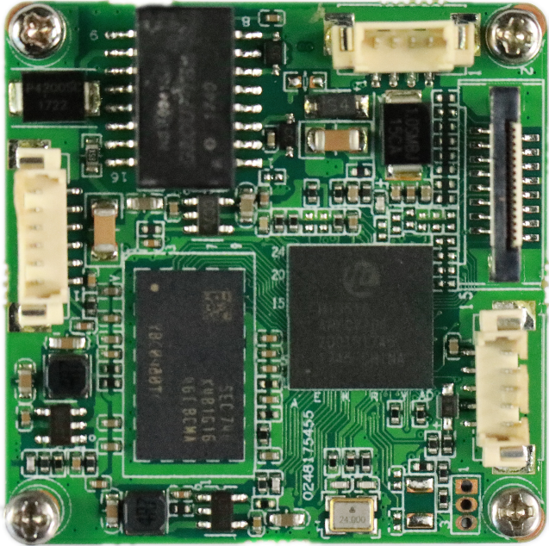

Socket | Specific No | Interface Description
J3 | 1 | ETHRX-
 | 2 | ETHRX+
 | 3 | LED/PHY_AD1
 | 4 | ETHTX-
 | 5 | ETHTX+
 | 6 | LED/PHY_AD0
J1 | 1 | NC
 | 2 | NC
 | 3 | GND
 | 4 | 12V
J14 | 1 | AC_OUT
 | 2 | MIC_P
 | 3 | GND
 | 4 | ALMIN_GPIO144
 | 5 | GND
J19 | 1 | SD0_CCLK_OUT
 | 2 | SD0_CCMD
 | 3 | SD0_CDATA0
 | 4 | SD0_CDATA1
 | 5 | SD0_CDATA2
 | 6 | SD0_CDATA3
 | 7 | LED_GPIO57
 | 8 | GND
 | 9 | SET_GPIO56
 | 10 | BAT
 | 11 | GND
 | 12 | ALMOUT_GPIO145
 | 13 | USB_DM
 | 14 | USB_DP
 | 15 | +5V
 | 16 | USB_CONTROL
J12 | 1 | +12V
 | 2 | +12V
 | 3 | GND
 | 4 | GND
 | 5 | +5V
 | 6 | GND
 | 7 | MIPI0_CKP/VI0_DATA7
 | 8 | MIPI0_D3P/VI0_DATA6
 | 9 | MIPI0_D3M/VI0_DATA5
 | 10 | MIPI1_CKM/VI0_DATA4
 | 11 | MIPI1_CKP/VI0_DATA3
 | 12 | MIPI0_D2P/VI0_DATA2
 | 13 | MIPI0_D2M/VI0_DATA1
 | 14 | MIPI0_D0P/VI0_DATA0
 | 15 | MIPI0_D1M/VI0_HS
 | 16 | MIPI0_D1P/VI0_CLK
 | 17 | MIPI0_D0M/VI0_VS
 | 18 | GND
 | 19 | SENSOR0_CLK
 | 20 | SPI0_CLK/I2C0_SCL
 | 21 | SPI0_CSN
 | 22 | SPI0_SDI
 | 23 | NC
 | 24 | SAR_ADC_CH1/GPIO16_1
 | 25 | GND
 | 26 | GND
 | 27 | GND
 | 28 | +1.8V
 | 29 | SPI0_SDO/I2C0_SDA
 | 30 | MIPI1_D0M/VI0_DATA15
 | 31 | MIPI1_D1M/VI0_DATA14
 | 32 | MIPI1_D1P/VI0_DATA13
 | 33 | MIPI1_D2P/VI0_DATA12
 | 34 | MIPI1_D2M/VI0_DATA11
 | 35 | MIPI1_D3M/VI0_DATA10
 | 36 | MIPI1_D3P/VI0_DATA9
 | 37 | MIPI0_CKM/VI0_DATA8
 | 38 | IRCA1_GPIO134
 | 39 | IRCB1_GPIO135
 | 40 | GND
J13 | 1 | +12V
 | 2 | +12V
 | 3 | GND
 | 4 | GND
 | 5 | +5V
 | 6 | GND
 | 7 | MIPI2_D2P/VI1_DATA7
 | 8 | MIPI2_D2M/VI1_DATA6
 | 9 | VI1_DATA5/GPIO2_7
 | 10 | VI1_DATA4/GPIO2_6
 | 11 | VI1_DATA3/GPIO2_5
 | 12 | VI1_DATA2/GPIO2_4
 | 13 | VI1_DATA1/GPIO2_3
 | 14 | VI1_DATA0/GPIO2_2
 | 15 | VI1_HS/GPIO3_0
 | 16 | VI1_CLK/GPIO2_1
 | 17 | VI1_VS/GPIO2_0
 | 18 | GND
 | 19 | SENSOR1_CLK
 | 20 | SPI1_CLK/I2C1_SCL
 | 21 | SPI1_CSN
 | 22 | SPI1_SDI
 | 23 | NC
 | 24 | SAR_ADC_CH2/GPIO16_2
 | 25 | GND
 | 26 | GND
 | 27 | GND
 | 28 | +1.8V
 | 29 | SPI1_SDO/I2C1_SDA
 | 30 | MIPI2_CKM/VI1_DATA15
 | 31 | MIPI2_CKP/VI1_DATA14
 | 32 | MIPI2_D3M/VI1_DATA13
 | 33 | MIPI2_D3P/VI1_DATA12
 | 34 | MIPI2_D1M/VI1_DATA11
 | 35 | MIPI2_D1P/VI1_DATA10
 | 36 | MIPI2_D0P/VI1_DATA9
 | 37 | MIPI2_D0M/VI1_DATA8
 | 38 | IRCA2_GPIO136
 | 39 | IRCB2_GPIO137
 | 40 | GND

