BLK16E-S2-38X38-IM-B-V1_01 Interface Description
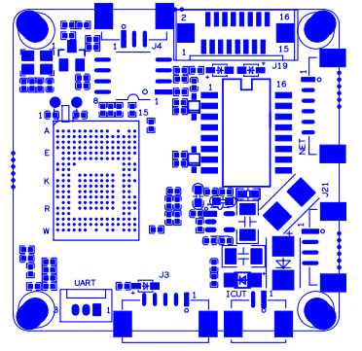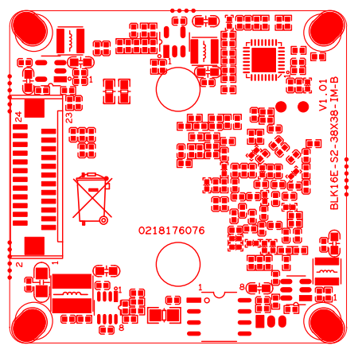

sign | Socket | Specific No | Interface Description
 | J20 | 1 | ETHRX-
 |  | 2 | ETHRX+
 |  | 3 | LED/PHY_AD1
 |  | 4 | ETHTX-
 |  | 5 | ETHTX+
 |  | 6 | LED/PHY_AD0
 | J4 | 1 | 红外输入
 |  | 2 | GND
 |  | 3 | +5V
 | J5 | 1 | BOUT
 |  | 2 | AOUT
 | J21 | 1 | NC
 |  | 2 | NC
 |  | 3 | GND
 |  | 4 | 12V
 | J2 | 1 | UART_RX
 |  | 2 | UART_TX
 |  | 3 | GND
 | J3 | 1 | AC_OUT
 |  | 2 | AC_IN
 |  | 3 | GND
 |  | 4 | ALARM_GPIO
 |  | 5 | GND
 | J19 | 1 | SD_CLK
 |  | 2 | SD_CMD
 |  | 3 | SD_DATA0
 |  | 4 | SD_DATA1
 |  | 5 | SD_DATA2
 |  | 6 | SD_DATA3
 |  | 7 | ALARM2_GPIO82
 |  | 8 | GND
 |  | 9 | KEY_SET
 |  | 10 | BAT
 |  | 11 | GND
 |  | 12 | ALARM_OUT
 |  | 13 | USB_DM
 |  | 14 | USB_DP
 |  | 15 | +5V
 |  | 16 | USB_CONTROL
 | J9 | 1 | MIPI_D3P/VI_DAT0
 |  | 2 | MIPI_D1M/VI_DAT1
 |  | 3 | MIPI_D1P/VI_DAT2
 |  | 4 | MIPI_CKM/VI_DAT3
 |  | 5 | MIPI_CKP/VI_DAT4
 |  | 6 | MIPI_D0M/VI_DAT5
 |  | 7 | MIPI_D0P/VI_DAT6
 |  | 8 | MIPI_D2M/VI_DAT7
 |  | 9 | MIPI_D2P/VI_DAT8
 |  | 10 | VI_DAT9
 |  | 11 | VI_DAT10
 |  | 12 | VI_DAT11
 |  | 13 | GND
 |  | 14 | GND
 |  | 15 | MIPI_D3M/VI_CLK
 |  | 16 | SENSOR_CLK
 |  | 17 | VI_HS
 |  | 18 | VI_VS
 |  | 19 | SPI0_SCLK/I2C0_SCL
 |  | 20 | SPI0_MOSI/I2C0_SDA
 |  | 21 | +3.3V
 |  | 22 | GND
 |  | 23 | VDDIO
 |  | 24 | +5V

