BLK16E-0323-38X38-S-C-V1_01 Interface Description
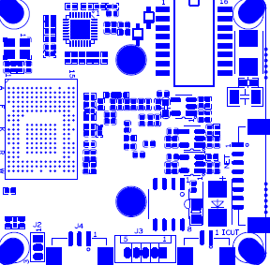

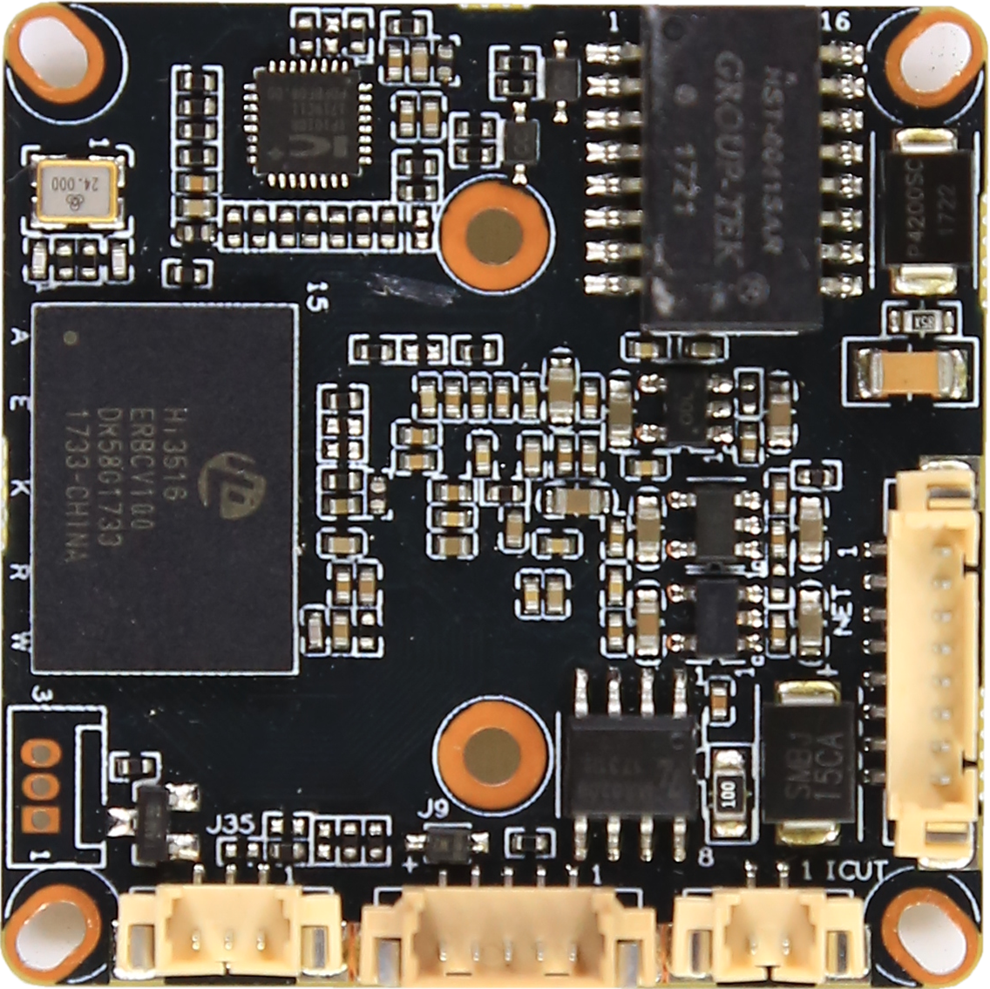
P1 Power Ethernet
P3 IRcut
P6 Alarm Audio

P3 Infrared

sign | Socket | Specific No | Interface Description | Function
P1 | J3 | 1 | LED/PHY_AD0 | LED
 |  | 2 | LED/PHY_AD1 | LED
 |  | 3 | ETHTX+ | Ethernet signal
 |  | 4 | ETHTX- | Ethernet signal
 |  | 5 | ETHRX+ | Ethernet signal
 |  | 6 | ETHRX- | Ethernet signal
 |  | 7 | GND | GND
 |  | 8 | 12V | 12V DC input
P3 | J4 | 1 | Infrared input | Infrared input
 |  | 2 | GND | GND
 |  | 3 | +3.3V | 3.3V DC input
P3 | J5 | 1 | BOUT | IRCUT output
 |  | 2 | AOUT | IRCUT output
P5 | J2 | 1 | UART_RX
 |  | 2 | UART_TX
 |  | 3 | GND | GND
P6 | J3 | 1 | AC_OUT | AC_OUT
 |  | 2 | AC_IN | MIC_P
 |  | 3 | GND | GND
 |  | 4 | ALARM_GPIO | ALARM_IN
 |  | 5 | GND | GND

