BLK16CV3-0330-WIFI-ZS-V2_01 Interface Description

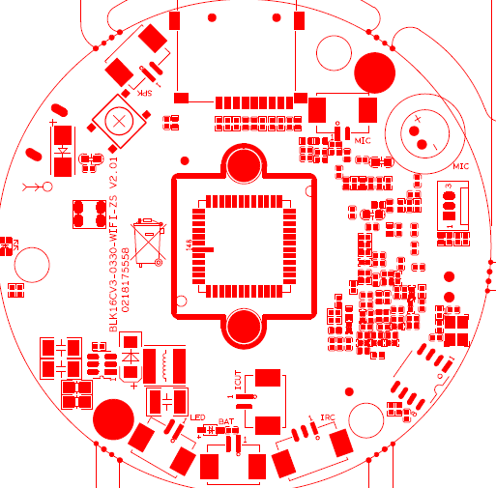
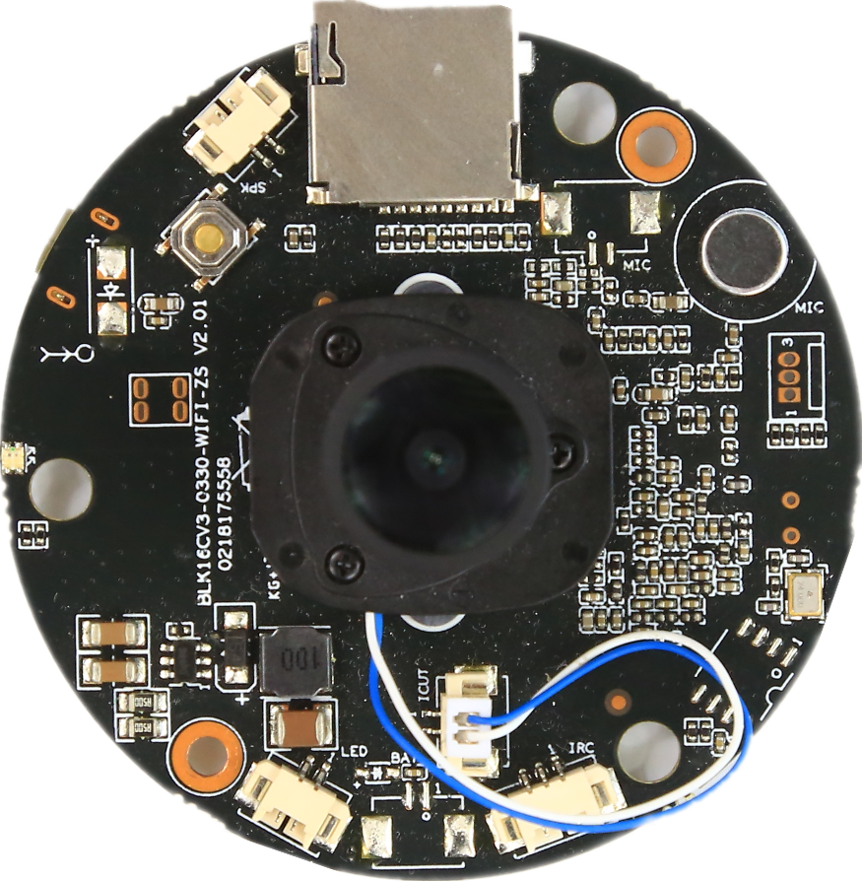
P5 SPK
P4 MIC
P2 IRcut
P6 LED
P3 RTC
P1

sign | Socket | Specific No | Interface Description | Function
P1 | J2 | 1 | SEN | RED_CTRL
 |  | 2 | GND | GND
 |  | 3 | 5V | 5V
P2 | J4 | 1 | BOUT | IRcut
 |  | 2 | AOUT | IRcut
P3 | J13 | 1 | GND | GND
 |  | 2 | VBAT | Rtc
P4 | J31 | 1 | AC_P | MIC INPUT P
 |  | 2 | AC_N | MIC INPUT N
P5 | J17 | 1 | VCP | +Speaker output
 |  | 2 | CVN | -Speaker output
P6 | J26 | 1 | +Lamp plate | +Lamp plate
 |  | 2 | -Lamp plate | -Lamp plate
P7 | J6 | 1 | GND | GND
 |  | 2 | UART_TX
 |  | 3 | UART_RX

