BLK16E-0235-32X32-S-V1_01 Interface Description
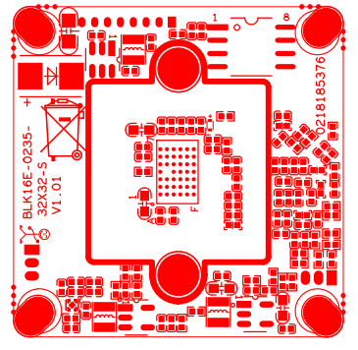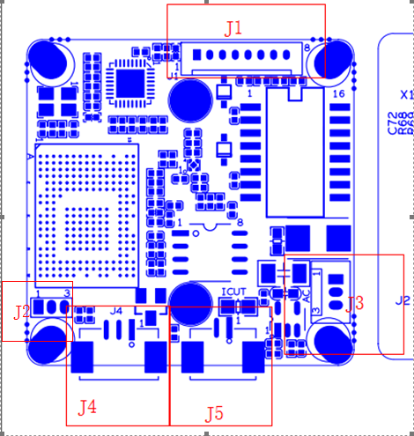
P3 Power& Ethernet

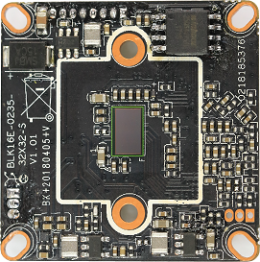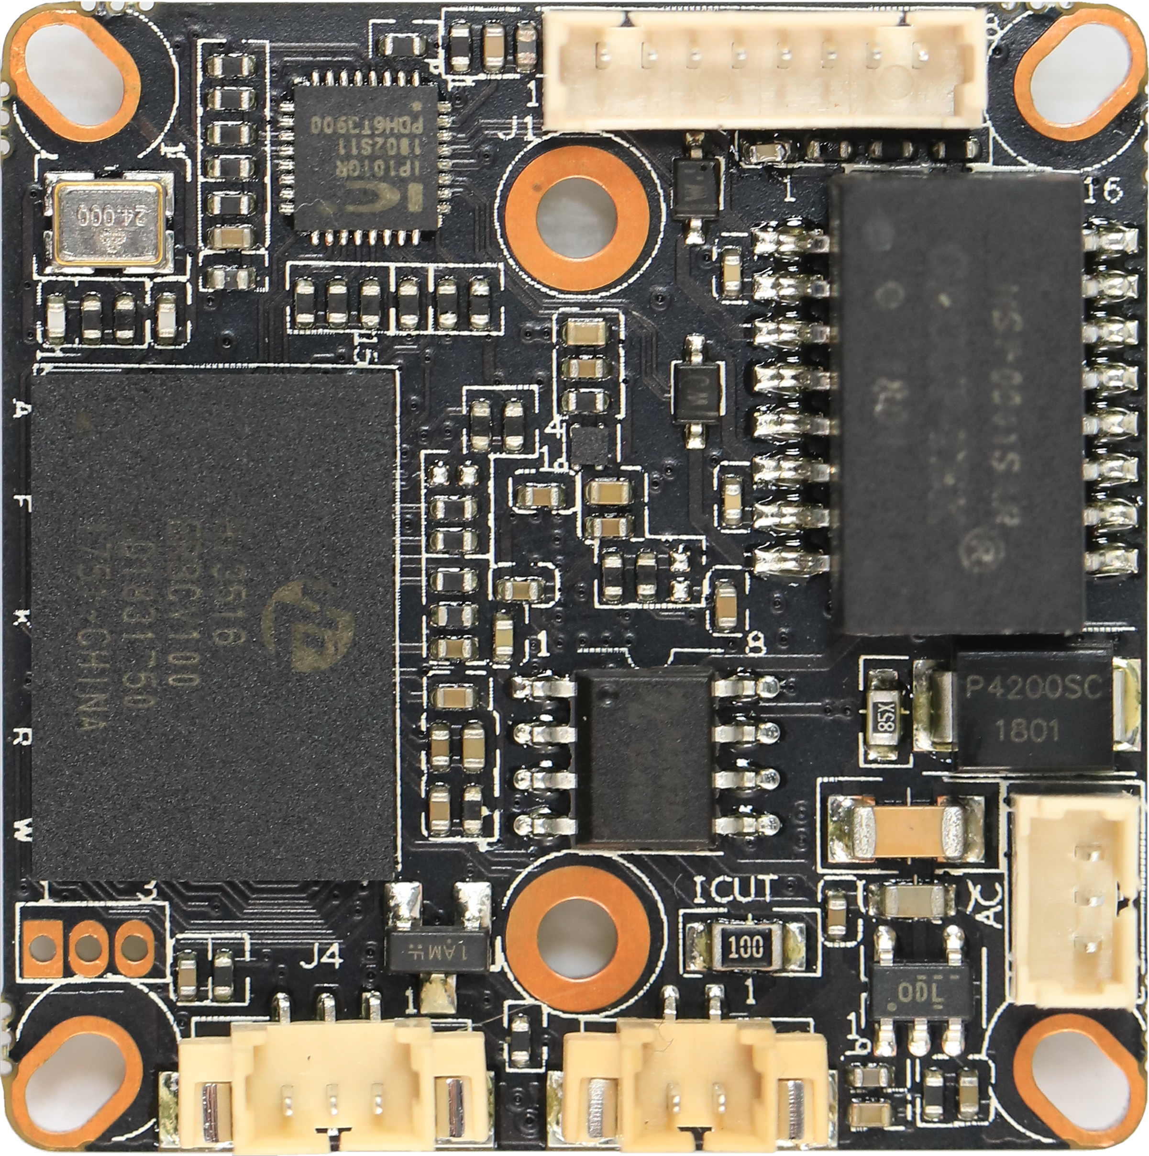
P5 Infrared
P4 IR-CUT
P2 Audio1/1

sign | Socket | Specific No | Interface Description | Function
P1 | J2 | 1 | UART0_RXD
 |  | 2 | UART0_TXD
 |  | 3 | GND | GND
P2 | J3 | 1 | AC_OUTL | AC_OUT
 |  | 2 | AC_INL | MIC_P
 |  | 3 | GND | GND
P3 | J1 | 1 | LED/PHYAD0 | LED
 |  | 2 | LED/PHYAD1 | LED
 |  | 3 | ETHTX+ | Ethernet signal
 |  | 4 | ETHTX- | Ethernet signal
 |  | 5 | THTR+ | Ethernet signal
 |  | 6 | THTR- | Ethernet signal
 |  |  | GND | GND
 |  |  | +12V | 12V DC input
P4 | J5 | 1 | BOUT | IR CUT
 |  | 2 | AOUT | IR CUT
P5 | J4 | 1 | Infrared input | Infrared input
 |  | 2 | GND | GND
 |  | 3 | 3.3V | 3.3V

