BLK16CV3-0022-39X39-B-V1_01 Interface Description
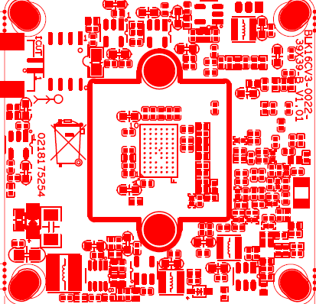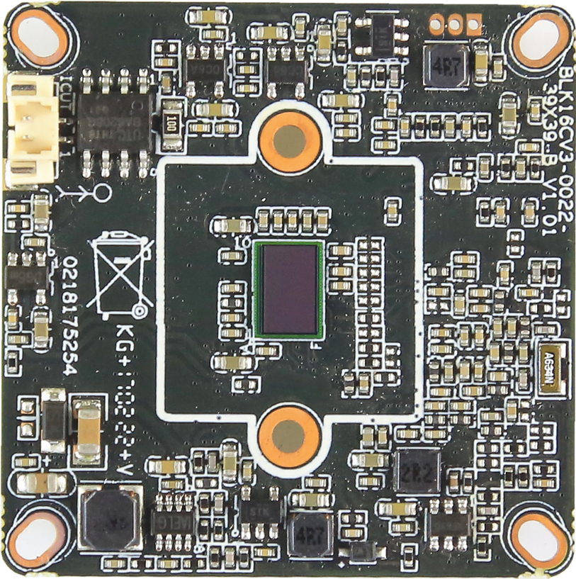
P4 IRcut
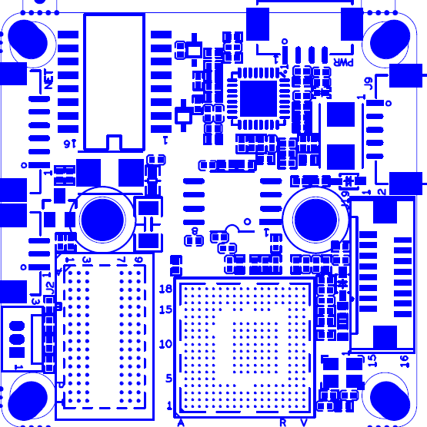
P5 power

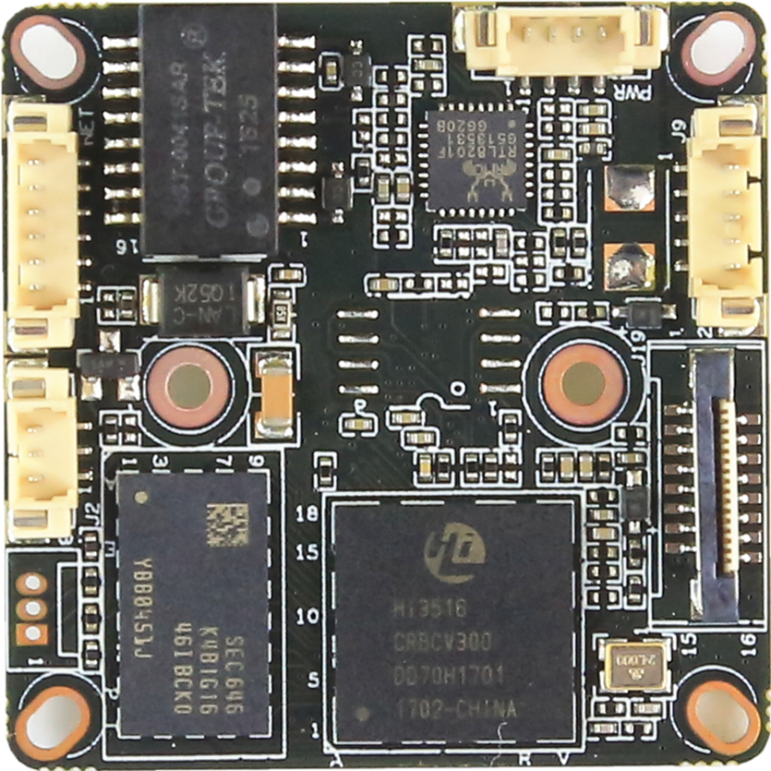
P7 Alarm Audio
This interface is not welded
P3 Infrared
P1 Ethernet

sign | Socket | Specific No | Interface Description | Function
P1 | J3 | 1 | ETHRX- | Ethernet signal
 |  | 2 | ETHRX+ | Ethernet signal
 |  | 3 | LED/PHY_AD1 | LED
 |  | 4 | ETHTX- | Ethernet signal
 |  | 5 | ETHTX+ | Ethernet signal
 |  | 6 | LED/PHY_AD0 | LED
P3 | J2 | 1 | Infrared input | Infrared input
 |  | 2 | GND | GND
 |  | 3 | +5V | 5V DC input
P4 | J4 | 1 | BOUT | IRCUT output
 |  | 2 | AOUT | IRCUT output
P5 | J7 | 1 | NC | Undefined
 |  | 2 | NC | Undefined
 |  | 3 | GND | GND
 |  | 4 | 12V | 12V DC input
P6 | J6 | 1 | UART_RX
 |  | 2 | UART_TX
 |  | 3 | GND | GND
P7 | J9 | 1 | AC_OUT | AC_OUT
 |  | 2 | AC_IN | MIC_P
 |  | 3 | GND | GND
 |  | 4 | ALARM_GPIO | ALARM_IN
 |  | 5 | GND | GND

