BLK18E-0042-0035-WK-WIFI-V1_01 Interface Description
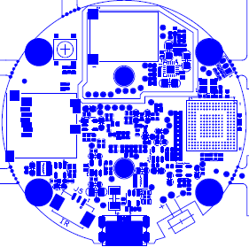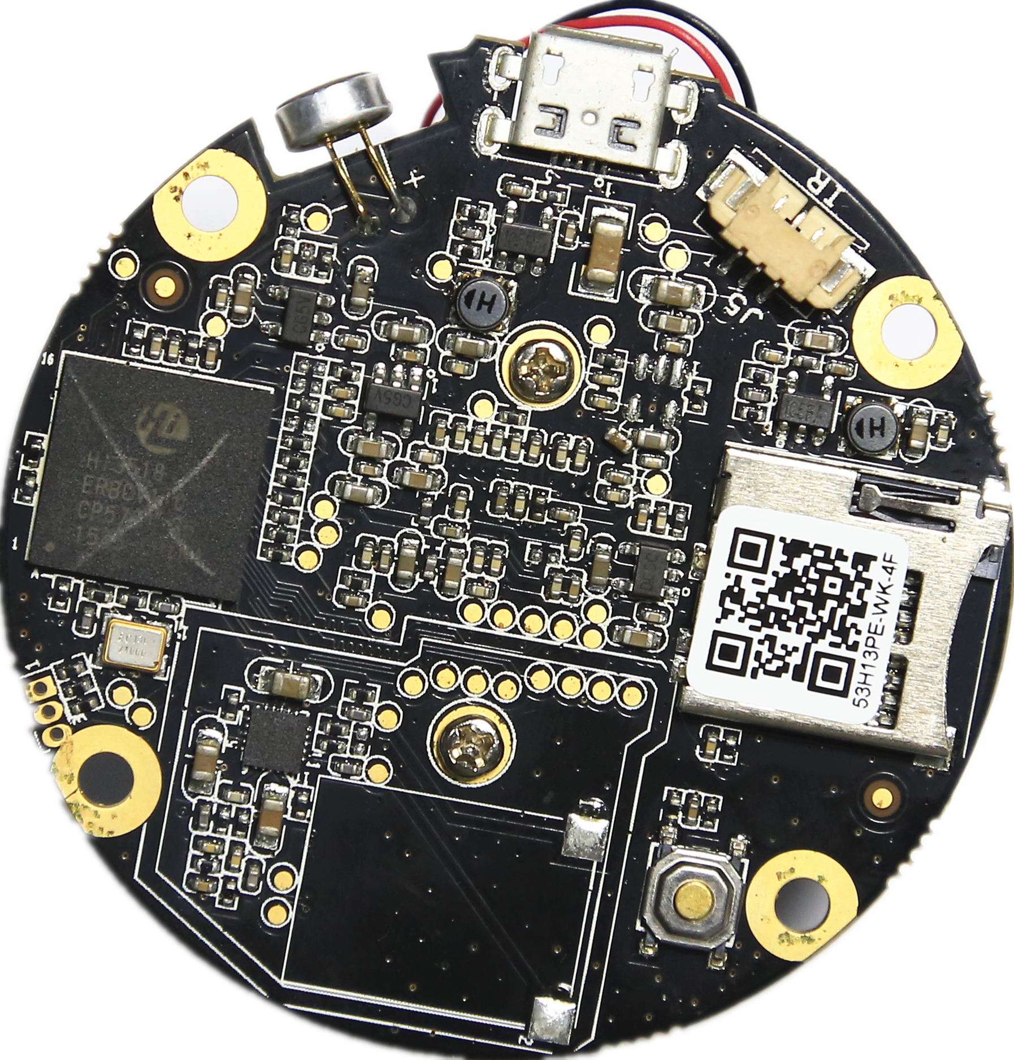
J6 MIC
J2 SPK
J7 USB
J5 Infrared
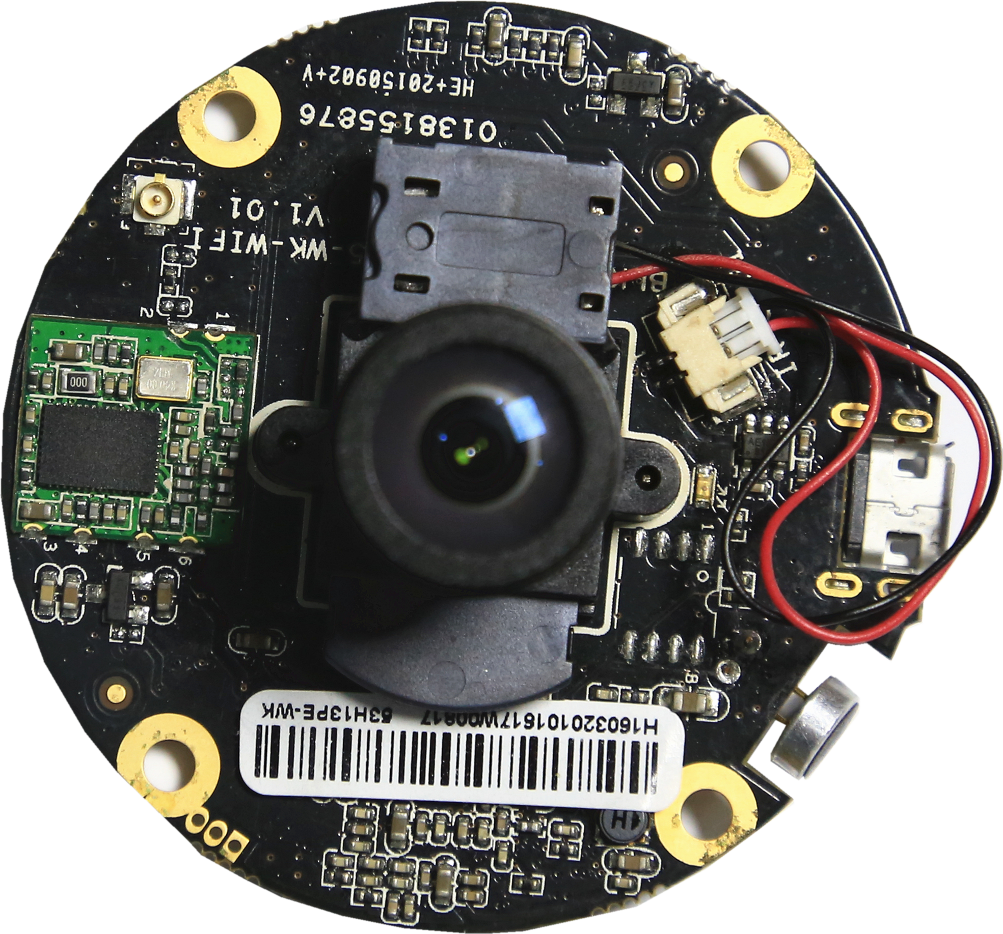
J1 ICR
WIFI
Label | Socket | Specific No | Interface Description | Label
P1 | J7 | 1 | VCC | GND
 |  | 2 | DM | USB
 |  | 3 | DP | USB
 |  | 4 | NC | NC
 |  | 5 | GND | GND
P2 | J3 | 1 | UART0_RXD
 |  | 2 | UART0_TXD
 |  | 3 | GND | GND
P3 | J6 | 1 | AC_LINE | MIC INPUT
 |  | 2 | AGND | AGND
P4 | J2 | 1 | SPK | SPK OUTPUT
 |  | 2 | SPK | SPK OUTPUT
P5 | J1 | 1 | OUT1 | IRCUT OUT
 |  | 2 | OUT2 | IRCUT OUT
P6 | J5 | 1 | +5V | +5V OUTPUT
 |  | 2 | IR | Infrared INPUT
 |  | 3 | GND | GND

