BLK18EV-2045-38X38-B-V1_01 Interface Description
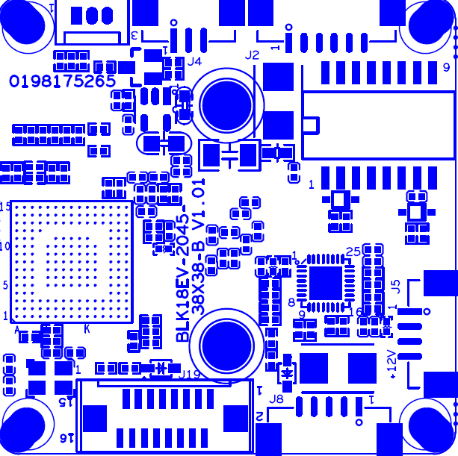
P4 Infrared
P2 Ethernet
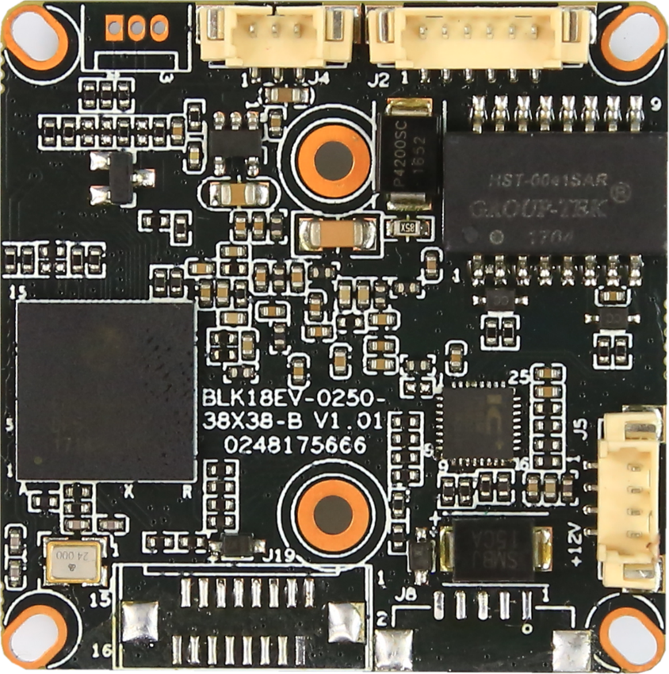
P1 power

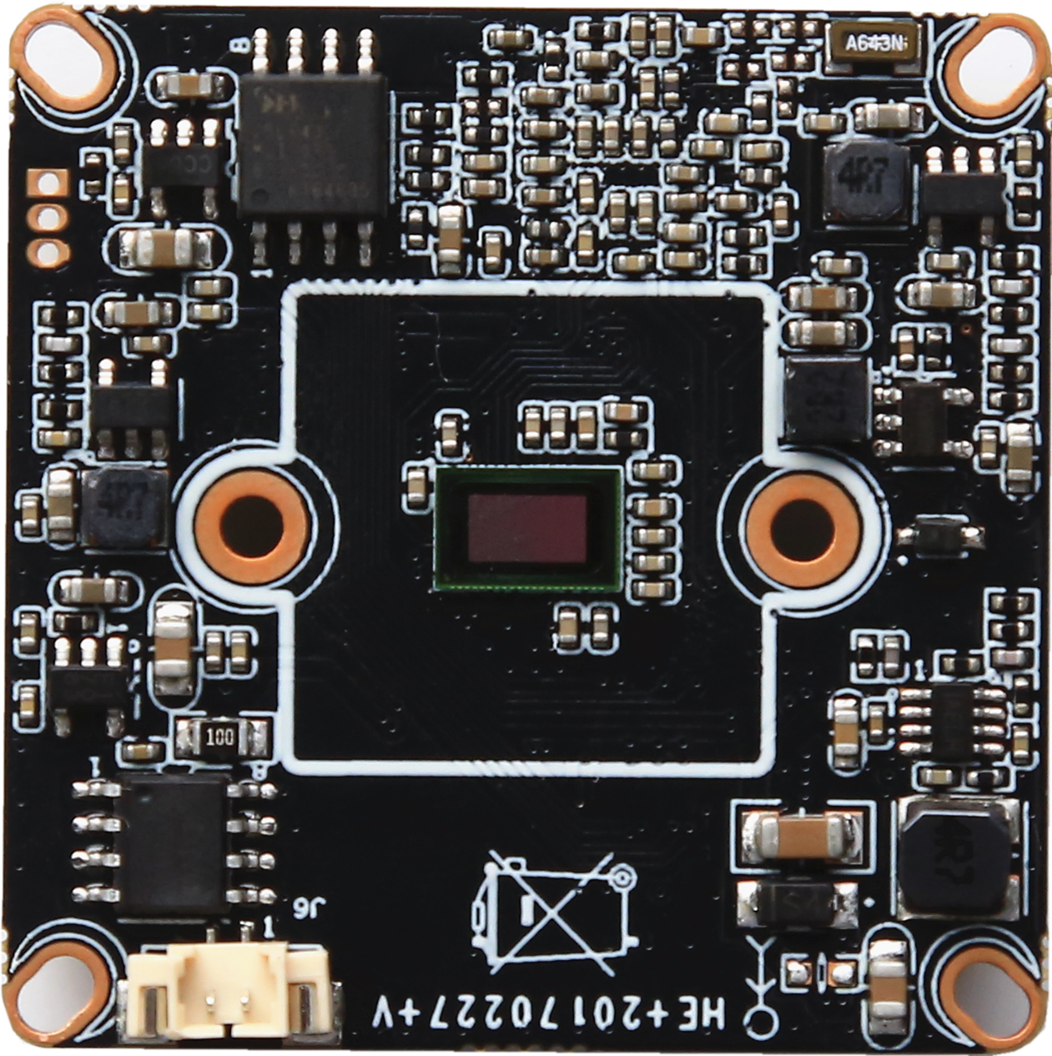
P5 IR-CUT

Detailed Definition
Label | Socket | Specific No | Interface Description | Function
P1 | J5 | 1 | NC | Undefined
 |  | 2 | NC | Undefined
 |  | 3 | GND | GND
 |  | 4 | +12V | 12V DC input
P2 | J2 | 1 | ETHTR- | Ethernet signal
 |  | 2 | ETHTR+ | Ethernet signal
 |  | 3 | LED/PHY_AD3 | LED
 |  | 4 | ETHTX- | Ethernet signal
 |  | 5 | ETHTX+ | Ethernet signal
 |  | 6 | LED/PHY_AD0 | LED
P3 | J3 | 1 | UART0_RXD
 |  | 2 | UART0_TXD
 |  | 3 | GND
P4 | J4 | 1 | Infrared input | Infrared input
 |  | 2 | GND | GND
 |  | 3 | +5V | 5V DC input
P5 | J6 | 1 | IRCUT_A | IRCUT output
 |  | 2 | IRCUT_B | IRCUT output

