BLK18EV-0062-0035-38X38-V1_01 Interface Description
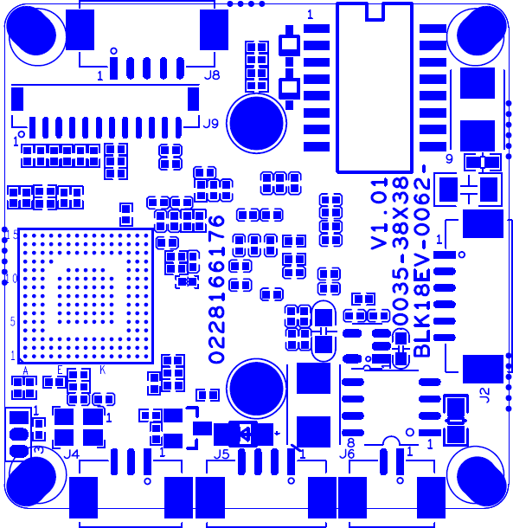
Audio alarm

J6 IRcut

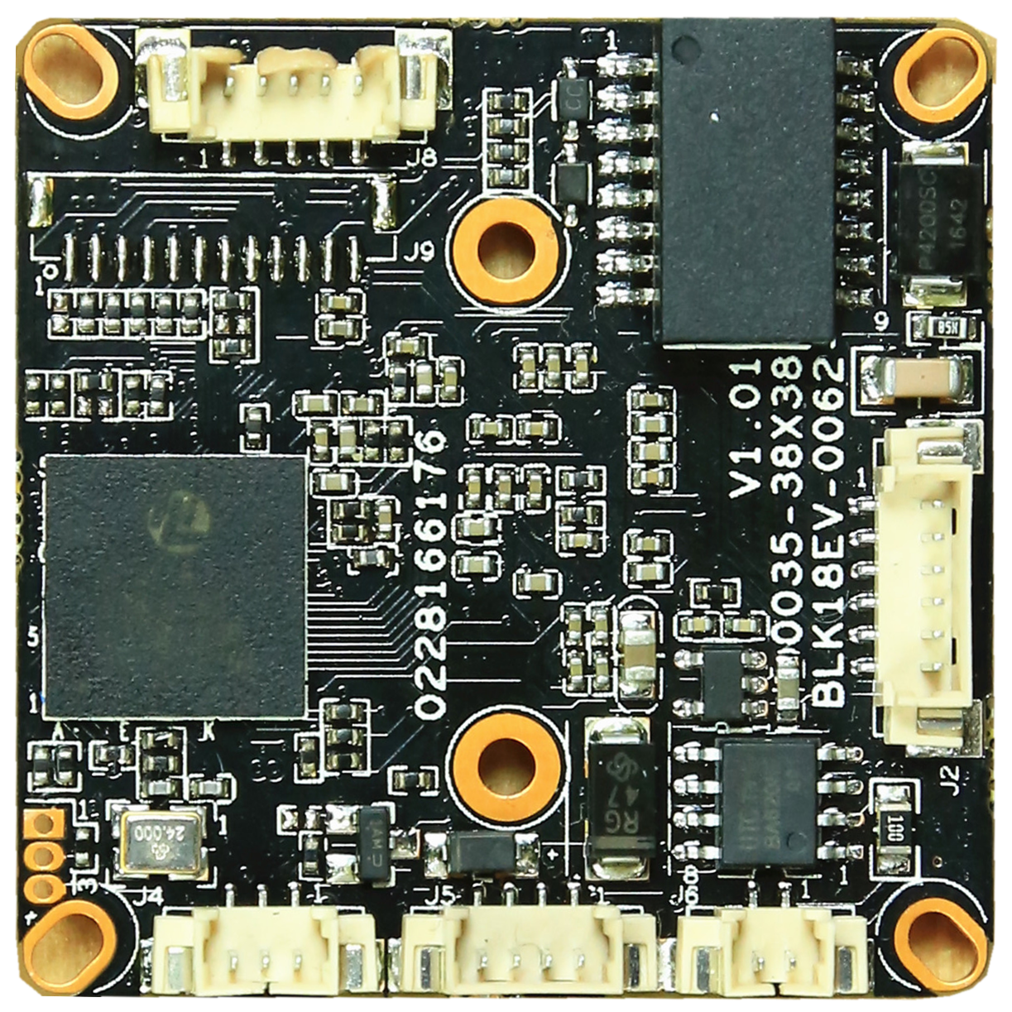
J4 Infrared

J5 power
This interface is not welded

J2 Ethernet

sign | Socket | Specific No | Interface Description | Function
P1 | J5 | 1 | NC | Undefined
 |  | 2 | NC | Undefined
 |  | 3 | GND | GND
 |  | 4 | +12V | 12V DC input
P2 | J2 | 1 | ETHTR- | Ethernet signal
 |  | 2 | ETHTR+ | Ethernet signal
 |  | 3 | LED/PHY_AD3 | LED
 |  | 4 | ETHTX- | Ethernet signal
 |  | 5 | ETHTX+ | Ethernet signal
 |  | 6 | LED/PHY_AD0 | LED
P3 | J3 | 1 | UART0_RXD
 |  | 2 | UART0_TXD
 |  | 3 | GND
P4 | J4 | 1 | Infrared input | Infrared input
 |  | 2 | GND | GND
 |  | 3 | NC | NC
P5 | J6 | 1 | IRCUT_A | IRCUT output
 |  | 2 | IRCUT_B | IRCUT output
P6 | J8 | 1 | AC_OUT | AC_OUT
 |  | 2 | MIC_P | MIC_P
 |  | 3 | AGND | GND
 |  | 4 | ALARM_IN | ALARM_IN
 |  | 5 | GND | GND

