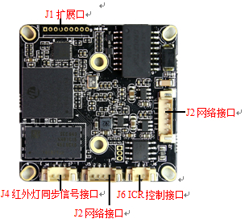
BLK16CV-0002-2035-38X38 V1.01 Detailed Definition
Label | Socket | Specific No | Interface Description | Function
P1 | J2 | 1 | ETHRX- | Ethernet signal
 |  | 2 | ETHRX+ | Ethernet signal
 |  | 3 | LED/PHY_AD3 | LED
 |  | 4 | ETHTX- | Ethernet signal
 |  | 5 | ETHTX+ | Ethernet signal
 |  | 6 | LED/PHY_AD0 | LED
P2 | J1 | 1 | GND | GND
 |  | 2 | USB_DP | USB_DP
 |  | 3 | USB_DM | USB_DM
 |  | 4 | +5V | +5V DC input
 |  | 5 | AC_OUT | AC_OUT
 |  | 6 | MIC_P | MIC_P
 |  | 7 | MIC_N | MIC_N
 |  | 8 | AGND | AGND
 |  | 9 | ALARM_IN | ALARM_IN
P3 | J4 | 1 | Infrared input | Infrared input
 |  | 2 | GND | GND
 |  | 3 | NC | NC
P3 | J6 | 1 | BOUT | IRCUT output
 |  | 2 | AOUT | IRCUT output
P4 | J5 | 1 | NC | NC
 |  | 2 | NC | NC
 |  | 3 | GND | GND
 |  | 4 | 12V | NC
P5 | J3 | 1 | GND | GND
 |  | 2 | UART_TX
 |  | 3 | UART_RX

