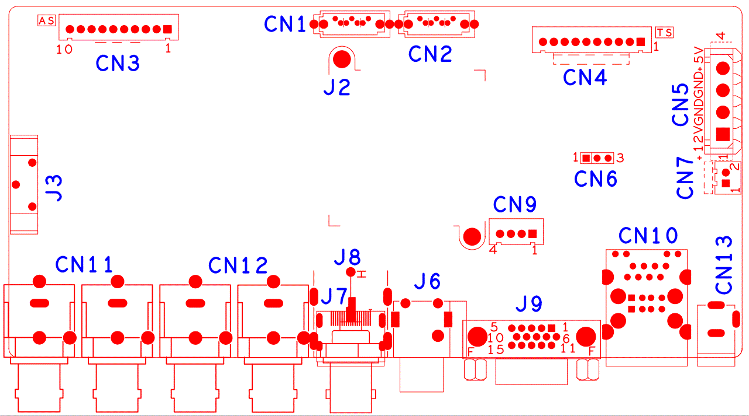
Socket | Function | Interface Description
CN3 | Front socket with MCU | 1:+5 | 2:GND | 3:+5_STB | 4:GND
 |  | 5:NC | 6:NC | 7:RXD_FRONT | 8:TXD_FRONT
 |  | 9:PWR_S | 10:GND
CN1 | SATA
CN2 | SATA
CN4 | 10PIN without MCU front panel seat | 1:+3.3 | 2:GND | 3:IR | 4:COL1
 |  | 5:COL3 | 6:COL4 | 7:ROW4 | 8:COL2
 |  | 9:ALARM | 10:REC
CN5 | SATA power socket | 1:+12 | 2:GND | 3:GND | 4:+5
CN6 | RS232
CN7 | Fan power socket | 1：+12 | 2：GND
CN13 | 12V input
CN10 | 2USB+RJ45
J9 | VGA
CN9 | Front panel USB expansion seat | 1:+5 | 2:USB3_DM1 | 3:USB3_DP1 | 4:GND
J6 | Audio RCA combination interface | up:AUDIO_OUT_MAIN | down:AUDIO1
J7 | HDMI
J8 | CVBS interface (only models with CVBS support this interface)
CN12 | 4ch BNC Video input | Left down:VIDEO4 | Left up:VIDEO3 | Right down:VIDEO2 | Right up:VIDEO1
CN11 | 4ch BNC Video input | Left down:VIDEO8 | Left up:VIDEO7 | Right down:VIDEO6 | Right up:VIDEO5
J3 | Battery seat
J2 | heat sink

