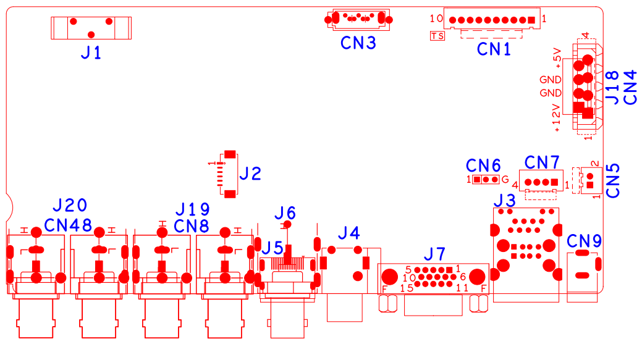

Socket | Function | Interface Description
CN2 | SATA
CN3 | SATA
CN1 | 10Pin TS | 1:+3.3 | 2:GND | 3:IR | 4:COL2
 |  | 5:COL1 | 6:ROW2 | 7:COL3 | 8:ROW1
 |  | 9:ALARM | 10:REC
J18/CN4 | Hard disk power supply interface | 1:+12 | 2:GND | 3:GND | 4:+5
CN6 | RS232
CN5 | Fan power | 1：+12 | 2：GND
CN9 | 12V input
J3 | 2USB+RJ45
J7 | VGA
CN7 | Front panel USB expansion | 1:+5 | 2:USB2_DM | 3:USB2_DP | 4:GND
J6 | Audio RCA combo interface | up: AUDIO1 | down: AUDIO_OUT_MAIN
J5 | HDMI
J6 | CVBS
J19/CN8 | BNC Video input | Bottom left:VIDEO4 | Top left:VIDEO3 | Bottom right:VIDEO2 | Top right:VIDEO1
J20/CN48 | BNC Video input | Bottom left:VIDEO8 | Top left:VIDEO7 | Bottom right:VIDEO6 | Top right:VIDEO5
J1 | Battery holder
J2 | Audio extension | 1:GND | 2、AUDIO4 | 3、AUDIO3 | 4：AUDIO2
 |  | 5：AUDIO1 | 6：AUDIO_OUT_MAIN

