Interface Description
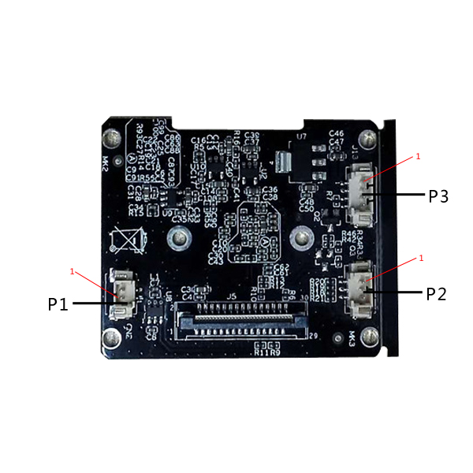
Socket | Specific No | Interface Description | Function
P1 | 1 | AE1511B OUT2 | IRCUT output 2
 | 2 | AE1511B OUT1 | IRCUT output 1
P2 | 1 | MOTOR_UP | Motor upper limit switch
 | 2 | GND | GND
 | 3 | MOTOR_DOWN | Lower limit switch of motor
P3 | 1 | +5V | +5V DC input
 | 2 | GND | GND
 | 3 | RED_C | RED_C
 | 4 | NC | NC

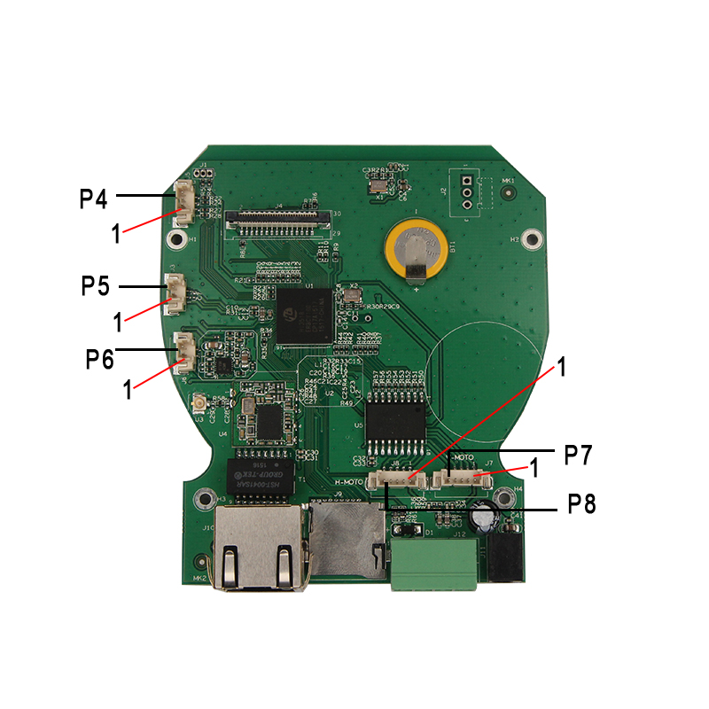

Socket | Specific No | Interface Description | Function
P4 | 1 | M_RIGHT | Motor right limit switch
 | 2 | GND | GND
 | 3 | M_LEFT | Motor left limit switch
P5 | 1 | AC_LINE | Audio input
 | 2 | GND | GND
P6 | 1 | AW8733ATQR VOP | speaker
 | 2 | AW8733ATQR VON | speaker
P7 | 1 | +5V_M1 | +5V DC input
 | 2 | ULN2803AFW OUT8 | ULN2803AFW OUT8
 | 3 | ULN2803AFW OUT7 | ULN2803AFW OUT7
 | 4 | ULN2803AFW OUT6 | ULN2803AFW OUT6
 | 5 | ULN2803AFW OUT5 | ULN2803AFW OUT5
P8 | 1 | +5V_M2 | +5V DC input
 | 2 | ULN2803AFW OUT1 | ULN2803AFW OUT1
 | 3 | ULN2803AFW OUT2 | ULN2803AFW OUT2
 | 4 | ULN2803AFW OUT3 | ULN2803AFW OUT3
 | 5 | ULN2803AFW OUT4 | ULN2803AFW OUT4

