NBD8032H4-QE
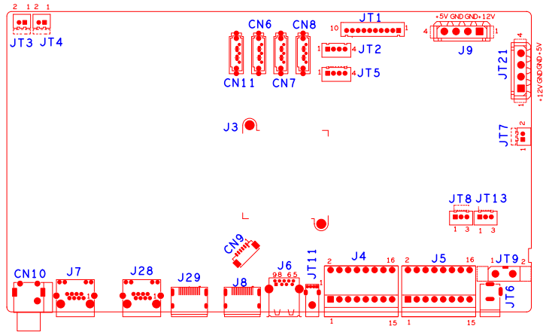

位号 | 功能描述 | 接口定义
JT3 | 风扇电源座子 | 1:+12 | 2:GND
JT4 | 风扇电源座子 | 1:+12 | 2:GND
JT7 | 风扇电源座子 | 1:+12 | 2:GND
JT6 | 12V输入电源接口
JT9 | 电源开关
JT8 | RS232接口 | 1:RXD | 2:TXD | 3:GND
JT13 | RS232接口 | 1:RXD | 2:TXD | 3:GND
JT2 | USB扩展接口
JT5 | USB扩展接口
J6 | USB3.0座子
JT11 | USB座子
J7 | 网口座子
J28 | 网口座子
J9 | 硬盘电源座子
JT21 | 硬盘电源座子
CN9 | VGA扩展座子 | 1:GND | 2: VGA_RED | 3: VGA_GREEN | 4: VGA_BLUE
 |  | 5: VGA_HSO | 6: VGA_VSO
JT1 | 10PIN带单片机前面板座子 | 1:+5 | 2:GND | 3:+5_STB | 4:GND
 |  | 5:NC | 6:NC | 7:RXD_FRONT | 8:TXD_FRONT
 |  | 9:PWR_S | 10:GND
J4 | 报警输入输出座子 | 1:ALARM_IN8 | 2:ALARM_IN16 | 3:GND | 4:GND
 |  | 5: ALARMOUT1_C | 6: ALARMOUT3_C | 7: ALARMOUT1_NO | 8:ALARMOUT3_NO
 |  | 9: ALARMOUT2_C | 10: ALARMOUT4_C | 11:ALARMOUT2_NO | 12:ALARMOUT4_NO
 |  | 13:RS232_R | 14:RS485_A | 15:RS232_T | 16:RS485_B
J5 | 报警输入输出座子 | 1:ALARM_IN1 | 2:ALARM_IN9 | 3:ALARM_IN2 | 4:ALARM_IN10
 |  | 5:ALARM_IN3 | 6:ALARM_IN11 | 7:ALARM_IN4 | 8:ALARM_IN12
 |  | 9: GND | 10:GND | 11:ALARM_IN5 | 12:ALARM_IN13
 |  | 13:ALARM_IN6 | 14:ALARM_IN14 | 15:ALARM_IN7 | 16:ALARM_IN15
CN10 | 音频输入输出座子 | 1T:AUDIO_OUT_MAIN | 2T:AUDIO_LINE_IN
CN6 | SATA接口
CN7 | SATA接口
CN8 | SATA接口
CN11 | SATA接口
J8 | HDMI接口
J29 | HDMI接口

