NBD8016T-Q-V2(单盘)
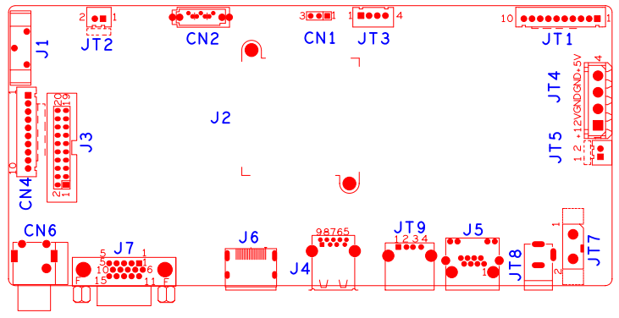

位号 | 功能描述 | 接口定义
JT2 | 风扇电源座子 | 1:+12 | 2:GND
JT5 | 风扇电源座子 | 1:+12 | 2:GND
JT8 | 12V电源输入接口
JT7 | 电源开关
CN1 | RS232接口 | 1:RXD | 2:TXD | 3:GND
JT3 | USB扩展接口
J5 | 网口座子
J4 | USB3.0座子
JT9 | USB座子
JT4 | 硬盘电源座子
J7 | VGA输入接口 | 1:VGA_RED | 2:VGA_GREEN | 3:VGA_BLUE | 4:NC
 |  | 5:GND | 6:GND | 7:GND | 8:GND
 |  | 9:NC | 10:GND | 11:NC | 12:NC
 |  | 13:VGA_HSO | 14:VGA_VSO | 15:NC
CN4 | 10PIN不带单片机前面板座子 | 1:+3.3V | 2:GND | 3:IR | 4:COL2
 |  | 5:COL1 | 6:ROW2 | 7: COL3 | 8:ROW1
 |  | 9:ALARM | 10:REC
J3 | 20PIN不带单片机前面板座子 | 1:GND | 2:ROW0 | 3:ROW4 | 4:COL4
 |  | 5:ROW3 | 6:COL0 | 7:COL2 | 8:ROW1
 |  | 9:COL1 | 10:ALARM | 11:REC | 12:IR
 |  | 13:LINK | 14:+3.3 | 15:COL3 | 16:ROW2
 |  | 17:NC | 18:GND | 19:NC | 20:NC
JT1 | 10PIN带单片机前面板座子 | 1:+5 | 2:GND | 3:+5_STB | 4:GND
 |  | 5:NC | 6:NC | 7:RXD_FRONT | 8:TXD_FRONT
 |  | 9:PWR_S | 10:GND
CN6 | 音频输入输出座子 | 1T:AUDIO_OUT_MAIN | 2T:AUDIO_LINE_IN1
CN2 | SATA接口
J6 | HDMI接口

