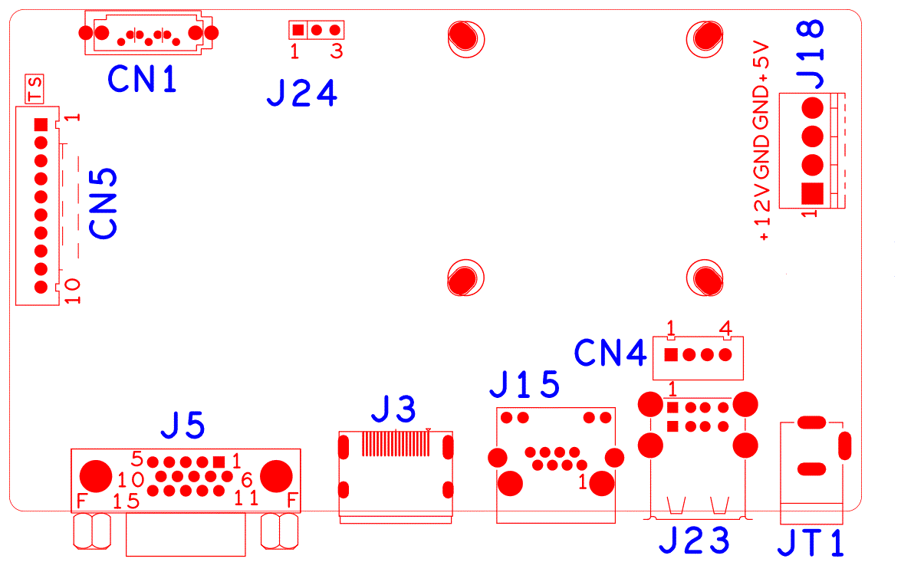

sign | Function | Interface Description
CN5 | Expansion seat without front panel of MCU | 1:+3.3 | 2:GND | 3:IR | 4:COL2
 |  | 5:COL1 | 6:ROW2 | 7:COL3 | 8:ROW1
 |  | 9:ALARM | 10:REC
CN1 | SATA
J24 | RS232
J7 | Hard Disk Power Seat | 1:+12 | 2:GND | 3:GND | 4:+5
JT1 | 12V Power switch
J23 | 2USB
CN4 | USB
J15 | RJ45
J3 | HDMI
J5 | VGA

NBD8016RA-ULK

