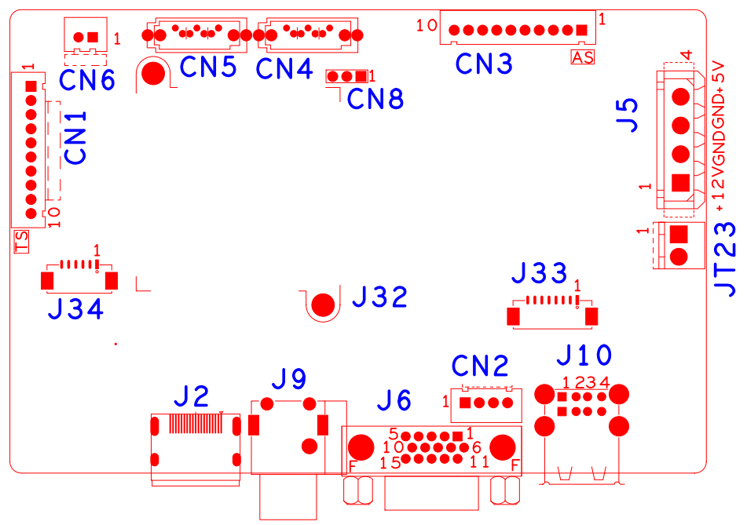

代号 | 功能描述 | 接口定义
CN1 | 10PIN不带单片机前面板扩展座子 | 1:+3.3 | 2:GND | 3:IR | 4:COL2
 |  | 5:COL1 | 6:ROW2 | 7:COL3 | 8:ROW1
 |  | 9:ALARM | 10:REC
CN6 | 风扇电源座子 | 1:+12 | 2:GND
CN5 | SATA接口
CN4 | SATA接口
CN8 | RS232
CN3 | 带单片机前面板扩展座子 | 1:+5 | 2:GND | 3:+5_STB | 4:GND
 |  | 5:NC | 6:NC | 7:RXD_FRONT | 8:TXD_FRONT
 |  | 9:PWR_S | 10:GND
J5 | 硬盘电源座子 | 1:+12 | 2:GND | 3:GND | 4:+5
JT23 | POE电源输入扩展座子 | 1:GND | 2:+12
J10 | 2口USB组合接口
J33 | 网络差分扩展座子 | 1:DD- | 2:DD+ | 3:DC- | 4:DC+
 |  | 5:ETHRX- | 6:ETHRX+ | 7:ETHTX- | 8:ETHTX+
CN2 | 前面板USB扩展座子 | 1:+5 | 2:USB2_DM | 3:USB2_DP | 4:GND
J6 | VGA接口
J9 | 音频RCA接口 | 上:AUDIO_IN | 下:AUDIO_OUT
J2 | HDMI接口
J34 | MDIO扩展座子 | 1:GPIO_MDIO0 | 2:GPIO_MDCK0 | 3:GND | 4:GPIO_MDIO1
 |  | 5:GPIO_MDCK1 | 6:POE_RSTN
J32 | 散热片

