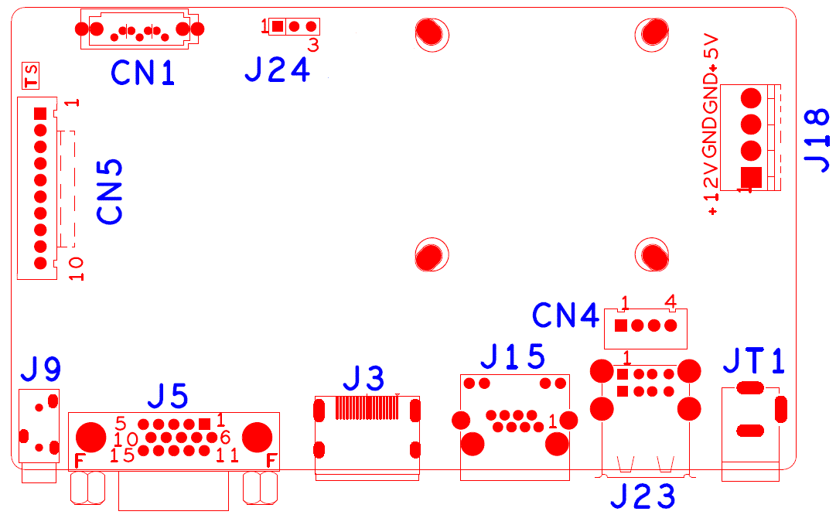

|  |  |  |  |  |  |
| --- | --- | --- | --- | --- | --- |
| sign | Function | Interface Description | | | |
| CN5 | Expansion seat without front panel of MCU | 1:+3.3 | 2:GND | 3:IR | 4:COL2 |
|  |  | 5:COL1 | 6:ROW2 | 7:COL3 | 8:ROW1 |
|  |  | 9:ALARM | 10:REC |  |  |
| CN1 | SATA |  |  |  |  |
| J24 | RS232 |  |  |  |  |
| J7 | Hard Disk Power Seat | 1:+12 | 2:GND | 3:GND | 4:+5 |
| [1]JT1 | 12V Power switch |  |  |  |  |
| J23 | 2USB |  |  |  |  |
| CN4 | USB |  |  |  |  |
| J15 | RJ45 |  |  |  |  |
| J3 | HDMI |  |  |  |  |
| J5 | VGA |  |  |  |  |
| J9 | 3.5mm audio output |  |  |  |  |

1. NBD8008RA-ULA