NBD8004T-QW(双盘带VGA)
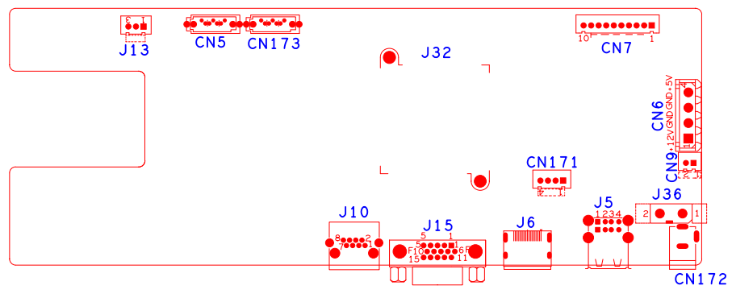
位号 | 功能描述 | 接口定义
CN9 | 风扇电源座子 | 1:+12 | 2:GND
CN172 | 12V输入电源接口
J36 | 电源开关
J13 | XM722调试接口 | 1: RXD | 2:TXD | 3:GND
CN171 | USB扩展接口
J5 | 2USB座子
J10 | 网口座子
CN6 | 硬盘电源座子
J15 | VGA输入接口 | 1:VGA_RED | 2: VGA_GREEN | 3: VGA_BLUE | 4:NC
 |  | 5: GND | 6:GND | 7:GND | 8:GND
 |  | 9:NC | 10:GND | 11:NC | 12:NC
 |  | 13: VGA_HSO | 14: VGA_VSO | 15:NC
CN7 | 10PIN不带单片机前面板座子 | 1:+3.3 | 2:GND | 3:IR | 4:COL2
 |  | 5: COL1 | 6:ROW2 | 7:COL3 | 8:ROW1
 |  | 9: ALARM | 10:REC
CN5 | SATA接口
CN173 | SATA接口
J6 | HDMI接口

