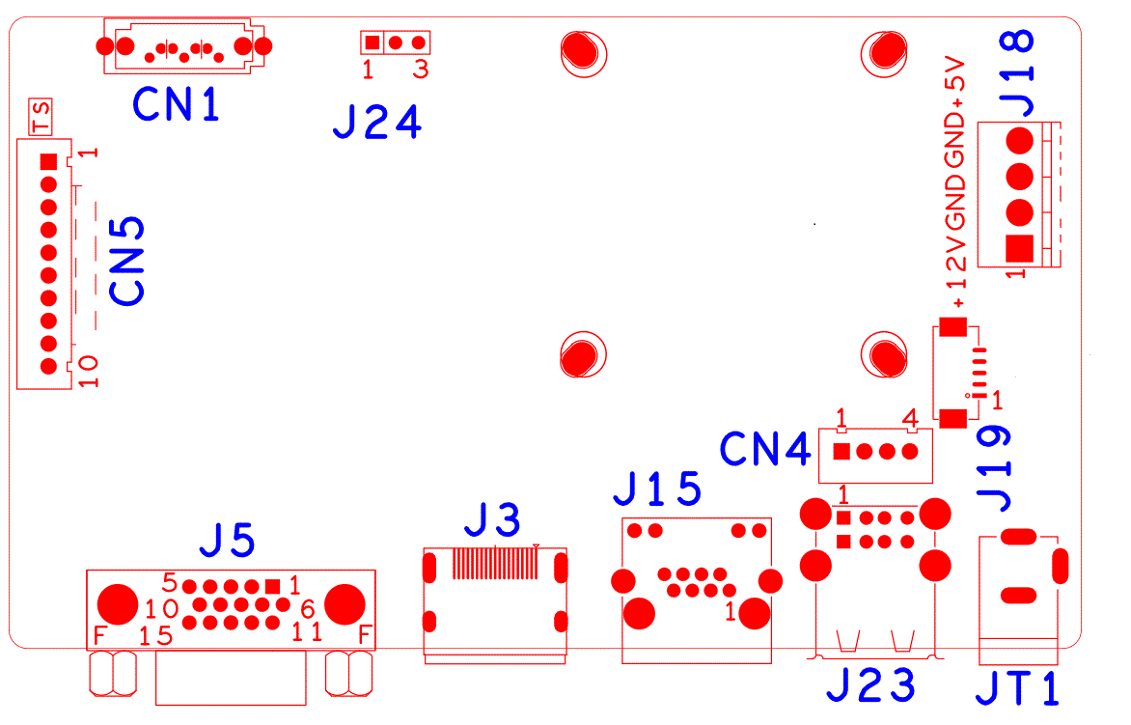

代号 | 功能描述 | 接口定义
CN5 | 不带单片机前面板扩展座子 | 1:+3.3 | 2:GND | 3:IR | 4:COL2
 |  | 5:COL1 | 6:ROW2 | 7:COL3 | 8:ROW1
 |  | 9:ALARM | 10:REC
CN1 | SATA接口
J24 | RS232
J18 | 硬盘电源座子 | 1:+12 | 2:GND | 3:GND | 4:+5
J19 | WIFI扩展座子 | 1:GND | 2: USBDP_WIFI | 3: USBDM_WIFI | 4: +5
 |  | 5: USB_CTRL
JT1 | 12V电源输入接口
J23 | 2USB组合接口
CN4 | USB扩展座子
J15 | RJ45网口
J3 | HDMI接口
J5 | VGA接口

本接口说明对应800米WIFI套包NVR产品，WIFI模块架在主板右上脚38孔位上

