NBD7004T-PW
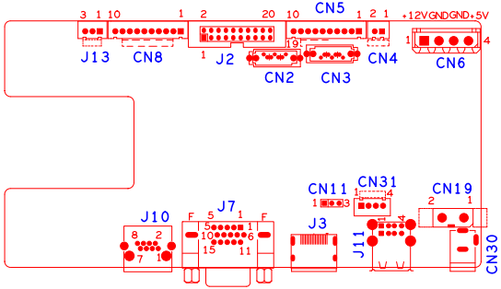

位号 | 功能描述 | 接口定义
CN4 | 风扇电源座子 | 1:+12 | 2:GND
CN30 | 12V输入电源接口
CN19 | 电源开关
J13 | XM722调试接口 | 1:GPIO4_RX | 2:GPIO11_TX | 3:GND
CN11 | 主控调试接口 | 1：UART0_RXD | 2：UART0_TXD | 3：GND
CN31 | USB扩展接口
J11 | 2USB座子
J10 | 网口座子
CN6 | 硬盘电源座子
J7 | VGA输入接口 | 1:VGA_RED | 2: VGA_GREEN | 3: VGA_BLUE | 4:NC
 |  | 5: GND | 6:GND | 7:GND | 8:GND
 |  | 9:NC | 10:GND | 11:NC | 12:NC
 |  | 13: VGA_HSO | 14: VGA_VSO | 15:NC
CN8 | 10PIN带单片机前面板座子 | 1:+5 | 2:GND | 3:+5_STB | 4:GND
 |  | 5:NC | 6:NC | 7:RXD_FRONT | 8:TXD_FRONT
 |  | 9:PWR_S | 10:GND
CN5 | 10PIN不带单片机前面板座子 | 1:+3.3 | 2:GND | 3:IR | 4:COL1
 |  | 5: COL3 | 6: COL4 | 7:ROW4 | 8: COL2
 |  | 9: ALARM | 10:REC
J2 | 20PIN不带单片机前面板座子 | 1:GND | 2:ROW0 | 3:ROW1 | 4:ROW2
 |  | 5:ROW3 | 6:COL0 | 7:COL1 | 8:COL2
 |  | 9:COL3 | 10:ALARM | 11:REC | 12:IR
 |  | 13:LINK | 14:+3.3 | 15:ROW4 | 16:COL4
 |  | 17:NC | 18:GND | 19:NC | 20:NC
CN2 | SATA接口
CN3 | SATA接口
J3 | HDMI接口

