BRD-XMJP-BLK18E-0145-38X38-WP1-V1_01接口说明
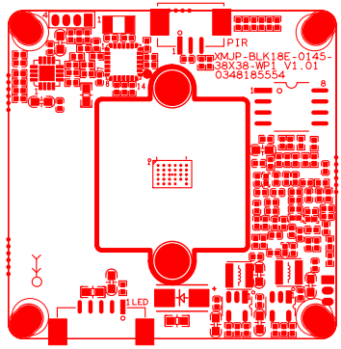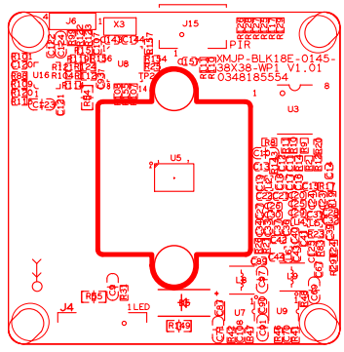

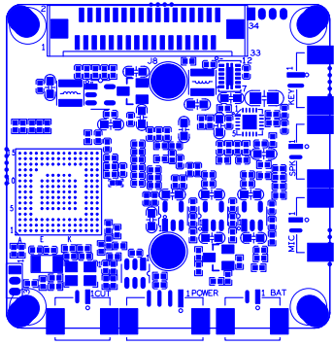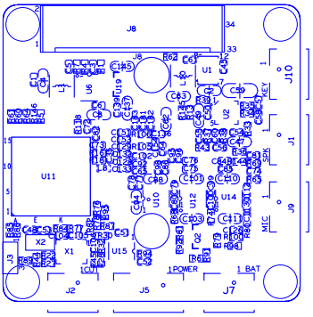

标注 | 丝印编号 | 针脚编号 | 针脚定义 | 功能
P1 | J5 | 1 | 空 | 空
 |  | 2 | 空 | 空
 |  | 3 | GND | 地
 |  | 4 | +5V | +5V 电源输入
P2 | J7 | 1 | GND | 地
 |  | 2 | LI-BAT | 锂电池正极
P3 | J2 | 1 | IR_CUT输出1 | IR_CUT输出1
 |  | 2 | IR_CUT输出2 | IR_CUT输出2
P4 | J4 | 1 | LED_EN | 红外灯电源使能
 |  | 2 | GPIO81 | 光敏信号采集
 |  | 3 | GND | 地
 |  | 4 | +5V_BQ | 电池电源正极
 |  | 5 | +3.3V | +3.3V
P5 | J9 | 1 | GND | 咪头负
 |  | 2 | MIC_P | 咪头正
P6 | J1 | 1 | VOP | 喇叭正
 |  | 2 | VON | 喇叭负
P7 | J15 | 1 | +3.3V_PIR | +3.3V
 |  | 2 | GND | 地
 |  | 3 | PIR_OUT | pir输出信号
P8 | J10 | 1 | SET_GPIO3 | 门铃按键
 |  | 2 | GND | 地
P9 | J8 | 1 | SD1_CLK | WIFI时钟信号
 |  | 2 | GND | 地
 |  | 3 | SD1_CMD | WIFI控制信号
 |  | 4 | SD1_D0 | WIFI数据0
 |  | 5 | SD1_D1 | WIFI数据1
 |  | 6 | SD1_D2 | WIFI数据2
 |  | 7 | SD1_D3 | WIFI数据3
 |  | 8 | GND | 地
 |  | 9 | CARD_DETECT | 热插拔
 |  | 10 | SD_EN | SD卡电源使能
 |  | 11 | SDIO1_CDATA3 | SD卡数据3
 |  | 12 | SDIO1_CDATA0 | SD卡数据0
 |  | 13 | SDIO1_CDATA1 | SD卡数据1
 |  | 14 | SDIO1_CDATA2 | SD卡数据2
 |  | 15 | SDIO1_CCMD | SD卡控制信号
 |  | 16 | SDIO1_CCLK_OUT | SD卡时钟信号
 |  | 17 | GND | 地
 |  | 18 | SD1_POWER_EN | WIFI使能信号
 |  | 19 | SD1_HOST_INTO | WIFI中断信号
 |  | 20 | SD1_DEVCE_WAKE | 唤醒单片机
 |  | 21 | WL_RST | WIFI复位
 |  | 22 | SD1_HOST_WAKE | 唤醒WIFI
 |  | 23 | GND | 地
 |  | 24 | MCU_LED1 | 蓝指示灯
 |  | 25 | MCU_LED2 | 红指示灯
 |  | 26 | SW_ON/OFF_F | 配网复位
 |  | 27 | GND | 地
 |  | 28 | SDIO1_VOUT | SD卡+3.3V
 |  | 29 | +1.8V_STB | +1.8V
 |  | 30 | GND | 地
 |  | 31 | +3.3V | +3.3V
 |  | 32 | GND | 地
 |  | 33 | +5V_BQ | 电池电源正极
 |  | 34 | +5V_BQ | 电池电源正极
BRD_XMJP-38X38-PORT-WP1-V1_01接口说明

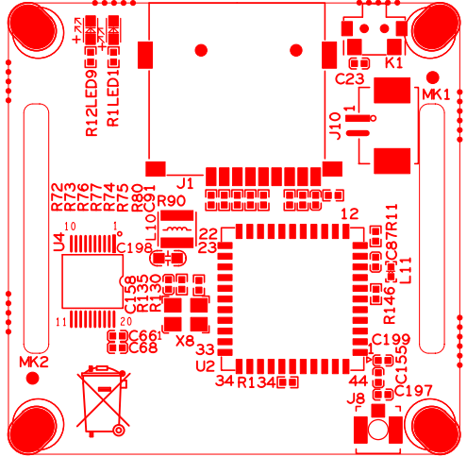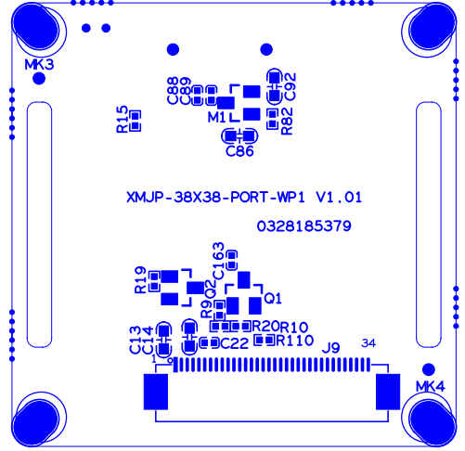

标注 | 丝印编号 | 针脚编号 | 针脚定义 | 功能
P1 | K1 | 配网复位reset
P2 | J1 | SD卡槽
P3 | J10 | 1 | SW ON/OFF | 配网复位RESET
 |  | 2 | GND | GND
P4 | J9 | 1 | 5V_BQ | 电池电源正极
 |  | 2 | 5V_BQ | 电池电源正极
 |  | 3 | GND | 地
 |  | 4 | +3.3V | +3.3V
 |  | 5 | GND | 地
 |  | 6 | +1.8V_STB | +1.8V
 |  | 7 | SDIO1_VOUT | SD卡+3.3V
 |  | 8 | GND | 地
 |  | 9 | SW_ON/OFF_F | 配网复位
 |  | 10 | MCU_LED2 | 红指示灯
 |  | 11 | MCU_LED1 | 蓝指示灯
 |  | 12 | GND | 地
 |  | 13 | SD1_HOST_WAKE | 唤醒WIFI
 |  | 14 | WL_RST | WIFI复位
 |  | 15 | SD1_DEVCE_WAKE | 唤醒单片机
 |  | 16 | SD1_HOST_INTO | WIFI中断信号
 |  | 17 | SD1_POWER_EN | WIFI使能信号
 |  | 18 | GND | 地
 |  | 19 | SDIO1_CCLK_OUT | SD卡时钟信号
 |  | 20 | SDIO1_CCMD | SD卡控制信号
 |  | 21 | SDIO1_CDATA2 | SD卡数据2
 |  | 22 | SDIO1_CDATA1 | SD卡数据1
 |  | 23 | SDIO1_CDATA0 | SD卡数据0
 |  | 24 | SDIO1_CDATA3 | SD卡数据3
 |  | 25 | SD_EN | SD卡电源使能
 |  | 26 | CARD_DETECT | 热插拔
 |  | 27 | GND | 地
 |  | 28 | SD1_D3 | WIFI数据3
 |  | 29 | SD1_D2 | WIFI数据2
 |  | 30 | SD1_D1 | WIFI数据1
 |  | 31 | SD1_D0 | WIFI数据0
 |  | 32 | SD1_CMD | WIFI控制信号
 |  | 33 | GND | 地
 |  | 34 | SD1_CLK | WIFI时钟信号

