P1 Ethernet
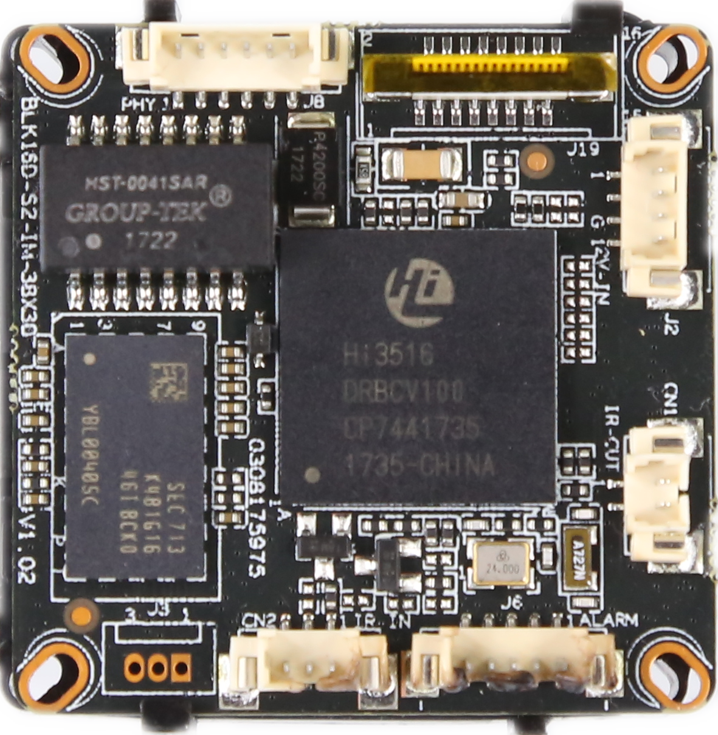
P6 audio/video
P3 IRcut
P2 Infrared interface
P4 power

sign | Socket | Specific No | Interface Description | Function
P1 | J3 | 1 | ETHRX- | Ethernet signal
 |  | 2 | ETHRX+ | Ethernet signal
 |  | 3 | LED/PHY_AD3 | LED
 |  | 4 | ETHTX- | Ethernet signal
 |  | 5 | ETHTX+ | Ethernet signal
 |  | 6 | LED/PHY_AD0 | LED
P2 | J2 | 1 | Infrared input | Infrared input
 |  | 2 | GND | GND
 |  | 3 | +5V | 5V DC input
P3 | J4 | 1 | BOUT | IRCUT output
 |  | 2 | AOUT | IRCUT output
P4 | J7 | 1 | NC | Undefined
 |  | 2 | NC | Undefined
 |  | 3 | GND | GND
 |  | 4 | 12V | 12V DC input
P5 | J1 | 1 | UART_RX
 |  | 2 | UART_TX
 |  | 3 | GND | GND
P6 | J6 | 1 | AC_OUT | AC_OUT
 |  | 2 | MIC_P | MIC_P
 |  | 3 | GND | GND
 |  | 4 | ALARM_IN | ALARM_IN
 |  | 5 | GND | GND

