BLK16D-38X38-AF-V1_01接口说明表-核心板接口详细定义
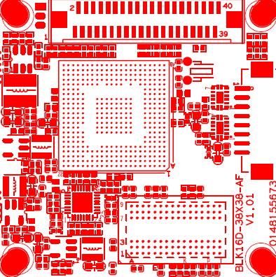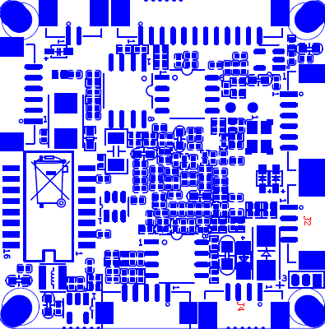
P7 SD卡、报警
P4 RTC电池
P9 扩展接口
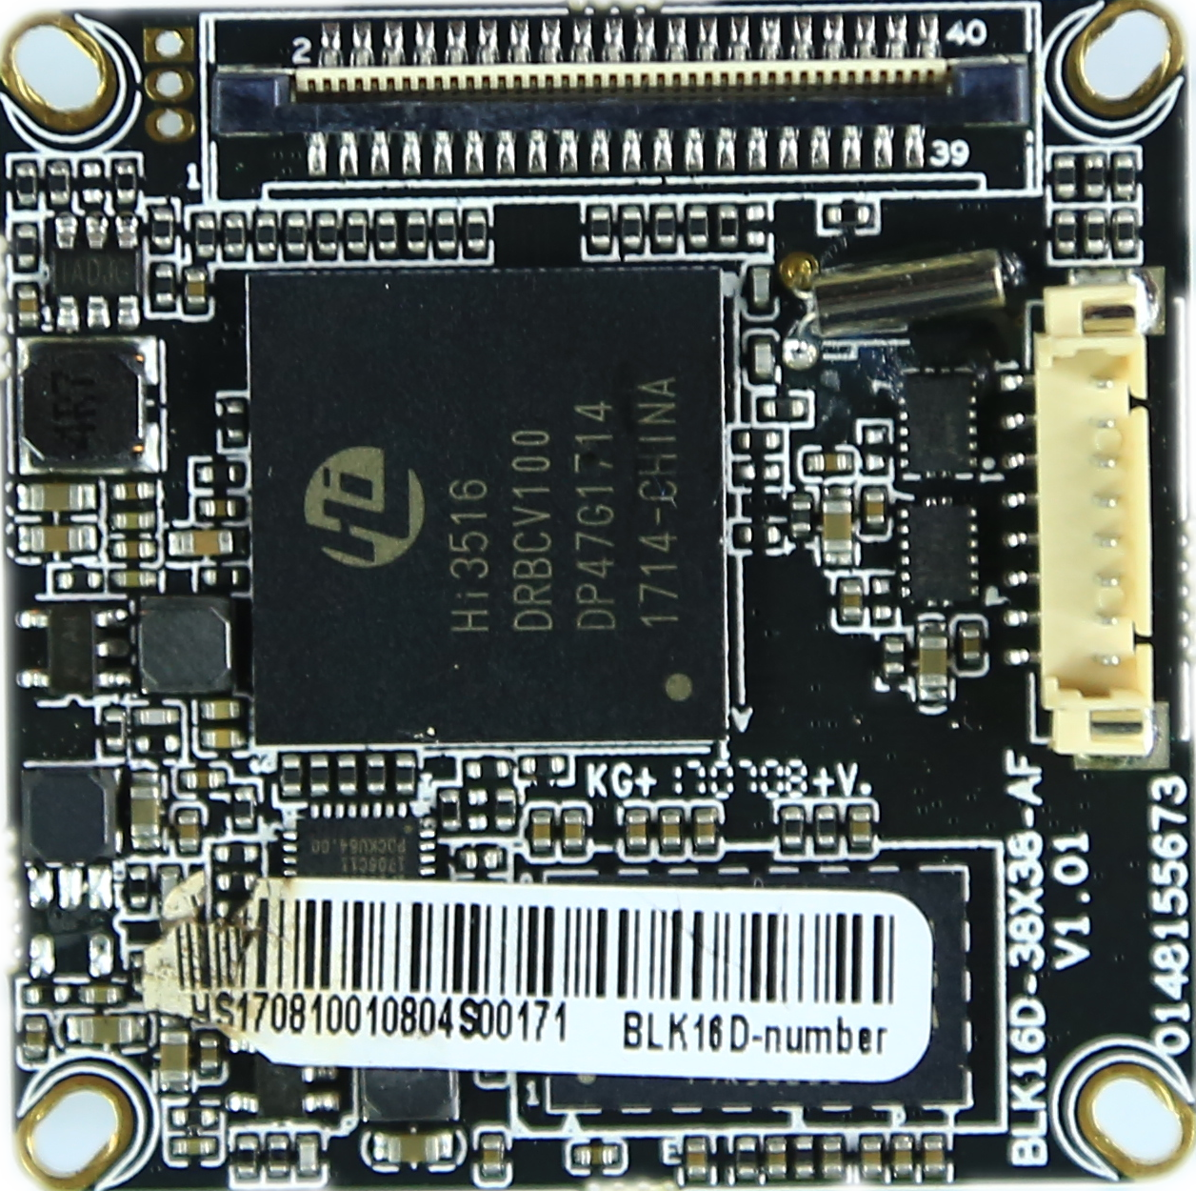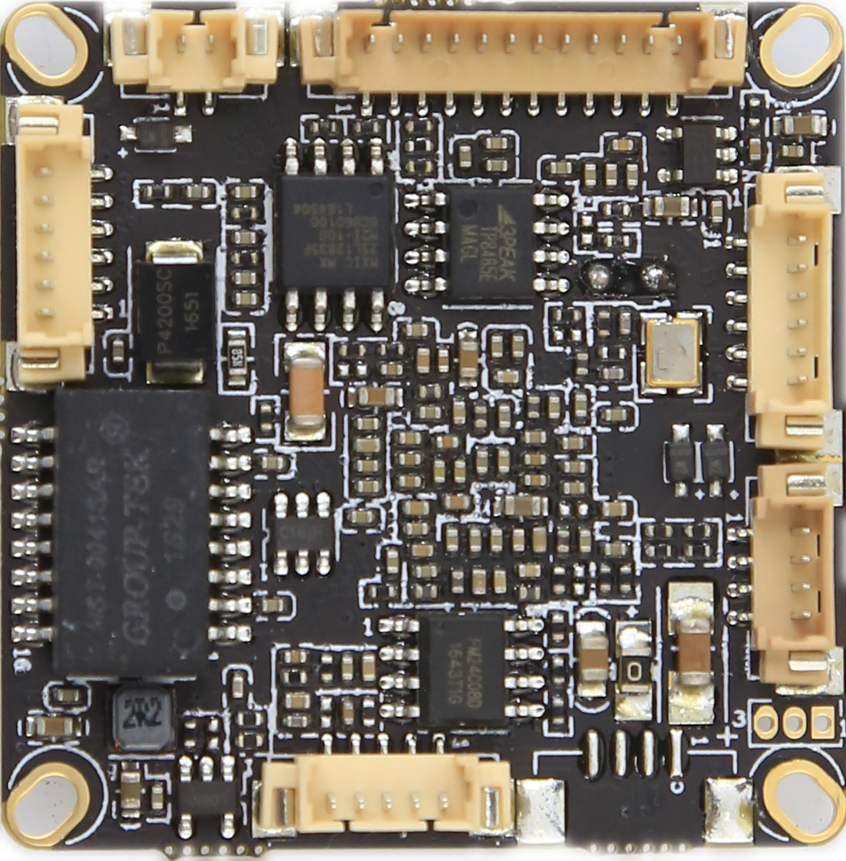
P8电机接口
P6云台报警
P1电源
P3 音频
P2网口

标注 | 丝印编号 | 针脚编号 | 针脚定义 | 功能
P1 | J2 | 1 | NC | 悬空
 |  | 2 | NC | 悬空
 |  | 3 | GND | GND
 |  | 4 | +12V | 12V输入
P2 | J8 | 1 | ETHTR- | 以太网信号
 |  | 2 | ETHTR+ | 以太网信号
 |  | 3 | LED/PHY_AD3 | 指示灯
 |  | 4 | ETHTX- | 以太网信号
 |  | 5 | ETHTX+ | 以太网信号
 |  | 6 | LED/PHY_AD0 | 指示灯
P3 | J6 | 1 | GND | GND
 |  | 2 | VDAC_CVBS | 视频输出
 |  | 3 | AGND | AGND
 |  | 4 | AC_OURL | 音频输出
 |  | 5 | AC_LINEL | 音频输入
P4 | J7 | 1 | GND | GND
 |  | 2 | VBAT | 电池正极
P5 | J3 | 1 | UART_RXD | 串口接收
 |  | 2 | UART_TXD | 串口发送
 |  | 3 | GND | GND
P6 | J4 | 1 | GND | GND
 |  | 2 | USB_DP | USB数据口
 |  | 3 | USB_DM | USB数据口
 |  | 4 | +5V | +5V
P7 | CN1 | 1 | ALARM_IN1 | 报警输入1
 |  | 2 | GND | GND
 |  | 3 | ALARM_IN2 | 报警输入2
 |  | 4 | GND | GND
 |  | 5 | RS485A | 485通信接口
 |  | 6 | RS485B | 485通信接口
P8 | J9 | 1 | U25_BOUT2 | 电机驱动接口
 |  | 2 | U25_BOUT1 | 电机驱动接口
 |  | 3 | U26_BOUT2 | 电机驱动接口
 |  | 4 | U26_BOUT1 | 电机驱动接口
 |  | 5 | U26_AOUT2 | 电机驱动接口
 |  | 6 | U26_AOUT1 | 电机驱动接口
 |  | 7 | U25_AOUT2 | 电机驱动接口
 |  | 8 | U25_AOUT1 | 电机驱动接口
P9 | J1 | 1 | 电源正极(12v) | 12V电源输入
 |  | 2 | 电源正极(12v) | 12V电源输入
 |  | 3 | GND | 接地
 |  | 4 | GND | 接地
 |  | 5 | 电源正极(5v) | 5V 电源输入
 |  | 6 | GND | 接地
 |  | 7 | DOUT7 | 视频信号输出
 |  | 8 | DOUT6 | 视频信号输出
 |  | 9 | DOUT5 | 视频信号输出
 |  | 10 | DOUT4 | 视频信号输出
 |  | 11 | DOUT3 | 视频信号输出
 |  | 12 | DOUT2 | 视频信号输出
 |  | 13 | DOUT1 | 视频信号输出
 |  | 14 | DOUT0 | 视频信号输出
 |  | 15 | VIDEOIN_HD | 行同步信号
 |  | 16 | VIDEOIN_PCLK | 时钟信号
 |  | 17 | VIDEOIN_VD | 场同步信号
 |  | 18 | GND | 接地
 |  | 19 | NC | 空闲脚
 |  | 20 | SCL | I2C时钟脚
 |  | 21 | NC | 空闲脚
 |  | 22 | MCBSP_DR_SPI1_EN | SPI使能脚
 |  | 23 | NC | 空闲脚
 |  | 24 | REDCTRL | 红外灯信号输入
 |  | 25 | GND | 接地
 |  | 26 | GND | 接地
 |  | 27 | GND | 接地
 |  | 28 | 1.8V输出 | 1.8V输出
 |  | 29 | SDA | I2C数据脚
 |  | 30 | NC | 空闲脚
 |  | 31 | NC | 空闲脚
 |  | 32 | NC | 空闲脚
 |  | 33 | NC | 空闲脚
 |  | 34 | DOUT11 | 视频信号输出
 |  | 35 | DOUT10 | 视频信号输出
 |  | 36 | DOUT9 | 视频信号输出
 |  | 37 | DOUT8 | 视频信号输出
 |  | 38 | IRCUT | IRCUT控制
 |  | 39 | IRCUT | IRCUT控制
 |  | 40 | GND | 接地
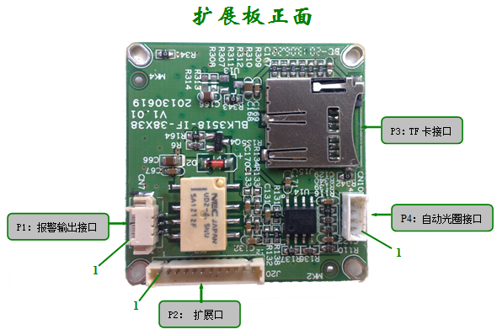
（-P扩展板，-B无）
标注 | 丝印编号 | 针脚编号 | 针脚定义 | 功能
P1 | CN7 | 1 | ALARM NO | 报警输出口
 |  | 2 | ALARM COM | 报警公共端
 |  | 3 | GND | 地
P2 | J20 | 1 | GND | 地
 |  | 2 | 5V | 5V电源
 |  | 3 | 3.3V | 3.3V电源
 |  | 4 | GPIO32 | 报警输出
 |  | 5 | GPIO53 | PWM输出
 |  | 6 | - | -
 |  | 7 | SD_CLK | SD卡时钟
 |  | 8 | SD_CMD | SD卡命令
 |  | 9 | SD_DATA3 | SD卡数据3
 |  | 10 | SD_DATA2 | SD卡数据2
 |  | 11 | SD_DATA1 | SD卡数据1
 |  | 12 | SD_DATA0 | SD卡数据0
P4 | CN10 | 1 | IRIS_CON- | 阻尼信号负
 |  | 2 | IRIS_CON+ | 阻尼信号正
 |  | 3 | IRIS_DRV | 驱动
 |  | 4 | GDN | 地
前端板
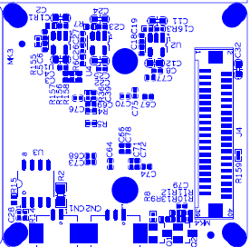
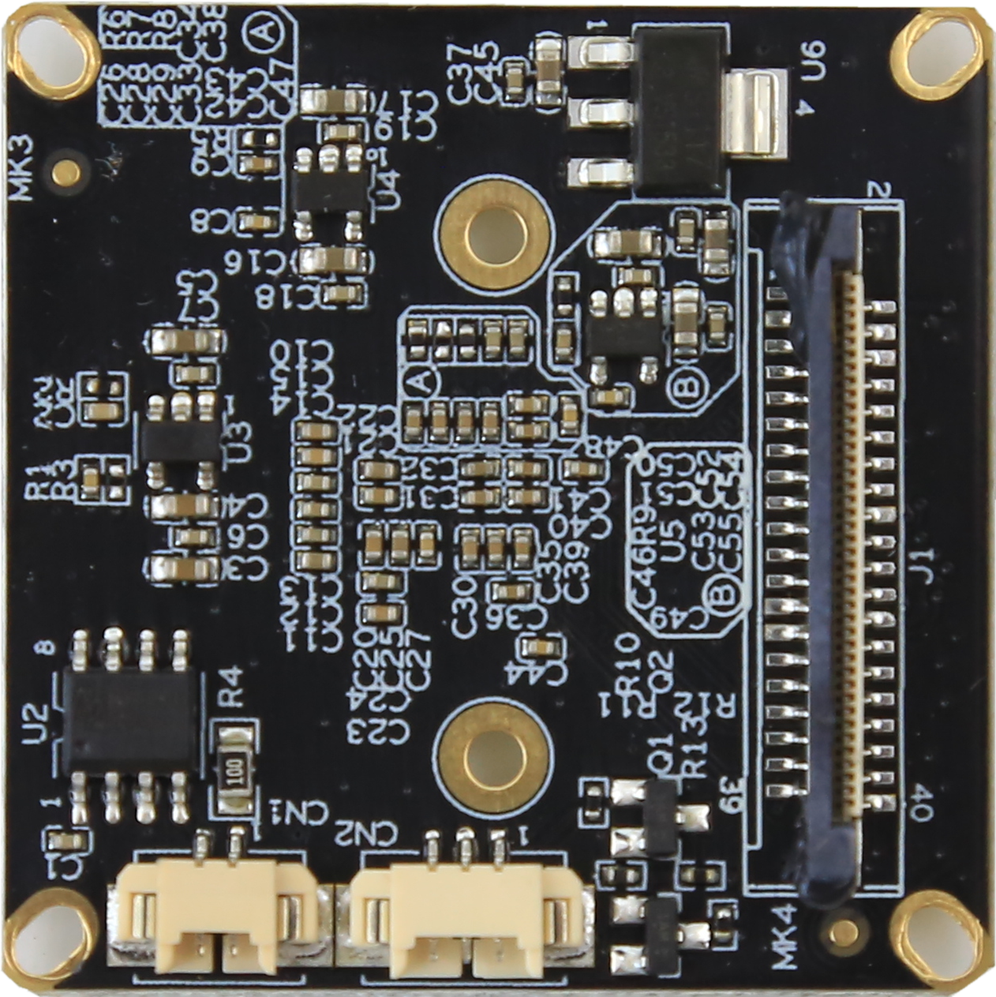
P2扩展接口
P2 灯板
P3 IR-CUT

P1 | J4 | 1 | 电源正极(12v) | 12V电源输入
 |  | 2 | 电源正极(12v) | 12V电源输入
 |  | 3 | GND | 接地
 |  | 4 | GND | 接地
 |  | 5 | 电源正极(5v) | 5V 电源输入
 |  | 6 | GND | 接地
 |  | 7 | DOUT7 | 视频信号输出
 |  | 8 | DOUT6 | 视频信号输出
 |  | 9 | DOUT5 | 视频信号输出
 |  | 10 | DOUT4 | 视频信号输出
 |  | 11 | DOUT3 | 视频信号输出
 |  | 12 | DOUT2 | 视频信号输出
 |  | 13 | DOUT1 | 视频信号输出
 |  | 14 | DOUT0 | 视频信号输出
 |  | 15 | VIDEOIN_HD | 行同步信号
 |  | 16 | VIDEOIN_PCLK | 时钟信号
 |  | 17 | VIDEOIN_VD | 场同步信号
 |  | 18 | GND | 接地
 |  | 19 | NC | 空闲脚
 |  | 20 | SCL | I2C时钟脚
 |  | 21 | NC | 空闲脚
 |  | 22 | MCBSP_DR_SPI1_EN | SPI使能脚
 |  | 23 | NC | 空闲脚
 |  | 24 | REDCTRL | 红外灯信号输入
 |  | 25 | GND | 接地
 |  | 26 | GND | 接地
 |  | 27 | GND | 接地
 |  | 28 | 1.8V输出 | 1.8V输出
 |  | 29 | SDA | I2C数据脚
 |  | 30 | NC | 空闲脚
 |  | 31 | NC | 空闲脚
 |  | 32 | NC | 空闲脚
 |  | 33 | NC | 空闲脚
 |  | 34 | DOUT11 | 视频信号输出
 |  | 35 | DOUT10 | 视频信号输出
 |  | 36 | DOUT9 | 视频信号输出
 |  | 37 | DOUT8 | 视频信号输出
 |  | 38 | IRCUT | IRCUT控制
 |  | 39 | IRCUT | IRCUT控制
 |  | 40 | GND | 接地
P2 | CN2 | 1 | 灯板输入 | 灯板输入
 |  | 2 | GND | GND
 |  | 3 | NC | 空闲脚
P3 | CN1 | 1 | IRCUT输入控制 | IRCUT输入控制
 |  | 2 | IRCUT输入控制 | IRCUT输入控制

