J5
1 2

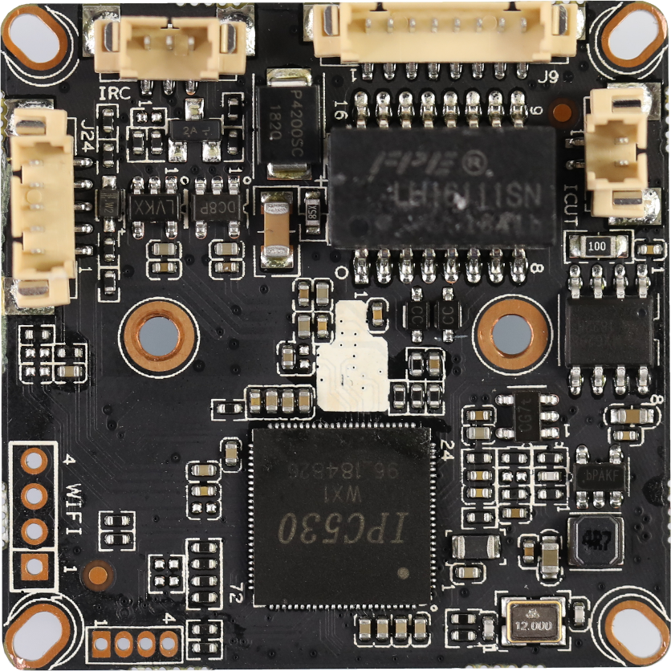
J9

8
7
...
2
1
J6
3
2
1
5 4 3 2 1
J24
4 3 2 1
J1

BLK530WX1-0235P-38X38-S-V1_01接口定义
座子位号 | 引脚标号 | 接口定义 | 功能定义
J9 | 1 | LED0 | 网络指示灯控制 | 接尾线
 | 2 | LED1 | 网络指示灯控制
 | 3 | ETHTX+ | 网络数据发送+
 | 4 | ETHTX- | 网络数据发送-
 | 5 | ETHRX+ | 网络数据接收+
 | 6 | ETHRX- | 网络数据接收-
 | 7 | GND | 地
 | 8 | 12V | 12V电源输入
J5 | 1 | IR-CUTA | IR-CUT控制线 | 接IR_CUT
 | 2 | IR-CUTA | IR-CUT控制线
J6 | 1 | IR-IN | 红外信号输入 | 接灯板
 | 2 | GND | 地
 | 3 | PWM-OUT | PWM信号输出
J24 | 1 | AC_OUT | 音频输出 | 音频座子
 | 2 | AC_IN | 音频输入
 | 3 | GND | 地
 | 4 | ALARM-IN | 报警输入
 | 5 | ALARM-OUT | 报警输出（预留）
J1 | 1 | 3.3V | WIFI模块供电 | 接USB WIFI模块
 | 2 | USB_DN | USB数据线
 | 3 | USB_DP | USB数据线
 | 4 | GND | 地

