P3 Infrared
P6 power&NET
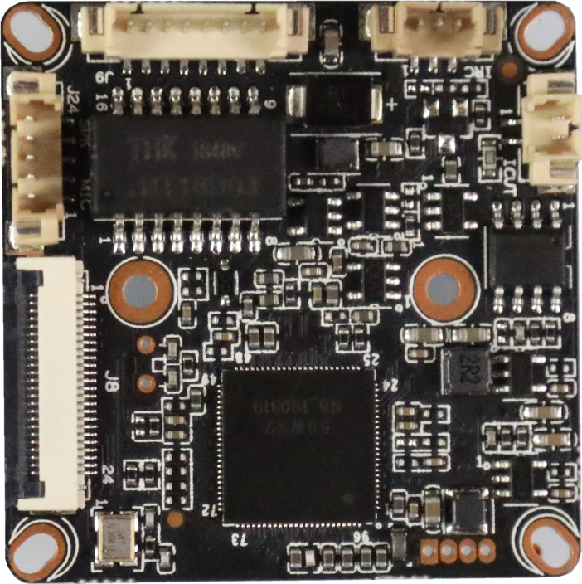
P4 Extension
P5 Alarm Audio
P1 IRcut

sign | Socket | Specific No | Interface Description | Function
P1 | J5 | 1 | IC-CUT | IRCUT output
 |  | 2 | IC-CUT | IRCUT output
P3 | J6 | 1 | LED_CTRL | GPIO/PWM
 |  | 2 | GND | GND
 |  | 3 | Pwm | IRIN
P4 | J8 | 1 | 3.3V | 3.3V
 |  | 2 | 3.3V | 3.3V
 |  | 3 | GND | GND
 |  | 4 | RTC_BAT | ALARM_IN1
 |  | 5 | ALARM_IN1 | KET_SET
 |  | 6 | KET_SET | LED_CTRL
 |  | 7 | LED_CTRL | ALARM_OUT
 |  | 8 | ALARM_OUT | GND
 |  | 9 | GND | WIFI_DATA0
 |  | 10 | WIFI_DATA0 | WIFI_PDN
 |  | 11 | WIFI_PDN | GND
 |  | 12 | GND | WIFI_CMD
 |  | 13 | WIFI_CMD | GND
 |  | 14 | GND | WIFI_CLK
 |  | 15 | WIFI_CLK | GND
 |  | 16 | GND | SD_DATA3
 |  | 17 | SD_DATA3 | ALARM_IN1
 |  | 18 | SD_DATA2 | SD_DATA2
 |  | 19 | SD_DATA1 | SD_DATA1
 |  | 20 | SD_DATA0 | SD_DATA0
 |  | 21 | GND | GND
 |  | 22 | SD_CMD | SD_CMD
 |  | 23 | GND | GND
 |  | 24 | SD_CLK | SD_CLK
P5 | J24 | 1 | MICN | MICN
 |  | 2 | MICP | MICP
 |  | 3 | ALARM_IN | ALARM_IN
 |  | 4 | SPKP | SPKP
 |  | 5 | SPKN | SPKN
P6 | J9 | 1
 |  | 2 | LED1/PHYAD1+ | LED
 |  | 3 | ETHRX- | Ethernet signal
 |  | 4 | ETHRX+ | Ethernet signal
 |  | 5 | ETHTX- | Ethernet signal
 |  | 6 | ETHTX+ | Ethernet signal
 |  | 7 | GND | GND
 |  | 8 | 12V | 12V

