P2
IR-CUT接口

P6
音频报警接口

P3
红外接口

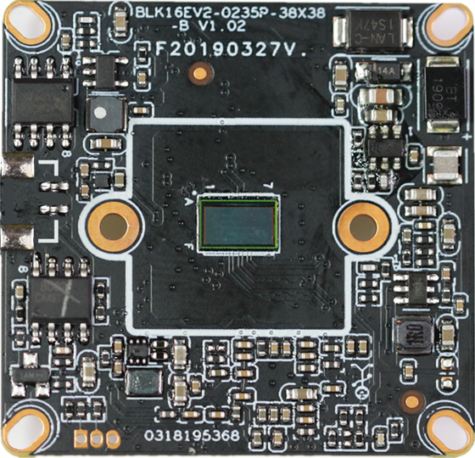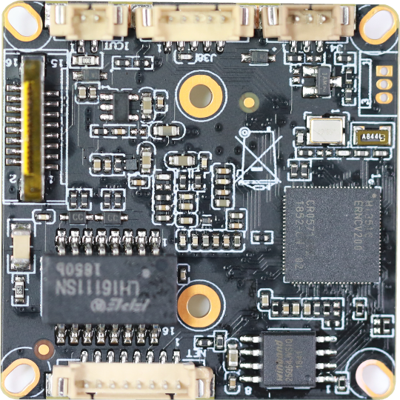
P1 供电和网络接口

标注 | 丝印编号 | 针脚编号 | 针脚定义 | 功能
P2 | J4 | 1 | IC-CUT | IC-CUT驱动
 |  | 2 | IC-CUT | IC-CUT驱动
P3 | J2 | 1 | IRIN_GPIO1_7 | IRIN
 |  | 2 | GND | 接地
 |  | 3 | GPIO2_0 | GPIO/PWM
P6 | J9 | 1 | AC_OUTL | 音频输出
 |  | 2 | AC_LINEL | 音频输入
 |  | 3 | GND | 接地
 |  | 4 | ALARM_IN1 | 报警输入
 |  | 5 | GND | 接地
P1 | J3 | 1 | LED/PHY_AD0 | 网络灯
 |  | 2 | LED/PHY_AD1 | 网络灯
 |  | 3 | ETHTX+ | 网口数据发送
 |  | 4 | ETHTX- | 网口数据发送
 |  | 5 | ETHRX+ | 网口数据接收
 |  | 6 | ETHRX- | 网口数据接收
 |  | 7 | GND | GND
 |  | 8 | 12V输入 | 12V输入

