BLK16CV3-0307-39X39-B V1.02接口说明-核心板接口详细定义

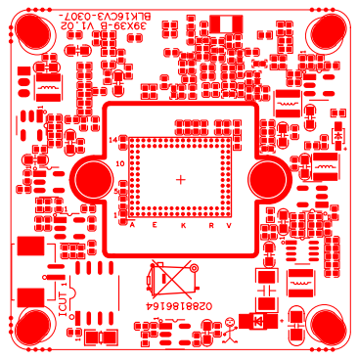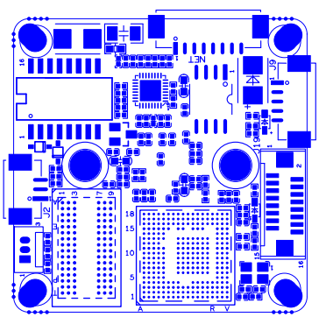
P1 电源网络接口

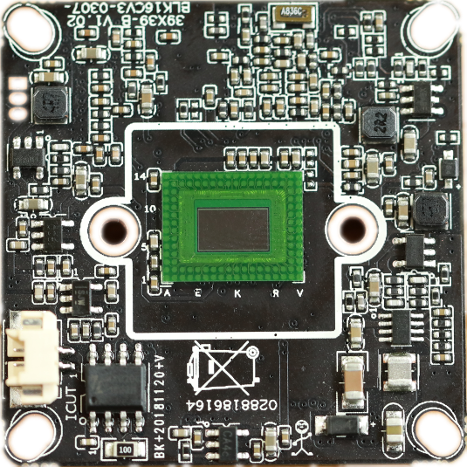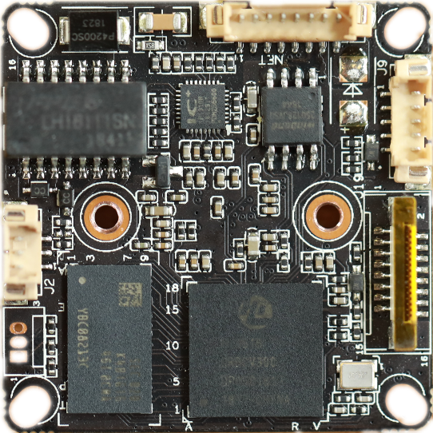
P2 IR-
CUT接口
P7 扩展接口
P6 音频报警接口
P3 红外接口

标注 | 丝印编号 | 针脚编号 | 针脚定义 | 功能
P2 | J4 | 1 | IC-CUT | IC-CUT驱动
 |  | 2 | IC-CUT | IC-CUT驱动
 | J1 | 1 | UATRO_RXD | 串口接收
 |  | 2 | UATRO_TXD | 串口发送
 |  | 3 | GND | 接地
P3 | J2 | 1 | GPIO6_6/PWM2 | GPIO/PWM
 |  | 2 | GND | 接地
 |  | 3 | IRC_GPIO80 | IRIN
P7 | J19 | 1 | SDIO1_CCLK_OUT | 时钟输出
 |  | 2 | SDIO1_CCMD | SD卡控制线
 |  | 3 | SDIO1_CDATA0 | 数据口0
 |  | 4 | SDIA1_CDATA1 | 数据口1
 |  | 5 | SDIA1_CDATA2 | 数据口2
 |  | 6 | SDIA1_CDATA3 | 数据口3
 |  | 7 | ALARM_IN2 | 报警输入
 |  | 8 | GND | 接地
 |  | 9 | KEY_GPIO8_4 | 按键
 |  | 10 | VBAT | RTC电池输入
 |  | 11 | GND | 接地
 |  | 12 | ALARM_OUT | 报警输出
 |  | 13 | USB_DM | USB数据口
 |  | 14 | USB_DP | USB数据口
 |  | 15 | VCC | 5V输入
 |  | 16 | USB_CONTROL | USB控制
P6 | J9 | 1 | AC_OUTL | 音频输出
 |  | 2 | AC_LINEL | 音频输入
 |  | 3 | GND | 接地
 |  | 4 | ALARM_IN1 | 报警输入
 |  | 5 | GND | 接地
P1 | J3 | 1 | ETHRX- | 以太网信号
 |  | 2 | ETHRX+ | 以太网信号
 |  | 3 | LED3/PHY_AD3 | 指示灯
 |  | 4 | ETHTX- | 以太网信号
 |  | 5 | ETHTX+ | 以太网信号
 |  | 6 | LED0/PHY_AD0 | 指示灯
 |  | 7 | GND | GND
 |  | 8 | 12V | 12V

