IPC-RB_18EVBLK-XST-V1.01接口说明表
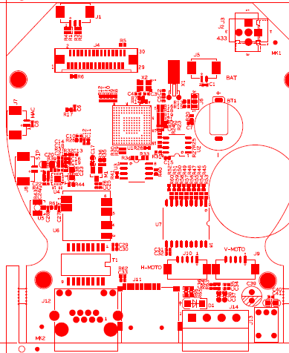
标注 | 丝印编号 | 针脚编号 | 针脚定义 | 功能
P1 | J6 | 1 | RXD | 串口接收
 |  | 2 | TXD | 串口发送
 |  | 3 | GND | GND
P2 | J8 | 1 | 喇叭输出 | 喇叭输出
 |  | 2 | 喇叭输出 | 喇叭输出
P3 | J7 | 1 | Mic | 咪头输入
 |  | 2 | GND | GND
P5 | J9 | 1 | +5V_M1 | 电机5v
 |  | 2 | Out8 | 电机控制
 |  | 3 | Out7 | 电机控制
 |  | 4 | Out6 | 电机控制
 |  | 5 | Out5 | 电机控制
P6 | J10 | 1 | +5V_M2 | 电机5v
 |  | 2 | Out4 | 电机控制
 |  | 3 | Out3 | 电机控制
 |  | 4 | Out2 | 电机控制
 |  | 5 | Out1 | 电机控制
P7 | J2 | 1 | +5V | 5输出
 |  | 2 | 433 | 433天线
 |  | 3 | GND | GND
P8 | J3 | 1 | +5V | 5输出
 |  | 2 | 433 | 433天线
 |  | 3 | GND | GND
P9 | J1 | 1 | Left | 电机左转控制
 |  | 2 | 433 | GND
 |  | 3 | Right | 电机右转控制
P10 | J13 | 1 | GND | GND
 |  | 2 | +5V | 5V输入
 |  | 3 | GND | GND
P11 | J12 | 1 | ETHTX+ | 以太网数据口
 |  | 2 | ETHTX- | 以太网数据口
 |  | 3 | ETHRX+ | 以太网数据口
 |  | 4 | NC | NC
 |  | 5 | NC | NC
 |  | 6 | ETHRX- | 以太网数据口
 |  | 7 | NC | NC
 |  | 8 | NC | NC
 |  | 9 | LED0 | 灯
 |  | 10 | 3.3V | 3.3V输入
 |  | 11 | GND | GND
 |  | 12 | LED3 | 灯
P12 | J5 | 1 | GND | GND
 |  | 2 | RTC | RTC电池输入
P13 | J4 | 1 | 5V | 5V
 |  | 2 | 5V | 5V
 |  | 3 | GND | GND
 |  | 4 | GND | GND
 |  | 5 | GND | GND
 |  | 6 | DATA11 | Sensor数据
 |  | 7 | DATA10 | Sensor数据
 |  | 8 | DATA9 | Sensor数据
 |  | 9 | DATA8 | Sensor数据
 |  | 10 | DATA7 | Sensor数据
 |  | 11 | DATA6 | Sensor数据
 |  | 12 | DATA5 | Sensor数据
 |  | 13 | DATA4 | Sensor数据
 |  | 14 | DATA3 | Sensor数据
 |  | 15 | DATA2 | Sensor数据
 |  | 16 | DATA1 | Sensor数据
 |  | 17 | DATA0 | Sensor数据
 |  | 18 | HS | HS
 |  | 19 | VI_CLK | VI_CLK
 |  | 20 | VS | VS
 |  | 21 | GND | GND
 |  | 22 | SIOD | I2C数据
 |  | 23 | SIOC | I2C时钟
 |  | 24 | UP | 电机上控制
 |  | 25 | DOWN | 电机下控制
 |  | 26 | RED_CTRL | 红外灯控制
 |  | 27 | IRCUT_CTLR | Ircut控制
 |  | 28 | SENSOR_CLK | Sensor时钟
 |  | 29 | GND | GND
 |  | 30 | GND | GND

