BLK16D-S2-IM-38X38 V1.02 Interface Description
P7 Extension interface
P1 Ethernet
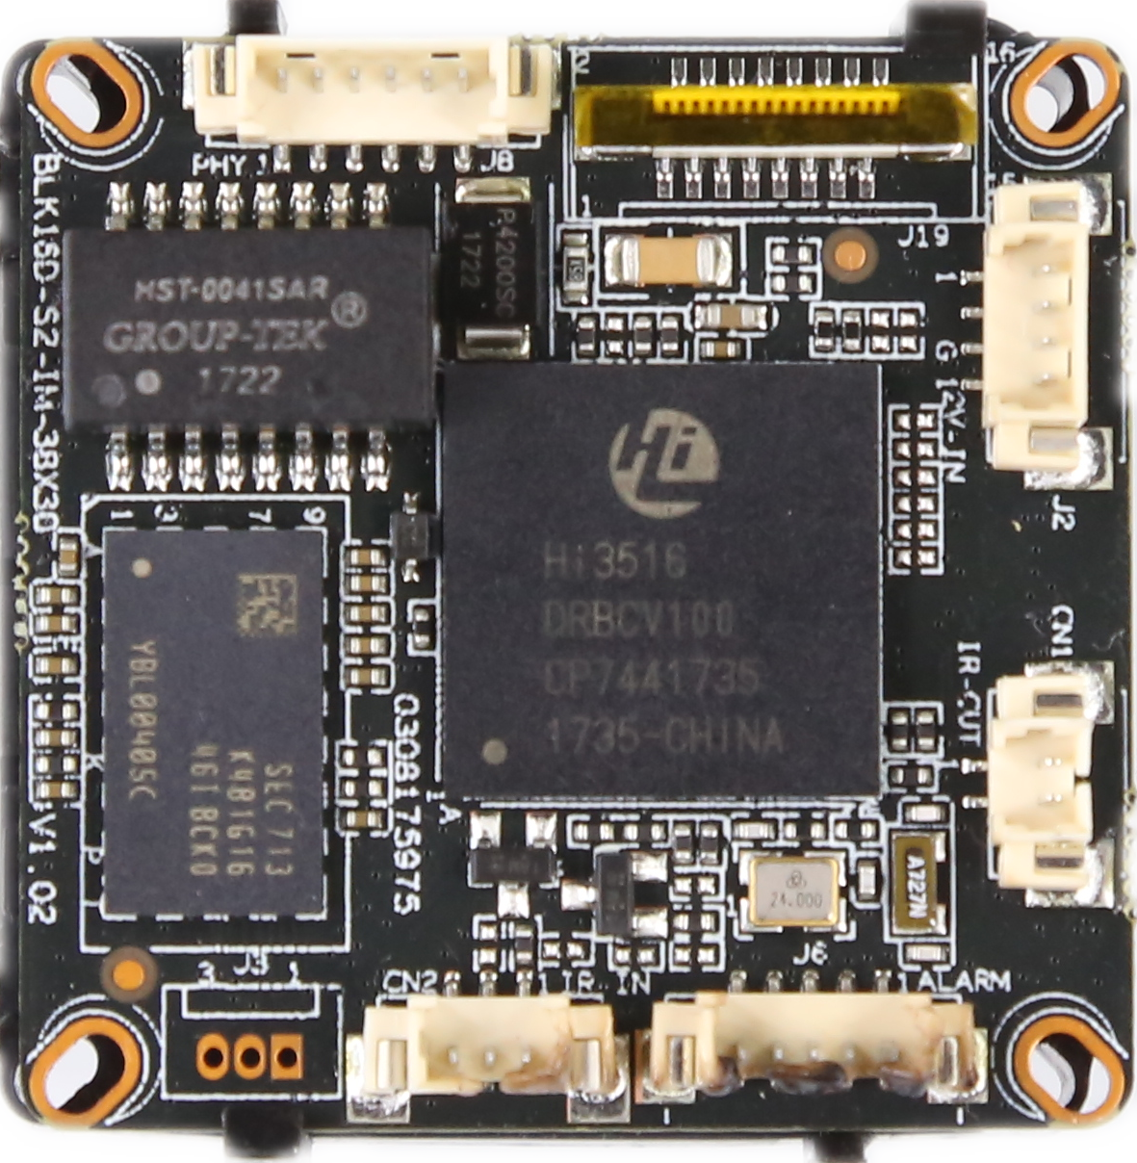
P4 power
P3 IRcut
P6 Alarm Audio
P2 Infrared

sign | Socket | Specific No | Interface Description | Function
P1 | J3 | 1 | ETHRX- | Ethernet signal
 |  | 2 | ETHRX+ | Ethernet signal
 |  | 3 | LED/PHY_AD3 | LED
 |  | 4 | ETHTX- | Ethernet signal
 |  | 5 | ETHTX+ | Ethernet signal
 |  | 6 | LED/PHY_AD0 | LED
P2 | J2 | 1 | Infrared input | Infrared input
 |  | 2 | GND | GND
 |  | 3 | +5V | 5V DC input
P3 | J4 | 1 | BOUT | IRCUT output
 |  | 2 | AOUT | IRCUT output
P4 | J7 | 1 | NC | Undefined
 |  | 2 | NC | Undefined
 |  | 3 | GND | GND
 |  | 4 | 12V | 12V DC input
P5 | J1 | 1 | UART_RX
 |  | 2 | UART_TX
 |  | 3 | GND | GND
P6 | J6 | 1 | AC_OUT | AC_OUT
 |  | 2 | MIC_P | MIC_P
 |  | 3 | GND | GND
 |  | 4 | ALARM_IN | ALARM_IN
 |  | 5 | GND | GND
P7 | J19 | 1 | SD_CLK | SD_CLK
 |  | 2 | SD_CMD | SD_CMD
 |  | 3 | SD_DATA0 | SD_DATA0
 |  | 4 | SD_DATA1 | SD_DATA1
 |  | 5 | SD_DATA2 | SD_DATA2
 |  | 6 | SD_DATA3 | SD_DATA3
 |  | 7 | LED_CTRL | LED_CTRL
 |  | 8 | GND | GND
 |  | 9 | Key-set | Key-set
 |  | 10 | BAT | RTC RTC battery input
 |  | 11 | GND | GND
 |  | 12 | ALARM_OUT | ALARM_OUT
 |  | 13 | USB_DM | USB_DM
 |  | 14 | USB_DP | USB_DP
 |  | 15 | +5V | +5V
 |  | 16 | USB_CONTRL | USB_CONTRL

