BLK16CV3-0330-WIFI-ZS-V2_01接口说明接口说明表

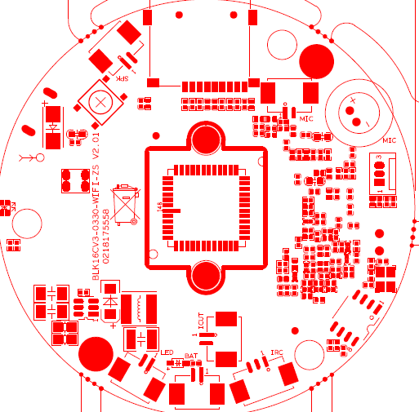
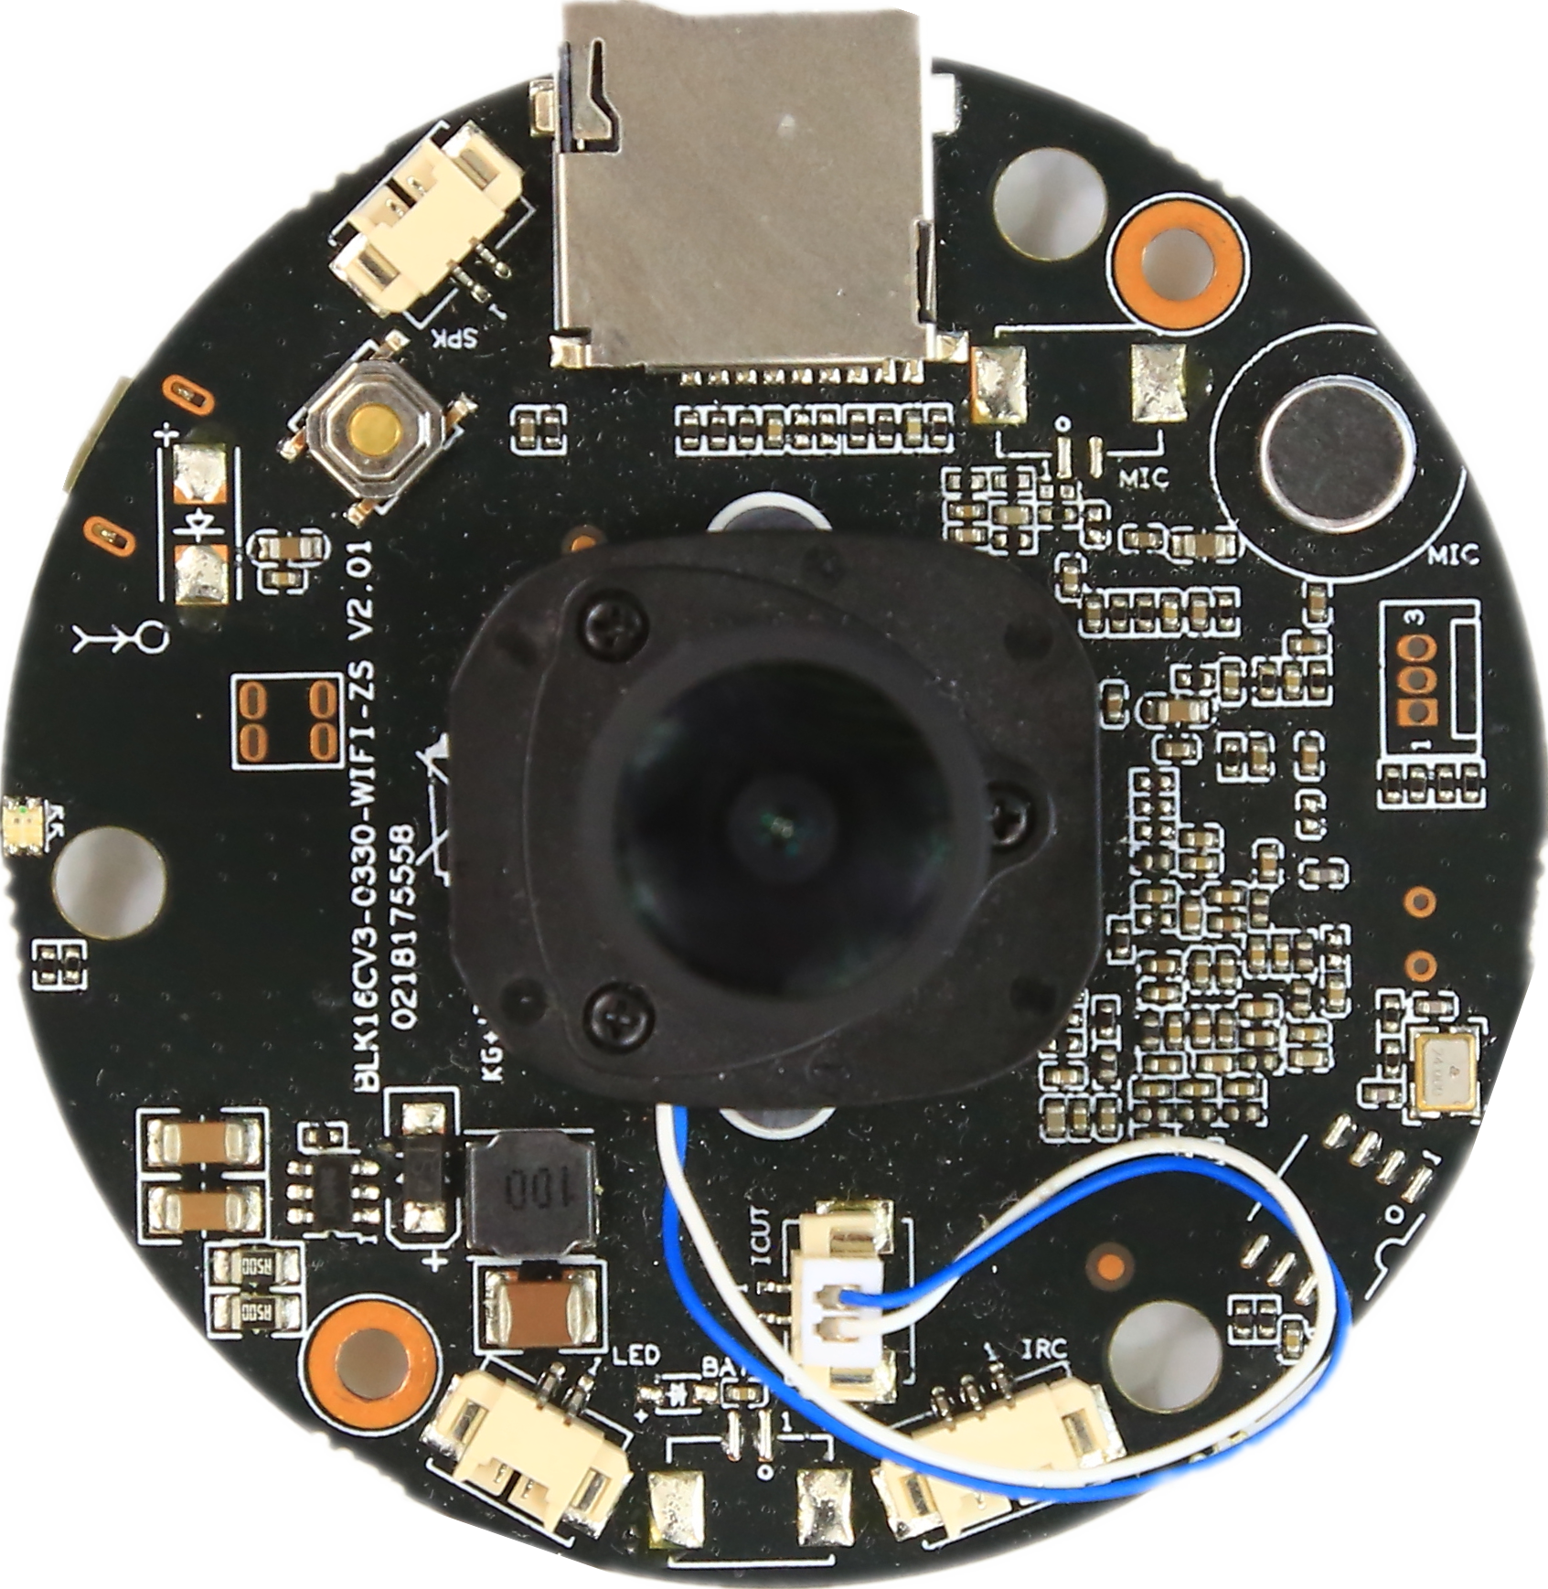
P5喇叭接口
P4 mic接口
P2 IRcut接口
P6 LED灯板接口
P3 RTC接口
P1红外输入接口

标注 | 丝印编号 | 针脚编号 | 针脚定义 | 功能
P1 | J2 | 1 | 红外输入 | 红外输入
 |  | 2 | GND | GND
 |  | 3 | 5V | 5V输出
P2 | J4 | 1 | BOUT | IRcut驱动输出
 |  | 2 | AOUT | IRcut驱动输出
P3 | J13 | 1 | GND | GND
 |  | 2 | VBAT | Rtc电池输入
P4 | J31 | 1 | AC_P | 咪头输入P
 |  | 2 | AC_N | 咪头输入N
P5 | J17 | 1 | VCP | 喇叭输出
 |  | 2 | CVN | 喇叭输出
P6 | J26 | 1 | 灯板正极 | 灯板正极
 |  | 2 | 灯板负极 | 灯板负极
P7 | J6 | 1 | GND | GND
 |  | 2 | UART_TX | 串口发送
 |  | 3 | UART_RX | 串口接收

