BLK16CV3-49X49-AF-V1_02 Interface Description
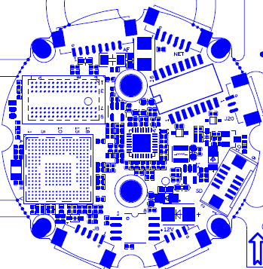
P4 IRCUT
P8 AF Motor
P1 Ethernet

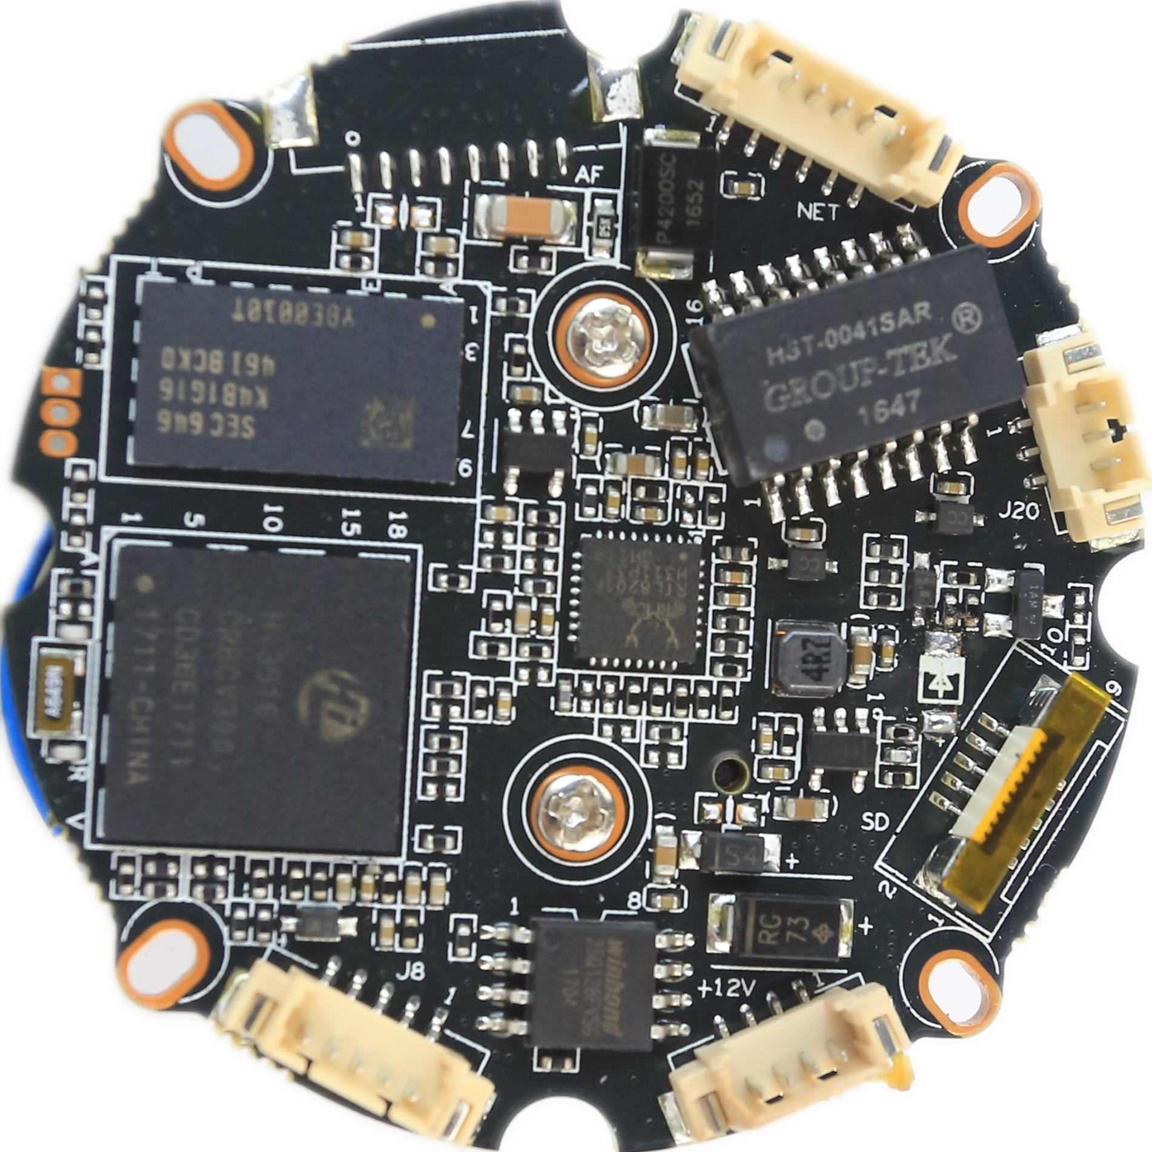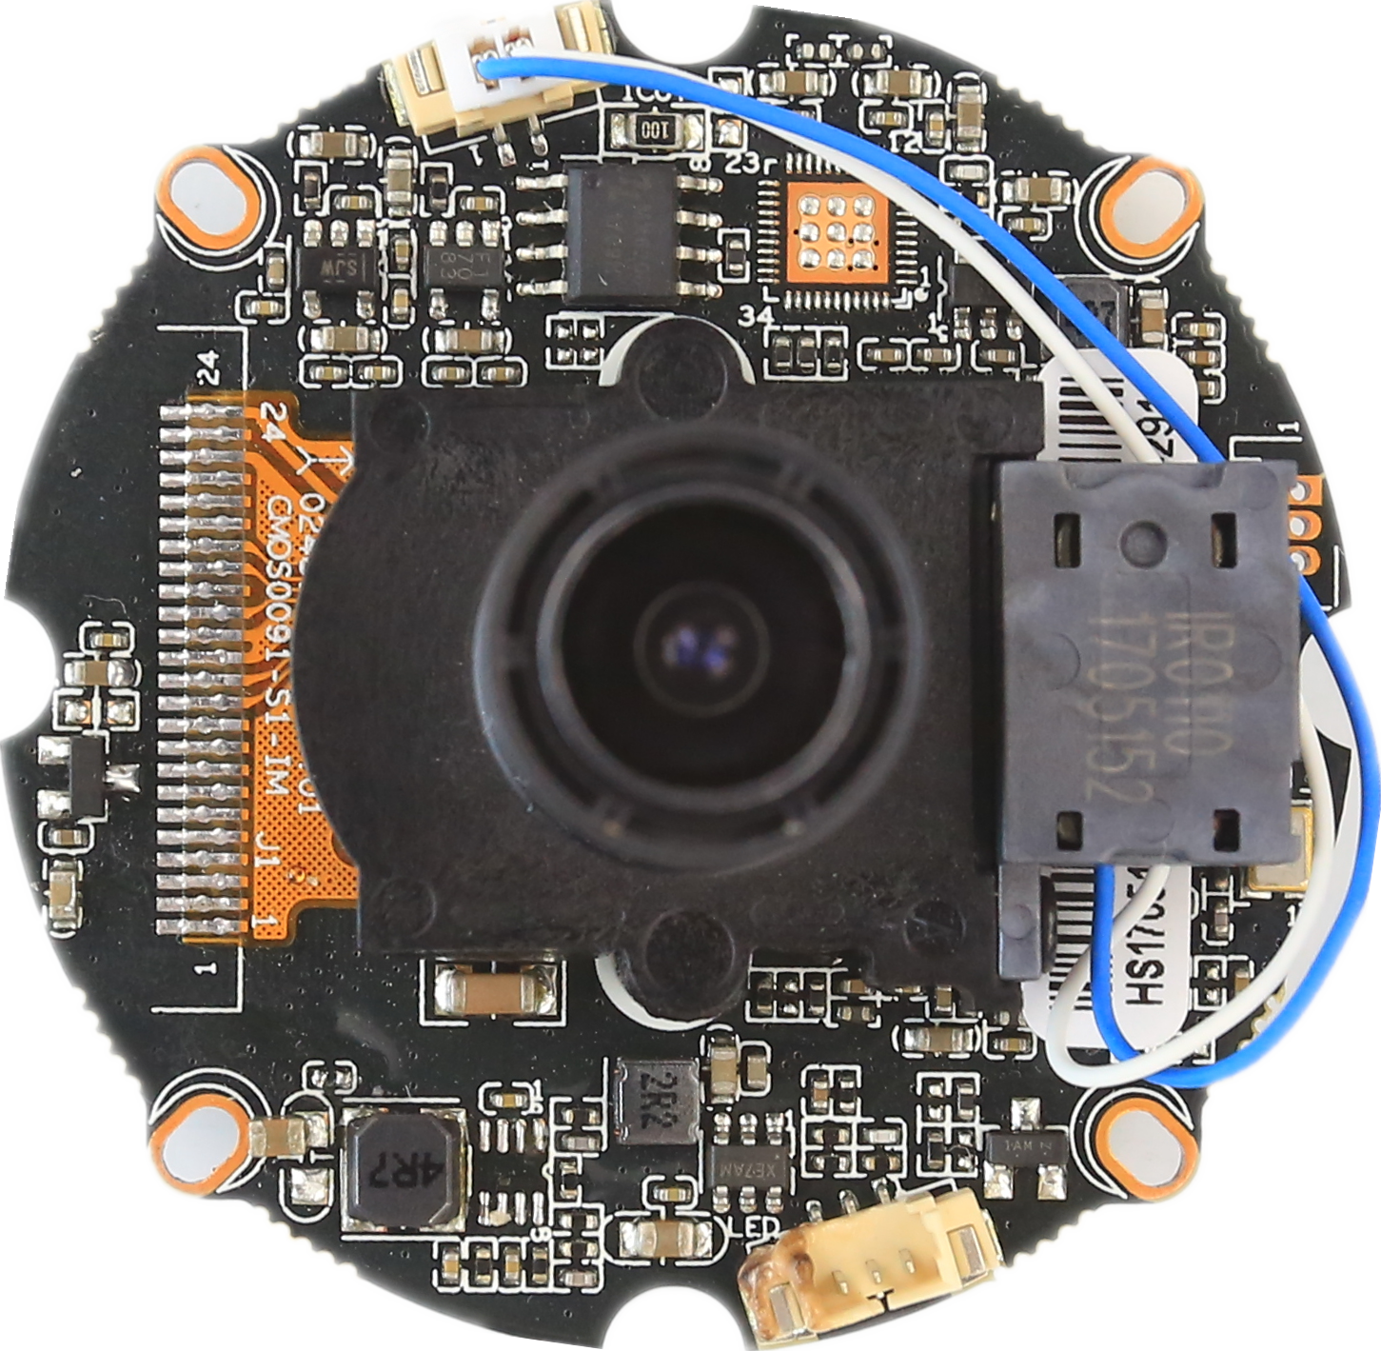
P3 Infrared

P7 Alarm
P2 Extension interface

P8 Audio&Alarm
P5 power

sign | Socket | Specific No | Interface Description | Function
P1 | J3 | 1 | ETHRX- | Ethernet signal
 |  | 2 | ETHRX+ | Ethernet signal
 |  | 3 | LED/PHY_AD3 | LED
 |  | 4 | ETHTX- | Ethernet signal
 |  | 5 | ETHTX+ | Ethernet signal
 |  | 6 | LED/PHY_AD0 | LED
P2 | J19 | 1 | SD_CLK | SD_CLK
 |  | 2 | SD_CMD | SD_CMD
 |  | 3 | SD_DATA0 | SD_DATA0
 |  | 4 | SD_DATA1 | SD_DATA1
 |  | 5 | SD_DATA2 | SD_DATA2
 |  | 6 | SD_DATA3 | SD_DATA3
 |  | 7 | GND | GND
 |  | 8 | GND | GND
 |  | 9 | +5V | +5V OUT
 |  | 10 | BAT | RTC
P3 | J2 | 1 | Infrared IN | Infrared IN
 |  | 2 | GND | GND
 |  | 3 | NC | NC
P4 | J4 | 1 | BOUT | IRcut
 |  | 2 | AOUT | IRcut
P5 | J7 | 1 | NC | NC
 |  | 2 | NC | NC
 |  | 3 | GND | GND
 |  | 4 | 12V | 12V IN
P6 | J6 | 1 | GND | GND
 |  | 2 | UART_TX | UART_TX
 |  | 3 | UART_RX | UART_RX
P7 | J20 | 1 | ALARM_OUT | ALARM_OUT
 |  | 2 | GND | GND
 |  | 3 | ALARM_IN | ALARM_IN
P8 | J8 | 1 | AC_OUT | AC_OUT
 |  | 2 | AC_IN | AC_IN
 |  | 3 | GND | GND
 |  | 4 | ALARM_IN2 | ALARM_IN2
 |  | 5 | GND | GND
P9 | J17 | 1 | OUT1 | AF Motor driven
 |  | 2 | OUT3 | AF Motor driven
 |  | 3 | OUT4 | AF Motor driven
 |  | 4 | OUT5 | AF Motor driven
 |  | 5 | OUT6 | AF Motor driven
 |  | 6 | OUT7 | AF Motor driven
 |  | 7 | OUT8 | AF Motor driven
 |  | 8 | OUT9 | AF Motor driven

