BLK16CV3-0237-39X39-B-V1_01接口说明表
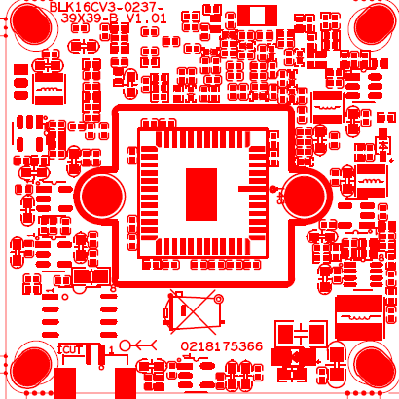

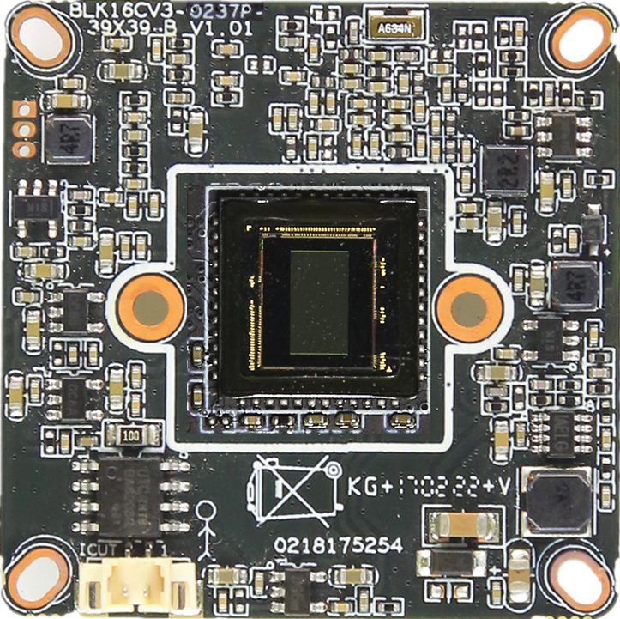
P4 ICR控制接口
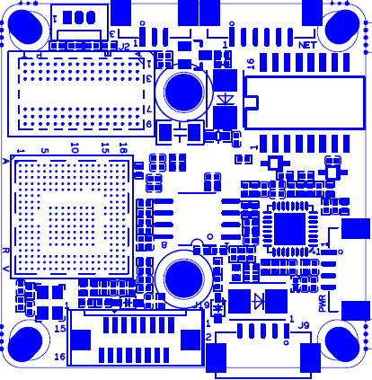
P5 电源接口

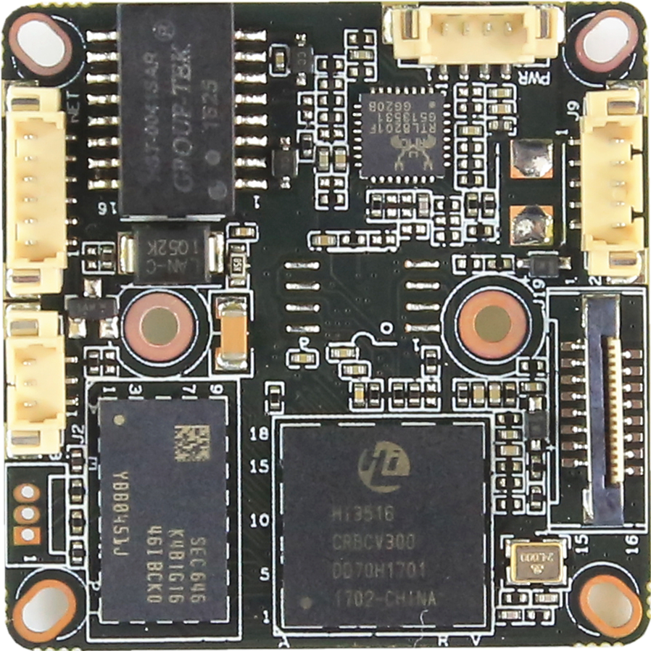
P2扩展板接口
P7音频报警接口
P1网络接口
P3红外同步信号接口

标注 | 丝印编号 | 针脚编号 | 针脚定义 | 功能
P1 | J3 | 1 | ETHRX- | 网口数据接收
 |  | 2 | ETHRX+ | 网口数据接收
 |  | 3 | LED/PHY_AD1 | 网络灯
 |  | 4 | ETHTX- | 网口数据发送
 |  | 5 | ETHTX+ | 网口数据发送
 |  | 6 | LED/PHY_AD0 | 网络灯
P2 | J19 | 1 | SD_CLK | SD时钟
 |  | 2 | SD_CMD | SD指令线
 |  | 3 | SD_DATA0 | SD数据
 |  | 4 | SD_DATA1 | SD数据
 |  | 5 | SD_DATA2 | SD数据
 |  | 6 | SD_DATA3 | SD数据
 |  | 7 | LED_CTRL | 灯板LED控制IO
 |  | 8 | GND | GND
 |  | 9 | Key-set | 按键控制IO
 |  | 10 | BAT | 外部RTC电池输入
 |  | 11 | GND | GND
 |  | 12 | ALARM_OUT | 报警输出
 |  | 13 | USB_DM | USB数据
 |  | 14 | USB_DP | USB数据
 |  | 15 | +5V | +5V
 |  | 16 | USB_CONTRL | USB_CONTL控制
P3 | J2 | 1 | 红外输入 | 红外输入
 |  | 2 | GND | GND
 |  | 3 | +5V | 5V输出
P4 | J4 | 1 | BOUT | IRcut驱动输出
 |  | 2 | AOUT | IRcut驱动输出
P5 | J7 | 1 | NC | 悬空
 |  | 2 | NC | 悬空
 |  | 3 | GND | GND
 |  | 4 | 12V | 12V输入
P6 | J6 | 1 | UART_RX | 串口接收
 |  | 2 | UART_TX | 串口发送
 |  | 3 | GND | GND
P7 | J9 | 1 | AC_OUT | 音频输出
 |  | 2 | AC_IN | 音频输入
 |  | 3 | GND | GND
 |  | 4 | ALARM_GPIO | 报警输入
 |  | 5 | GND | GND

