J6
1 2 3

J9
1 2 3 4… 7 8

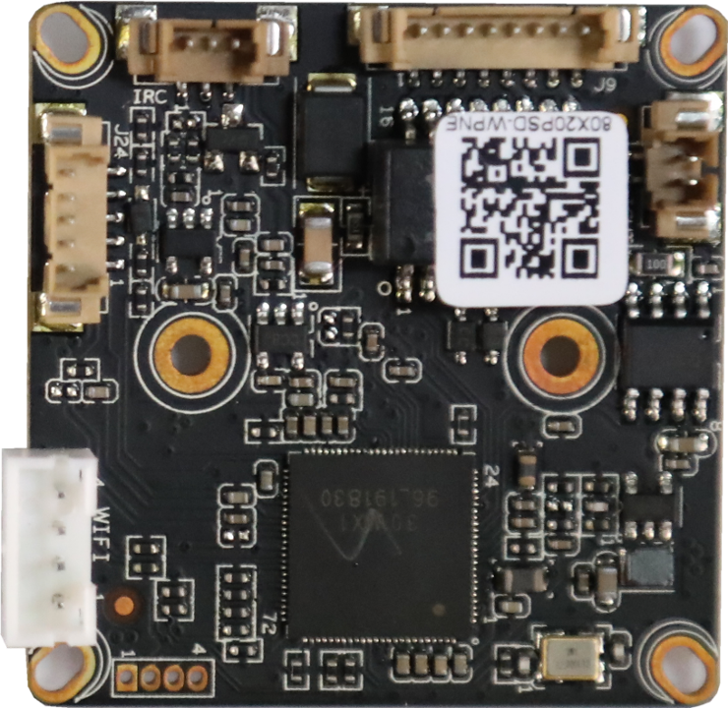
J1
4
3
2
1
J5
1
2
J24
5
4
3
2
1

Socket | Specific No | Interface Description | Function
J9 | 1 | LED0 | LED/PHY_AD0 | Connect the tail line of the camera module
 | 2 | LED1 | LED/PHY_AD1
 | 3 | ETHTX+ | Ethernet signal+
 | 4 | ETHTX- | Ethernet signal-
 | 5 | ETHRX+ | Ethernet signal+
 | 6 | ETHRX- | Ethernet signal-
 | 7 | GND | GND
 | 8 | 12V | 12V DC input
J24 | 1 | AC_OUTL | AC_OUT | Audio&Alarm
 | 2 | AC_INL/MICP | AC_IN
 | 3 | GND | GND
 | 4 | ALARM_IN1 | ALARM_GPIO
 | 5 | ALARM_OUT | ALARM_GPIO（Reserve）
J1 | 1 | +5V WIFI | +5Voutput | WIFI/4G module
 | 2 | USB_DN | USB data-
 | 3 | USB_DP | USB data+
 | 4 | GND | GND
J5 | 1 | IR_CUTA | IR-CUT A OUT | IR_CUT
 | 2 | IR_CUTB | IR-CUT B OUT
J6 | 1 | IR | Infrared input | Connect the camera lamp board
 | 2 | GND | GND
 | 3 | PWM | PWM-OUT

J5
15 13 ...5 3 1
16 14 ...6 4 2

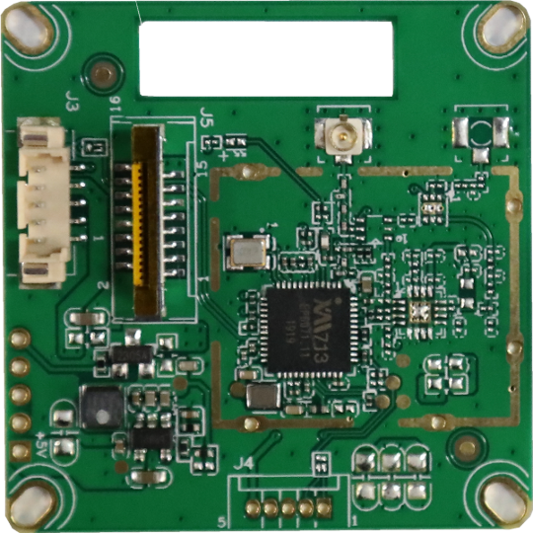
J4
1
2
3
4
5

ANT2

J2
5 4 3 2 1

J3
5 4 3 2 1

Socket | Specific No | Interface Description | Function
ANT2 |  | RF_TR | IPEX connector | Connect IPEX to SMA feeder
J4 | 1 | UART_TX | UART_TX | serial port
 | 2 | UART_RX | UART_RX
 | 3 | GND | GND
 | 4 | NC | NC
 | 5 | +3.3V | +3.3V out
J2 | 1 | +5V | +5V in | WIFI 2.0mm
 | 2 | USB_DM | USB_DM
 | 3 | USB_DP | USB_DP
 | 4 | GND | GND
 | 5 | USB_CTRL | WIFI power supply IO
J3 | 1 | +5V | +5V in | WIFI 1.25mm 5 PIN
 | 2 | USB_DM | USB_DM
 | 3 | USB_DP | USB_DP
 | 4 | GND | GND
 | 5 | USB_CTRL | WIFI power supply IO
J5 | 1 | NC | NC | WIFI FPC
 | 2 | NC | NC
 | 2 | NC | NC
 | 3 | NC | NC
 | 4 | NC | NC
 | 5 | NC | NC
 | 6 | NC | NC
 | 7 | NC | NC
 | 8 | GND | GND
 | 9 | NC | NC
 | 10 | NC | NC
 | 11 | GND | GND
 | 12 | NC | NC
 | 13 | USB_DM | USB_DM
 | 14 | USB_DP | USB_DP
 | 15 | +5V | +5V in
 | 16 | USB_CTRL | WIFI power supply IO

