BLK16E-0235P-AF-39X39-V1_01 Interface Description
P2 Alarm Audio
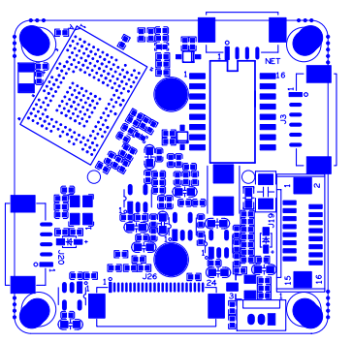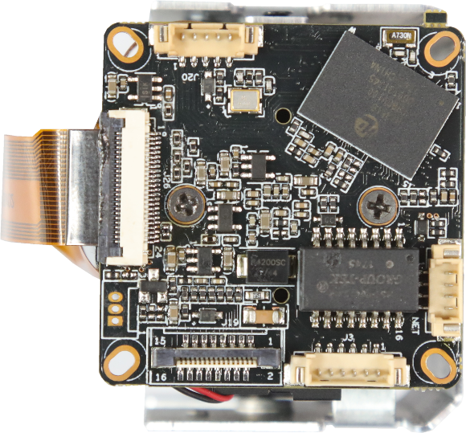
P5
P6 Ethernet
P4 power
P3 Extension
P1 Infrared

sign | Socket | Specific No | Interface Description
P1 | J30 | 1 | Infrared input
 |  | 2 | GND
 |  | 3 | GPIO0_0
P2 | J20 | 1 | AC_OUT
 |  | 2 | AC_IN
 |  | 3 | GND
 |  | 4 | ALARM_GPIO
 |  | 5 | GND
P3 | J19 | 1 | SD_CLK
 |  | 2 | SD_CMD
 |  | 3 | SD_DATA0
 |  | 4 | SD_DATA1
 |  | 5 | SD_DATA2
 |  | 6 | SD_DATA3
 |  | 7 | ALARM2_GPIO82
 |  | 8 | GND
 |  | 9 | KEY_SET
 |  | 10 | BAT
 |  | 11 | GND
 |  | 12 | ALARM_OUT
 |  | 13 | USB_DM
 |  | 14 | USB_DP
 |  | 15 | +5V
 |  | 16 | USB_CONTROL
P4 | J1 | 1 | 12V
 |  | 2 | GND
 |  | 3 | RXD1 | UART1
 |  | 4 | TXD1
 |  | 5 | RXD0 | UART0
 |  | 6 | TXD0
P6 |  | 1 | ETHRX-
 |  | 2 | ETHRX+
 |  | 3 | ETHTX-
 |  | 4 | ETHTX+

