天线接口
P7功能扩展接口
P2 音频输入接口
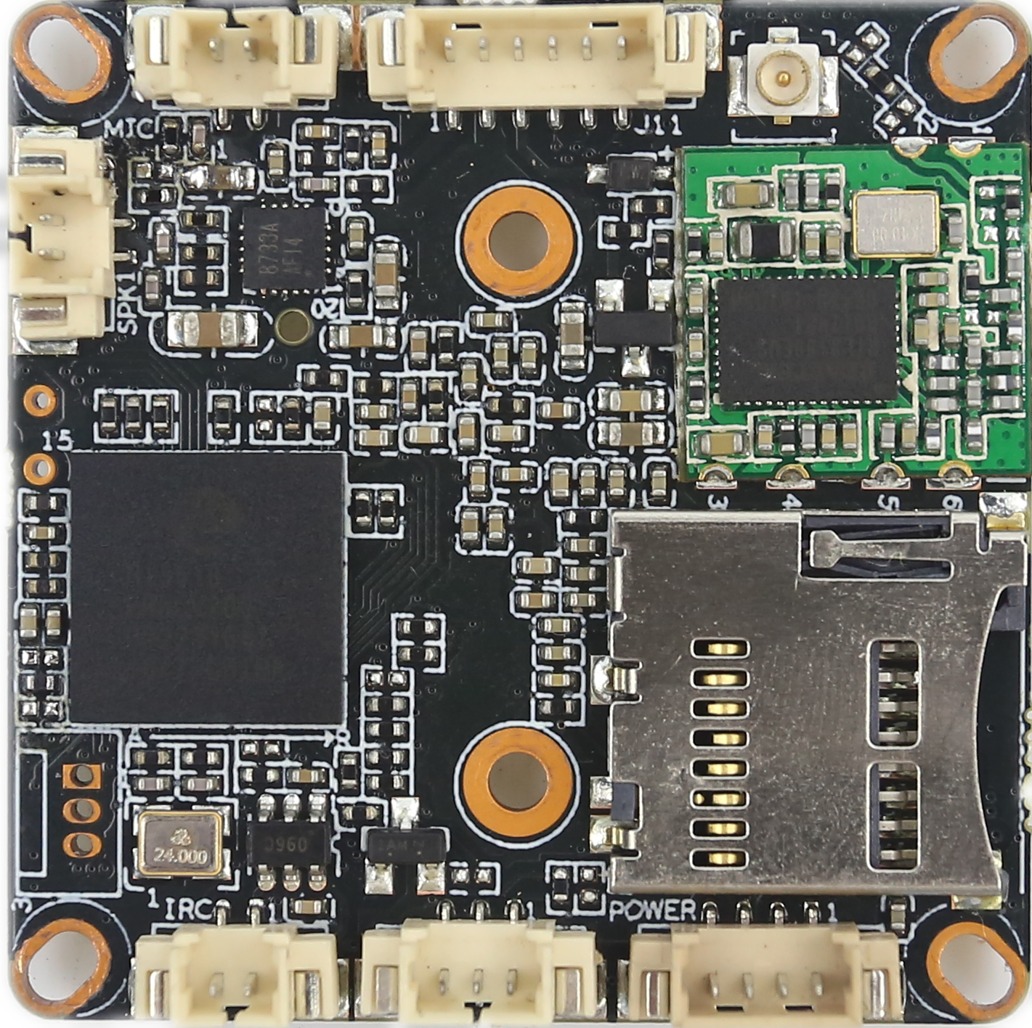
P3 IR-CUT接口
SD卡插槽
P4音频输出接口
P1串口
P5红外接口
P6电源接口

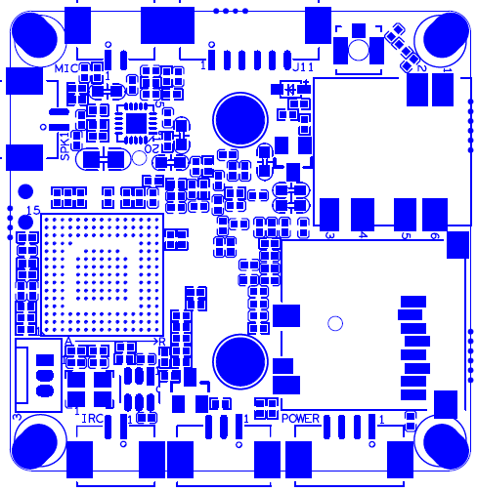
KA18EV-0062-0130-38X38-WIFI-V1_01接口说明表

标注 | 丝印编号 | 针脚编号 | 针脚定义 | 功能
P1 | J3 | 1 | Uart_RXD | 串口接收
 |  | 2 | Uart_TXD | 串口发送
 |  | 3 | GND | GND
P2 | J9 | 1 | MIC_P | 音频输入
 |  | 2 | GND | 地
P3 | J1 | 1 | OUT1 | IRCUT驱动输出
 |  | 2 | OUT2 | IRCUT驱动输出
P4 | J8 | 1 | 喇叭 | 喇叭
 |  | 2 | 喇叭 | 喇叭
P5 | J4 | 1 | 红外输入 | 红外输入
 |  | 2 | GND | GND
 |  | 3 | +5V输出 | +5V输出
P6 | J5 | 1 | BAT | Rtc电池（默认没有）
 |  | 2 | GND | GND
 |  | 3 | GND | GND
 |  | 4 | +12V | 12V电源输入
P7 | J11 | 1 | 3.3V | 3.3V
 |  | 2 | GND | GND
 |  | 3 | ALARM_IN | 报警/复位
 |  | 4 | GPIO63 | 预留GPIO
 |  | 5 | GPIO01 | 预留GPIO
 |  | 6 | GPIO02 | 预留GPIO

