BLK18E-0042-0035-WK-WIFI-V1_01接口说明
表-核心板接口详细定义
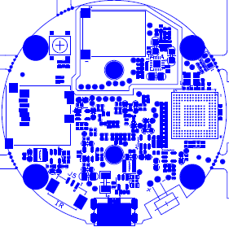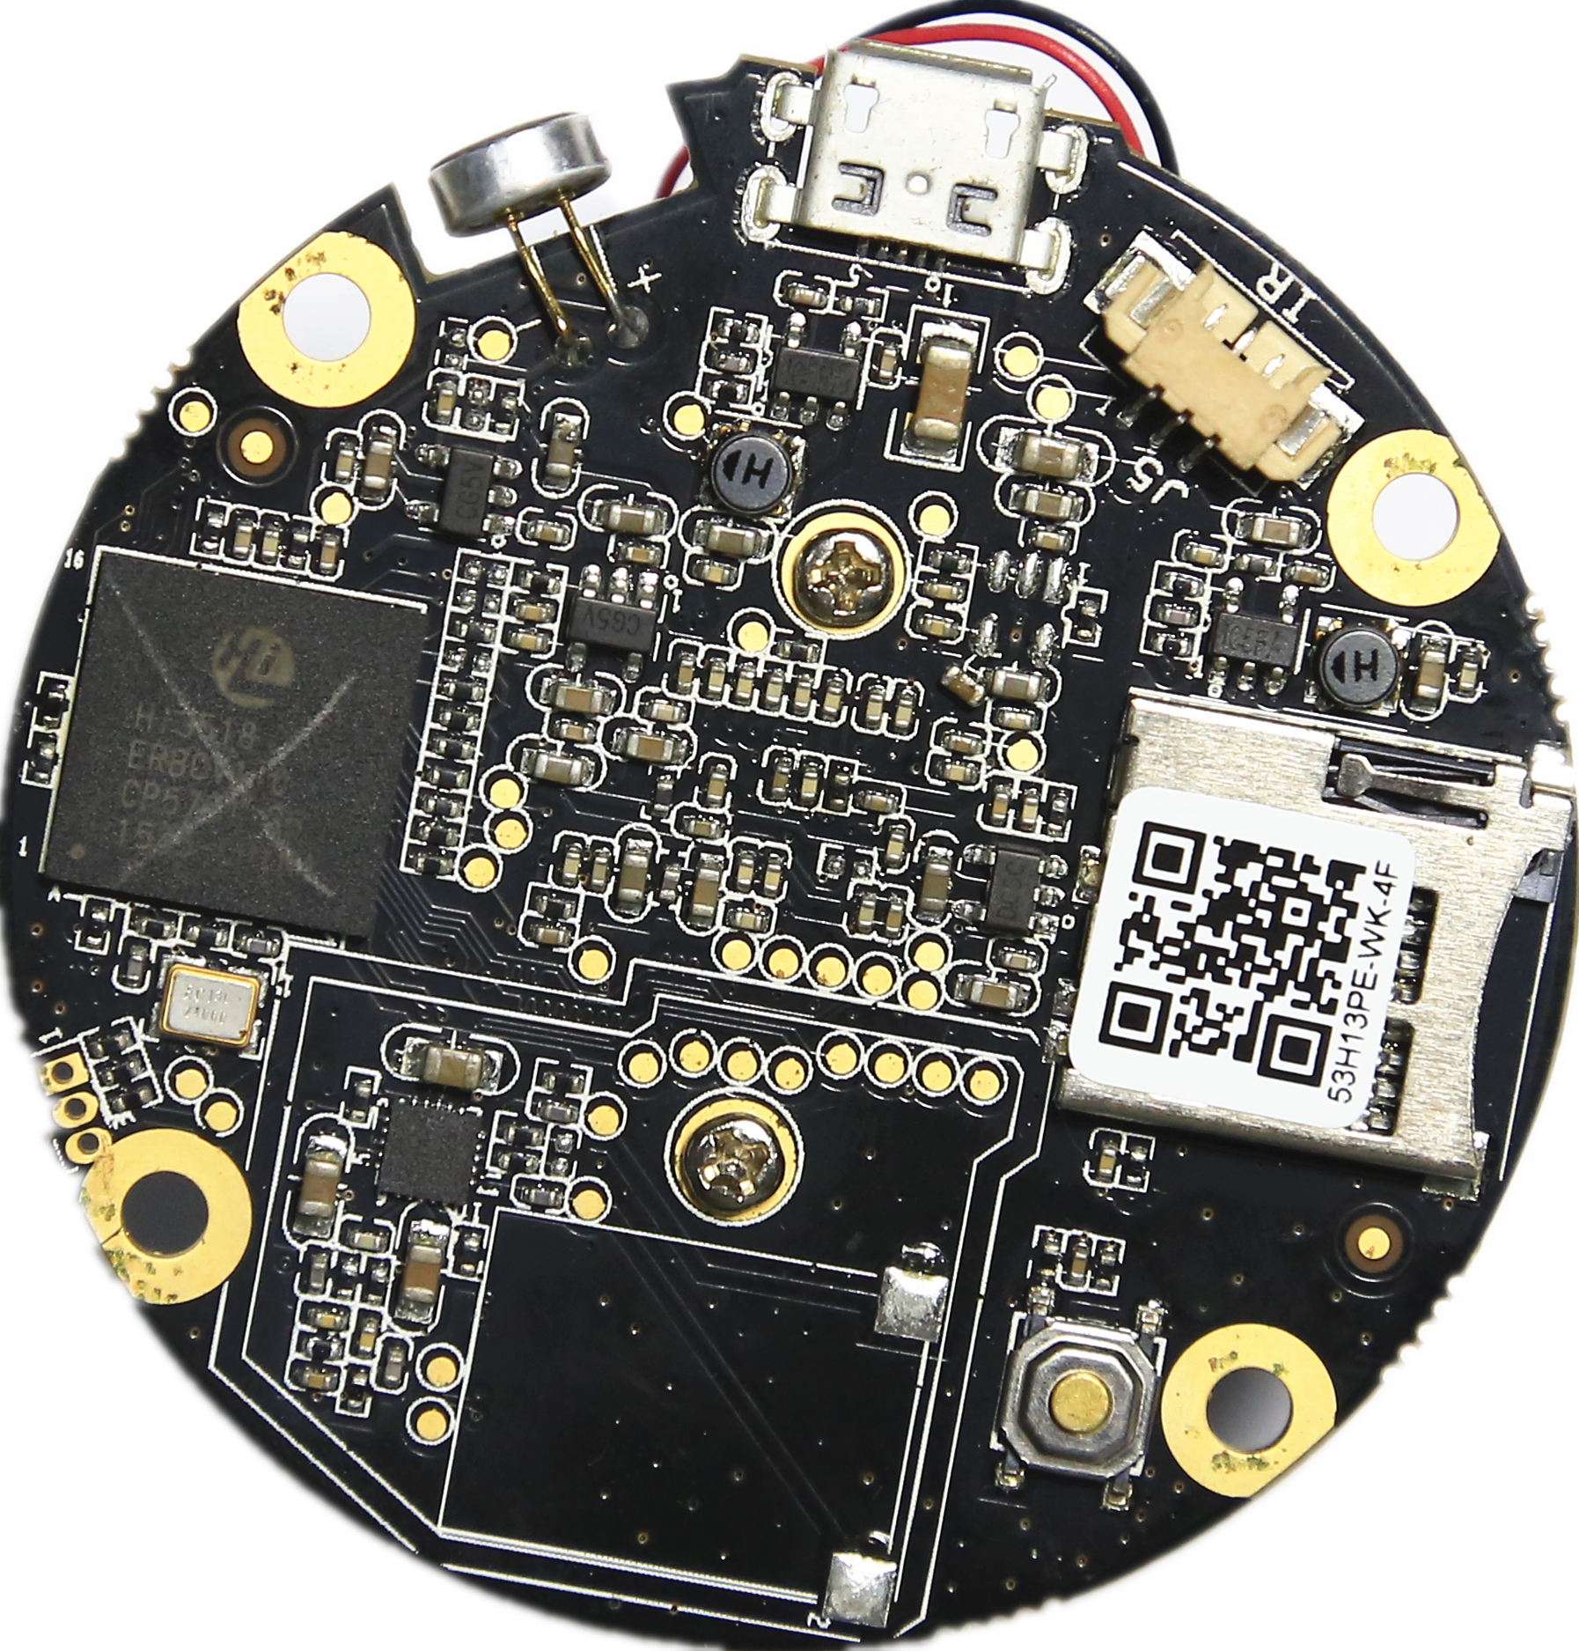
J2扬声器接口
J3 串口
J6 MIC音频接口
J7 USB接口
J5红外灯同步信号接口
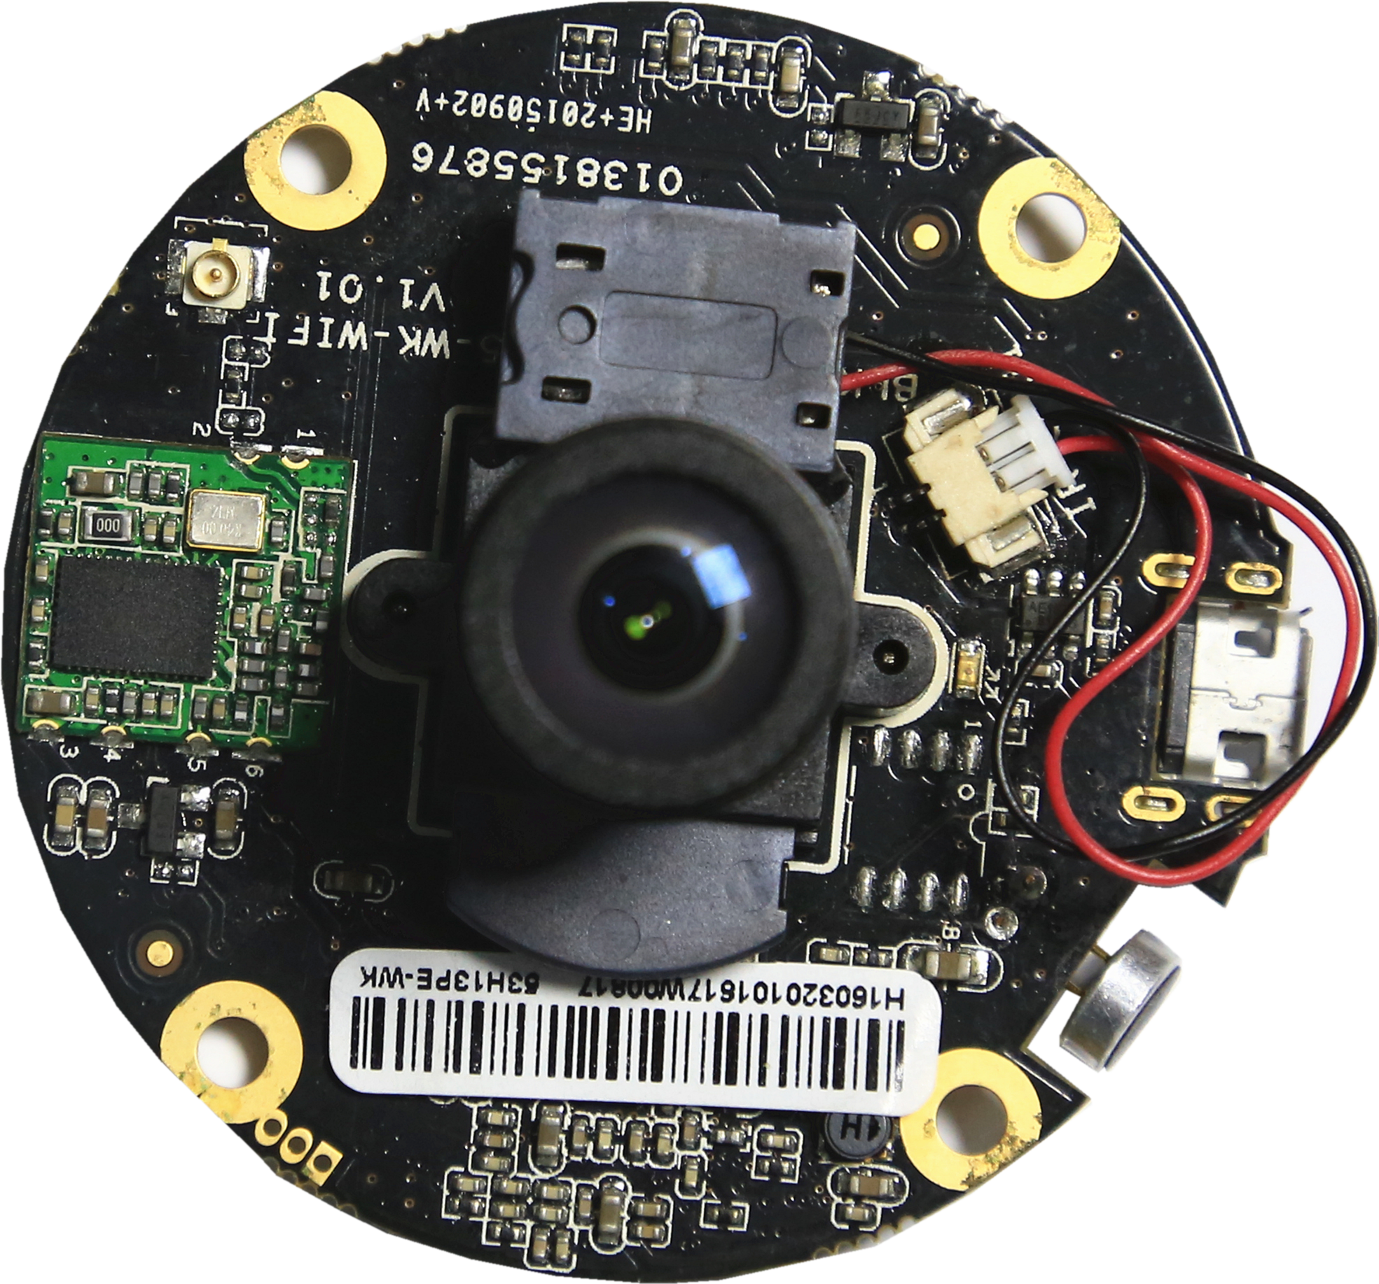
J1 ICR控制接口
天线接口
标注 | 丝印编号 | 针脚编号 | 针脚定义 | 功能
P1 | J7 | 1 | VCC | GND
 |  | 2 | DM | USB接口
 |  | 3 | DP | USB接口
 |  | 4 | NC | 悬空
 |  | 5 | GND | 地
P2 | J3 | 1 | UART0_RXD | 串口
 |  | 2 | UART0_TXD | 串口
 |  | 3 | GND | GND
P3 | J6 | 1 | AC_LINE | 音频输入
 |  | 2 | AGND | 模拟地
P4 | J2 | 1 | 喇叭 | 喇叭输出
 |  | 2 | 喇叭 | 喇叭输出
P5 | J1 | 1 | OUT1 | IRCUT输出
 |  | 2 | OUT2 | IRCUT输出
P6 | J5 | 1 | +5V | +5V输出
 |  | 2 | IR | 红外输入
 |  | 3 | GND | GND

