BLK510A-S1-38X38-IM-V1_03

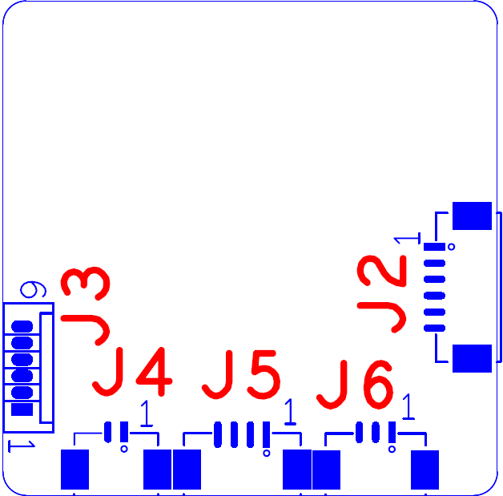

Label | Socket | Specific No | Interface Description
J1 | 1~24
J4 | 1 | IRCUT_A | IRCUT_A
 | 2 | IRCUT_B | IRCUT_B
J2 | 1 | RX- | ETHRX-
 | 2 | RX+ | ETHRX+
 | 3 | LED3 | PHY_AD0
 | 4 | TX- | ETHTX-
 | 5 | TX+ | ETHTX+
 | 6 | LED0 | PHY_AD3
J3 | 1 |  | 3.3V
 | 2 | GND | GND
 | 3 | UART_TXD | UART_TXD
 | 4 | UART__RXD | UART__RXD
 | 5 | SWICH_KEY | SWICH_KEY
 | 6 | EXT_RSTN | EXT_RSTN
J5 | 1
 | 2
 | 3 | GND | GND
 | 4 | 12V | 12V
J6 | 1 | LED_CTRL | Infrared input
 | 2 | GND | GND
 | 3 | NC | NC

