LK18EV-2045-38X38-B-V1_01 Interface Description
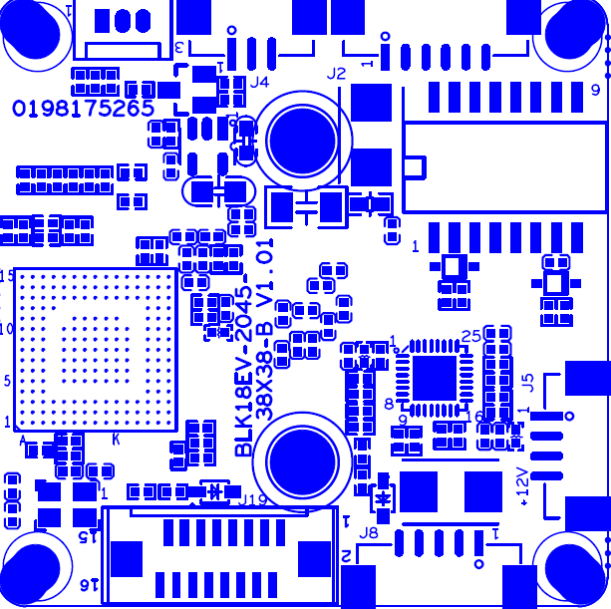
P4 Infrared
P2 Ethernet
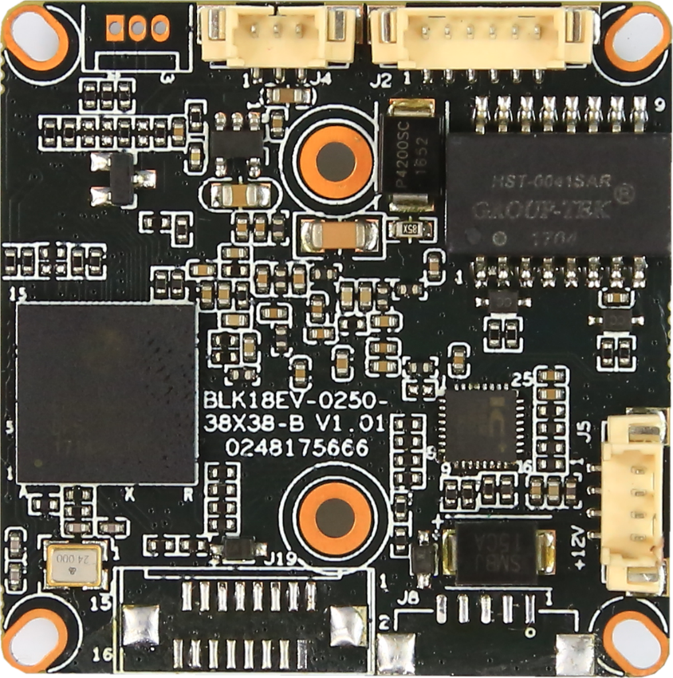
P7 Infrared interface
P6 Alarm Audio
P1 power

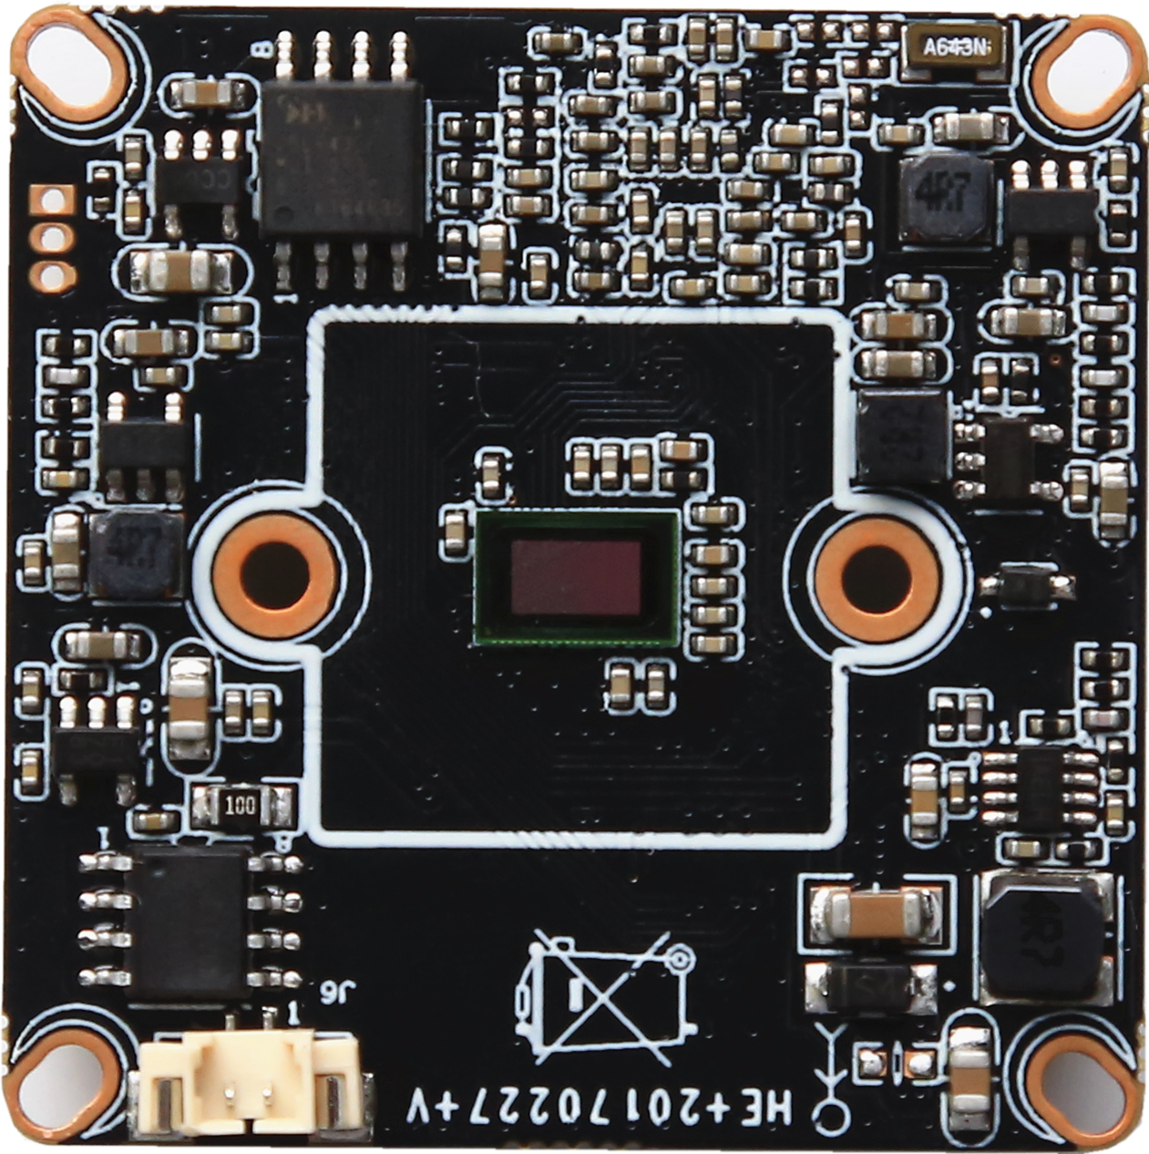
P5 IR-CUT

Detailed Definition
Label | Socket | Specific No | Interface Description | Function
P1 | J5 | 1 | NC | Undefined
 |  | 2 | NC | Undefined
 |  | 3 | GND | GND
 |  | 4 | +12V | 12V DC input
P2 | J2 | 1 | ETHTR- | Ethernet signal
 |  | 2 | ETHTR+ | Ethernet signal
 |  | 3 | LED/PHY_AD3 | LED
 |  | 4 | ETHTX- | Ethernet signal
 |  | 5 | ETHTX+ | Ethernet signal
 |  | 6 | LED/PHY_AD0 | LED
P3 | J3 | 1 | UART0_RXD
 |  | 2 | UART0_TXD
 |  | 3 | GND
P4 | J4 | 1 | Infrared input | Infrared input
 |  | 2 | GND | GND
 |  | 3 | +5V | 5V DC input
P5 | J6 | 1 | IRCUT_A | IRCUT output
 |  | 2 | IRCUT_B | IRCUT output
P6 | J8 | 1 | AC_OUT | AC_OUT
 |  | 2 | MIC_P | MIC_P
 |  | 3 | AGND | Analog ground
 |  | 4 | ALARM_IN | ALARM_IN
 |  | 5 | GND | GND

P7 | J19 | 1 | SD_CLK | SD_CLK
 |  | 2 | SD_CMD | SD_CMD
 |  | 3 | SD_DATA0 | SD_DATA0
 |  | 4 | SD_DATA1 | SD_DATA1
 |  | 5 | SD_DATA2 | SD_DATA2
 |  | 6 | SD_DATA3 | SD_DATA3
 |  | 7 | LED_CTRL | LED_CTRL
 |  | 8 | GND | GND
 |  | 9 | Key-set | Key-set
 |  | 10 | BAT | RTC RTC battery input
 |  | 11 | GND | GND
 |  | 12 | ALARM_OUT | ALARM_OUT
 |  | 13 | USB_DM | USB_DM
 |  | 14 | USB_DP | USB_DP
 |  | 15 | +5V | +5V
 |  | 16 | USB_CONTRL | USB_CONTRL

