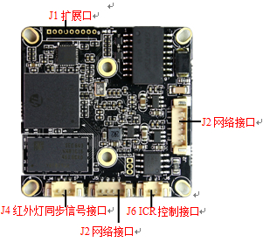
BLK16CV-0002-2035-38X38 V1.01模块-F22接口说明
标注 | 丝印编号 | 针脚编号 | 针脚定义 | 功能
P1 | J2 | 1 | ETHRX- | 网口数据接收
 |  | 2 | ETHRX+ | 网口数据接收
 |  | 3 | LED/PHY_AD3 | 网络灯
 |  | 4 | ETHTX- | 网口数据发送
 |  | 5 | ETHTX+ | 网口数据发送
 |  | 6 | LED/PHY_AD0 | 网络灯
P2 | J1 | 1 | GND | GND
 |  | 2 | USB_DP | USB数据口
 |  | 3 | USB_DM | USB数据口
 |  | 4 | +5V | 5V电源输出
 |  | 5 | AC_OUT | 音频输出
 |  | 6 | MIC_P | 音频输入
 |  | 7 | MIC_N | 音频输入
 |  | 8 | AGND | AGND
 |  | 9 | ALARM_IN | 报警输入
P3 | J4 | 1 | 红外输入 | 红外输入
 |  | 2 | GND | GND
 |  | 3 | NC | 悬空
P3 | J6 | 1 | BOUT | IRcut驱动输出
 |  | 2 | AOUT | IRcut驱动输出
P4 | J5 | 1 | NC | 悬空
 |  | 2 | NC | 悬空
 |  | 3 | GND | GND
 |  | 4 | 12V | 12V输入
P5 | J3 | 1 | GND | GND
 |  | 2 | UART_TX | 串口发送
 |  | 3 | UART_RX | 串口接收

