AHD-XM380V200-0005-32X32-V1_01接口说明
CN2 1 2 3

J2 4 3 2 1

CN1 1 2
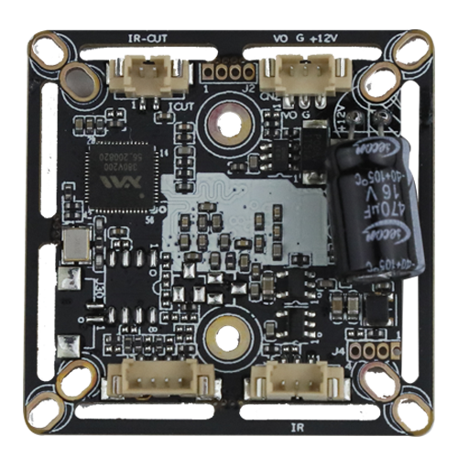

J4 1 2 3 4

J5 3 2 1

J3 4 3 2 1

详细定义
位号 | 接口详细编号 | 接口定义 |  | 实现功能
J3 | 1 | GND |  | 地
 | 2 | ADC2VIN |  | 制式转换
 | 3 | MODE_N/P |  | N/P制式转换
 | 4 | ADC2VIN |  | 制式转换
CN1 | 1 | DRIOUT1 |  | IRCUT接口
 | 2 | DRIOUT2
J5 | 1 | ADC1VIN |  | 光敏信号/白光驱动信号
 | 2 | GND |  | 地
 | 3 | LED1 |  | 红外驱动信号
CN2 | 1 | CVBS |  | Video out
 | 2 | GND |  | 地
 | 3 | +12V |  | 12V电源输入
J4 | 1 | GND |  | 串口座子
 | 2 | UARTO_TXD
 | 3 | UART0_RXD
 | 4 | SWITCH_PROG
J2 | 1 |  | ALARM_IN1 | 报警输入/红外驱动信号
 | 2 |  | GND | 地
 | 3 |  | 3.3V | 3.3V电源
 | 4 |  | GND | 地

