AHD-XM350-0239-32X32-V2_02Interface Description
CN1 1 2
CN2 1 2 3

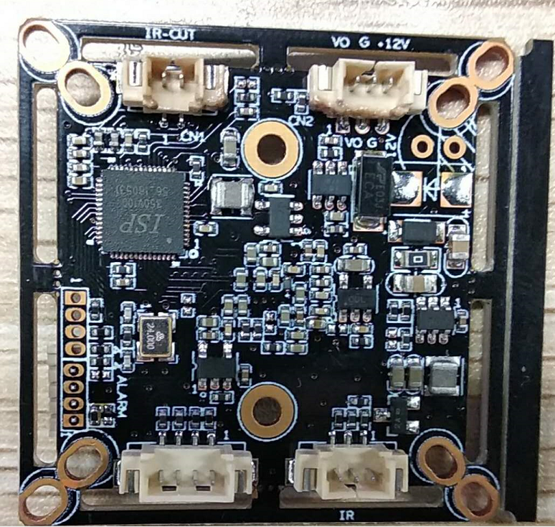
J1 3 2 1

J3 4 3 2 1

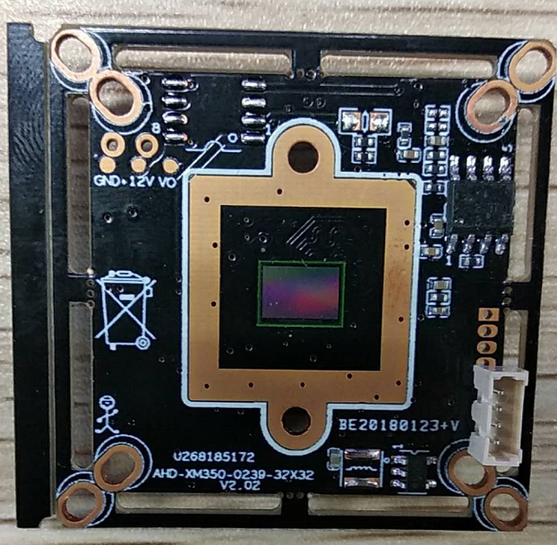
J2
4
3
2
1

、

Detailed Definition
Socket |  | Specific No. |  | Interface Description | Function
CN2 |  | 1 |  | CVBS | Video Out
 |  | 2 |  | GND | Ground
 |  | 3 |  | 12V | 12V DC input
CN1 |  | 1 |  | IRCUTA | IRCUT
 |  | 2 |  | IRCUTB
J1 |  | 1 |  | ADC1VIN | Red_CTRL
 |  | 2 |  | GND | Ground
 |  | 3 |  | NC | Undefined
J2 |  | 1 |  | ALARM_IN1 | ALARM input
 |  | 2 |  | GND | Ground
 |  | 3 |  | 3.3V | 3.3V DC input
 |  | 4 |  | GND | Ground
J3 | 1 |  | GND |  |  | Ground
 | 2 |  | CVI |  |  | Switch to CVI by grounding
 | 3 |  | MODE_N-P |  |  | N-P
 | 4 |  | TVI |  |  | Switch to TVI by grounding

