# AHD-XM330F1-0291-38X38-V1_01接口说明

**J26**  1 2 3 4 5 6

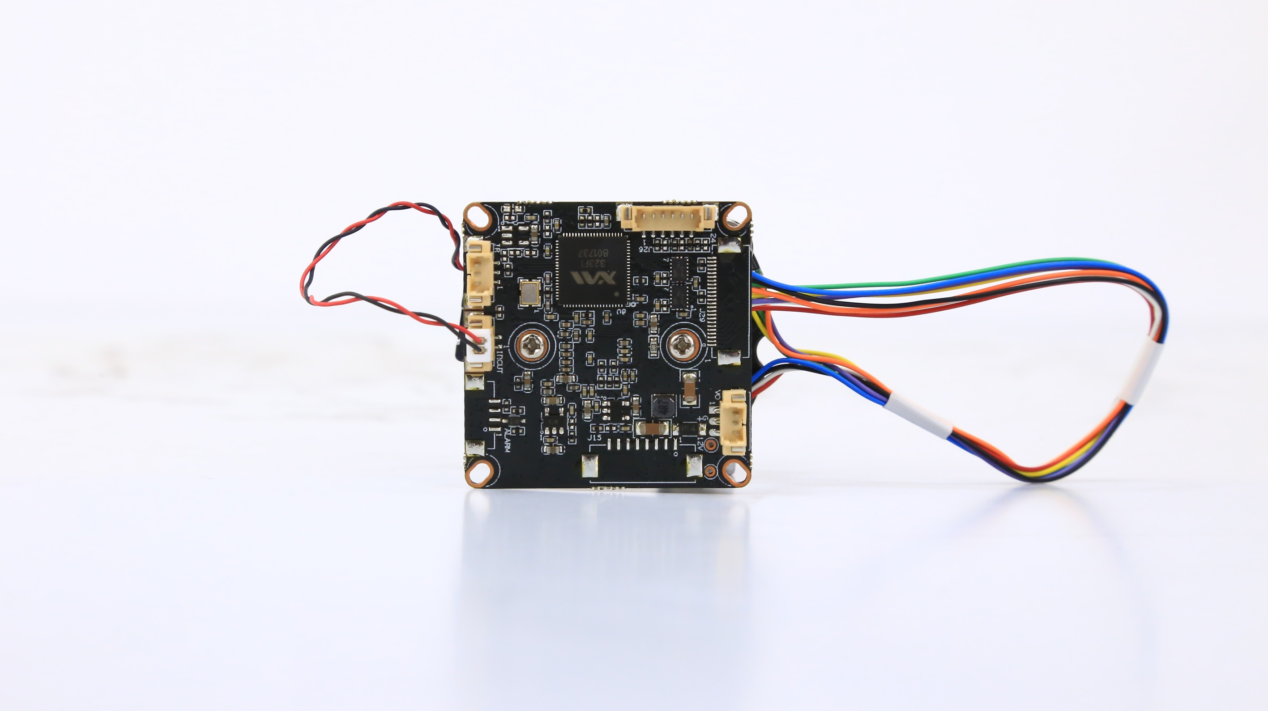

**J24**

3

2

1

**CN4**

2

1

**CN2**

3 2 1

**J11**

**8**

**7**

**6**

**5**

**4**

**3**

**2**

**1**

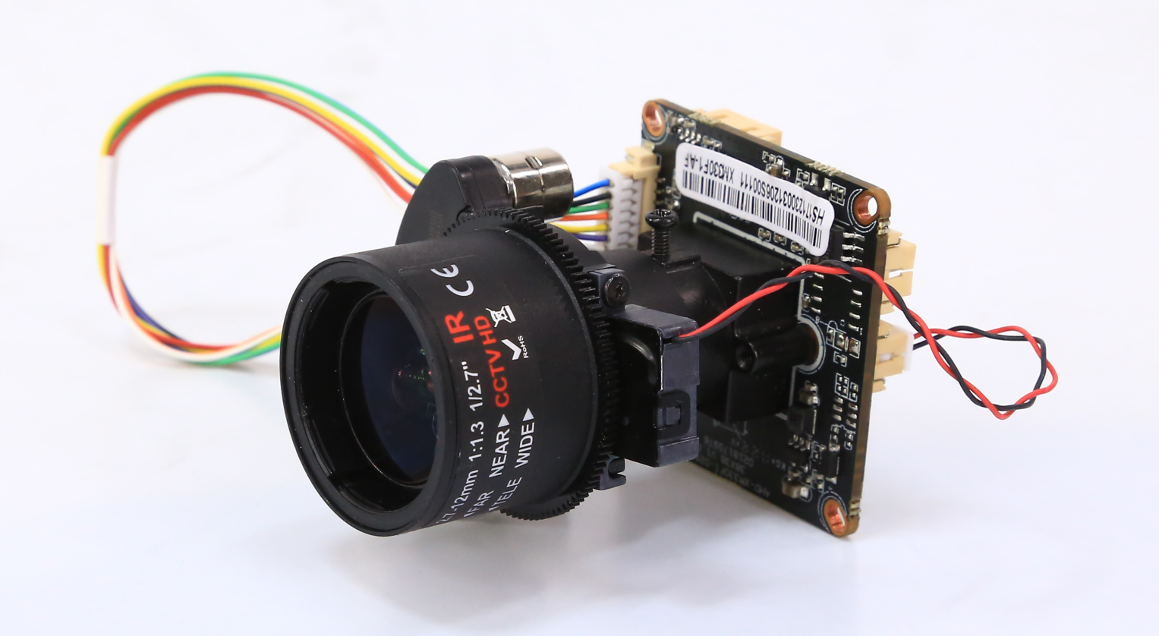、

**详细定义**

|  |  |  |  |  |
| --- | --- | --- | --- | --- |
| 位号 | 接口详细编号 | 接口定义 | 实现功能 | |
| CN2 | 1 | CVBS | Video Out | |
| 2 | GND | 地 | |
| 3 | 12V | 12V电源输入 | |
| CN4 | 1 | IRCUTA | IRCUT接口 | |
| 2 | IRCUTB |
| J11 | 1 | ZOOM_B- | AF座子 | |
| 2 | ZOOM_B+ |
| 3 | FOCUS_B- |
| 4 | FOCUS_B+ |
| 5 | FOCUS_A- |
| 6 | FOCUS_A+ |
| 7 | ZOOM_A- |
| 8 | ZOOM_A+ |
| J24 | 1 | ADC1VIN | Red_CTRL | |
| 2 | GND | 地 | |
| 3 | NC | 空闲 | |
| J26 | 1 | GND | 地 | |
| 2 | GND | | 地 |
| 3 | UARTO_TXD | | 串口发送 |
| 4 | UARTO_RXD | | 串口接收 |
| 5 | SWITCH_PROG | | 按键 |
| 6 | EXY_RSTN | | 复位 |