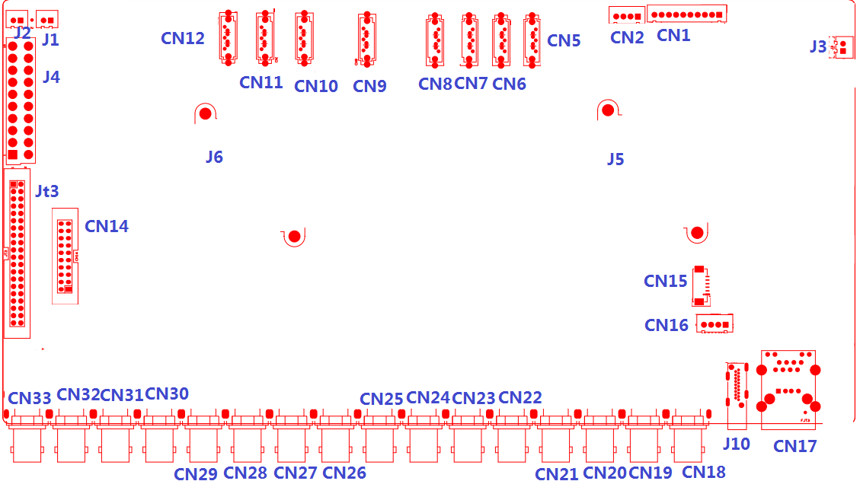

代号 | 功能描述 | 接口定义
CN14 | 音频+报警扩展座子 | 1:AUDIO_OUT_MAIN | 2:+5V | 3:GND | 4:+5V
 |  | 5: AUDIO1 | 6:+5V | 7:AUDIO4 | 8:AUDIO5
 |  | 9:GND | 10:GND | 11: AUDIO2 | 12:AUDIO3
 |  | 13:AUDIO8 | 14:AUDIO7 | 15:AUDIO6 | 16:ALARM_IN1
 |  | 17:ALARM_IN4 | 18:ALARM_IN2 | 19:ALOUT1 | 20:ALARM_IN3
JT3 | 40PIN组合扩展座子 | 1: VIDEO_OUT_MAIN | 2: AUDIO16 | 3: AUDIO15 | 4: GND
 |  | 5: AUDIO11 | 6: AUDIO12 | 7: GND | 8: AUDIO10
 |  | 9: AUDIO9 | 10: GND | 11: AUDIO14 | 12: AUDIO13
 |  | 13:GND | 14: ALOUT4 | 15: ALOUT2 | 16:GND
 |  | 17: ALOUT3 | 18: ALARM_IN16 | 19:GND | 20: RS232_R
 |  | 21: RS232_T | 22:GND | 23: RS485_B | 24: RS485_A
 |  | 25:GND | 26: ALARM_IN10 | 27: ALARM_IN9 | 28: ALARM_IN11
 |  | 29: ALARM_IN8 | 30: ALARM_IN12 | 31:GND | 32:GND
 |  | 33: ALARM_IN5 | 34: ALARM_IN13 | 35: ALARM_IN6 | 36: ALARM_IN14
 |  | 37: ALARM_IN7 | 38: ALARM_IN15 | 39:GND | 40:GND
J4 | ATX电源 | 1:+3.3V | 2:+3.3V | 3：GND | 4:+5V
 |  | 5:GND | 6:+5V | 7:GND | 8:NC
 |  | 9:+5_STB | 10:+12V | 11:+3.3 | 12:NC
 |  | 13:GND | 14:PWR_S | 15:GND | 16:GND
 |  | 17:GND | 18:NC | 19:+5V | 20：+5V
J1 | 风扇电源座子 | 1:+12V | 2:GND
J2 | 风扇电源座子 | 1:+12V | 2:GND
CN12 | SATA接口
CN11 | SATA接口
CN10 | SATA接口
CN9 | SATA接口
CN2 | USB扩展座子
CN1 | 10PIN带单片机前面板扩展座子 | 1:+5V | 2: GND | 3:+5_STB | 4:GND
 |  | 5:NC | 6:NC | 7: URXD3 | 8: UTXD3
 |  | 9: PWR_S | 10:GND
J3 | 风扇电源座子 | 1:+12V | 2:GND
CN17 | USB+单网口组合接口
J10 | 侧插式HDMI接口
CN16 | USB扩展座子
CN13 | VGA扩展座子
CN18 | BNC视频输入接口 | 上:VIDEO31 | 下：VIDEO32
CN19 | BNC视频输入接口 | 上:VIDEO29 | 下：VIDEO30
CN20 | BNC视频输入接口 | 上:VIDEO27 | 下：VIDEO28
CN21 | BNC视频输入接口 | 上:VIDEO25 | 下：VIDEO26
CN22 | BNC视频输入接口 | 上:VIDEO23 | 下：VIDEO24
CN23 | BNC视频输入接口 | 上:VIDEO21 | 下：VIDEO22
CN24 | BNC视频输入接口 | 上:VIDEO19 | 下：VIDEO20
CN25 | BNC视频输入接口 | 上:VIDEO17 | 下：VIDEO18
CN26 | BNC视频输入接口 | 上:VIDEO15 | 下：VIDEO16
CN27 | BNC视频输入接口 | 上:VIDEO13 | 下：VIDEO14
CN28 | BNC视频输入接口 | 上:VIDEO11 | 下：VIDEO12
CN29 | BNC视频输入接口 | 上:VIDEO9 | 下：VIDEO10
CN30 | BNC视频输入接口 | 上:VIDEO7 | 下：VIDEO8
CN31 | BNC视频输入接口 | 上:VIDEO5 | 下：VIDEO6
CN32 | BNC视频输入接口 | 上:VIDEO3 | 下：VIDEO4
CN33 | BNC视频输入接口 | 上:VIDEO1 | 下：VIDEO2
J5 | 散热片
J6 | 散热片
本接口说明对应产品型号：AHB8032F4-GS

