BLK16D-38X38-AF-V1_01 Interface Description

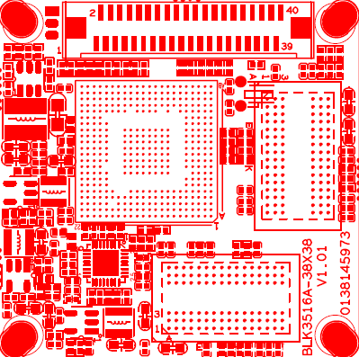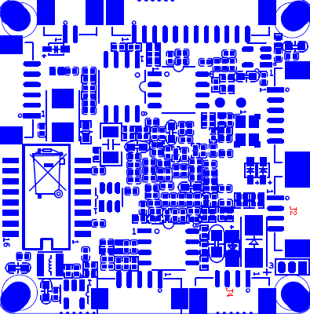
P4 RTC battery
P7 SD、ALARM
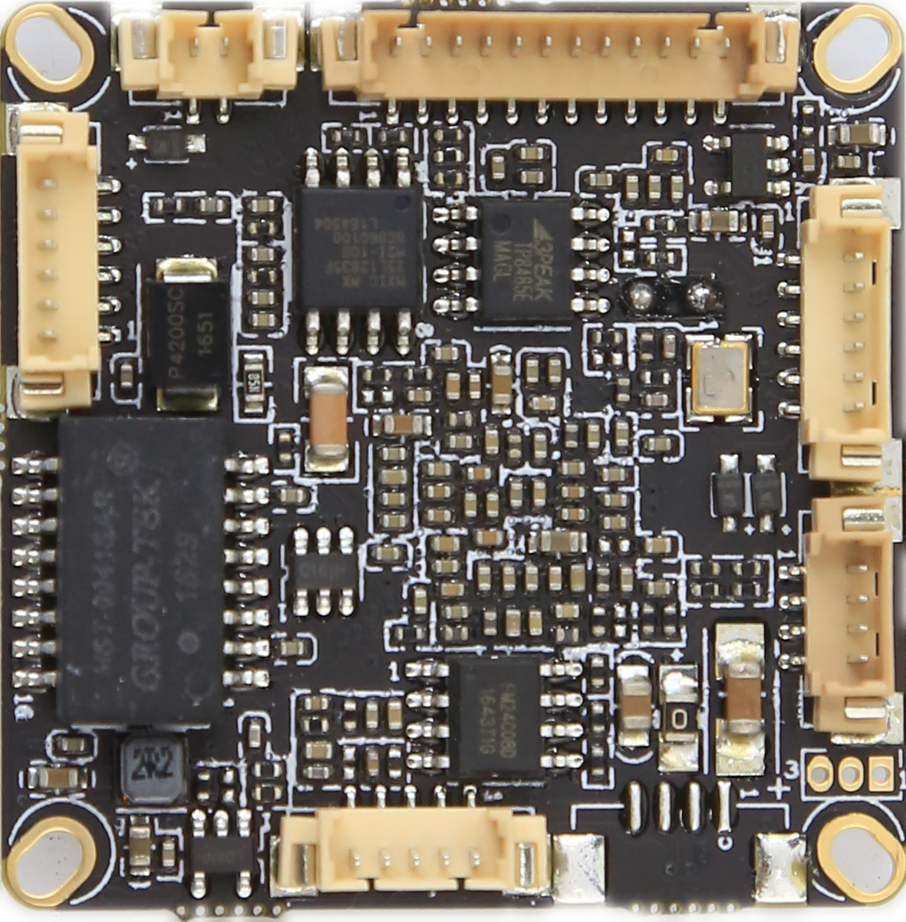
P1 power
P6 PTZ
P3 Audio
P2 Ethernet

sign | Socket | Specific No | Interface Description | Function
P1 | J2 | 1 | NC | Undefined
 |  | 2 | NC | Undefined
 |  | 3 | GND | GND
 |  | 4 | +12V | 12V DC input
P2 | J8 | 1 | ETHTR- | Ethernet signal
 |  | 2 | ETHTR+ | Ethernet signal
 |  | 3 | LED/PHY_AD3 | LED
 |  | 4 | ETHTX- | Ethernet signal
 |  | 5 | ETHTX+ | Ethernet signal
 |  | 6 | LED/PHY_AD0 | LED
P3 | J6 | 1 | GND | GND
 |  | 2 | VDAC_CVBS | VDAC_CVBS
 |  | 3 | AGND | AGND
 |  | 4 | AC_OURL | speaker_OUT
 |  | 5 | AC_LINEL | MIC_P
P4 | J7 | 1 | GND | GND
 |  | 2 | VBAT | VBAT
P5 | J3 | 1 | UART_RXD
 |  | 2 | UART_TXD
 |  | 3 | GND | GND
P6 | J4 | 1 | GND | GND
 |  | 2 | USB_DP | USB_DP
 |  | 3 | USB_DM | USB_DM
 |  | 4 | +5V | +5V
P7 | CN1 | 1 | ALARM_IN1 | ALARM_IN1
 |  | 2 | GND | GND
 |  | 3 | ALARM_IN2 | ALARM_IN2
 |  | 4 | GND | GND
 |  | 5 | RS485A | RS485A
 |  | 6 | RS485B | RS485B
P9 | J1 | 1 | (12v) | 12V DC input
 |  | 2 | (12v) | 12V DC input
 |  | 3 | GND | GND
 |  | 4 | GND | GND
 |  | 5 | (5v) | 5V DC input
 |  | 6 | GND | GND
 |  | 7 | DOUT7 | Video signal output
 |  | 8 | DOUT6 | Video signal output
 |  | 9 | DOUT5 | Video signal output
 |  | 10 | DOUT4 | Video signal output
 |  | 11 | DOUT3 | Video signal output
 |  | 12 | DOUT2 | Video signal output
 |  | 13 | DOUT1 | Video signal output
 |  | 14 | DOUT0 | Video signal output
 |  | 15 | VIDEOIN_HD | VIDEOIN_HD
 |  | 16 | VIDEOIN_PCLK | VIDEOIN_PCLK
 |  | 17 | VIDEOIN_VD | VIDEOIN_VD
 |  | 18 | GND | GND
 |  | 19 | NC | NC
 |  | 20 | SCL | SCL
 |  | 21 | NC | NC
 |  | 22 | MCBSP_DR_SPI1_EN | SPI
 |  | 23 | NC | NC
 |  | 24 | REDCTRL | REDCTRL
 |  | 25 | GND | GND
 |  | 26 | GND | GND
 |  | 27 | GND | GND
 |  | 28 | 1.8V output | 1.8V output
 |  | 29 | SDA | I2C SDA
 |  | 30 | NC | NC
 |  | 31 | NC | NC
 |  | 32 | NC | NC
 |  | 33 | NC | NC
 |  | 34 | DOUT11 | Video signal output
 |  | 35 | DOUT10 | Video signal output
 |  | 36 | DOUT9 | Video signal output
 |  | 37 | DOUT8 | Video signal output
 |  | 38 | IRCUT | IRCUT
 |  | 39 | IRCUT | IRCUT
 |  | 40 | GND | GND

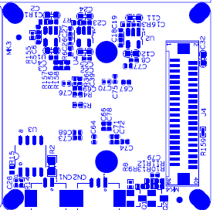
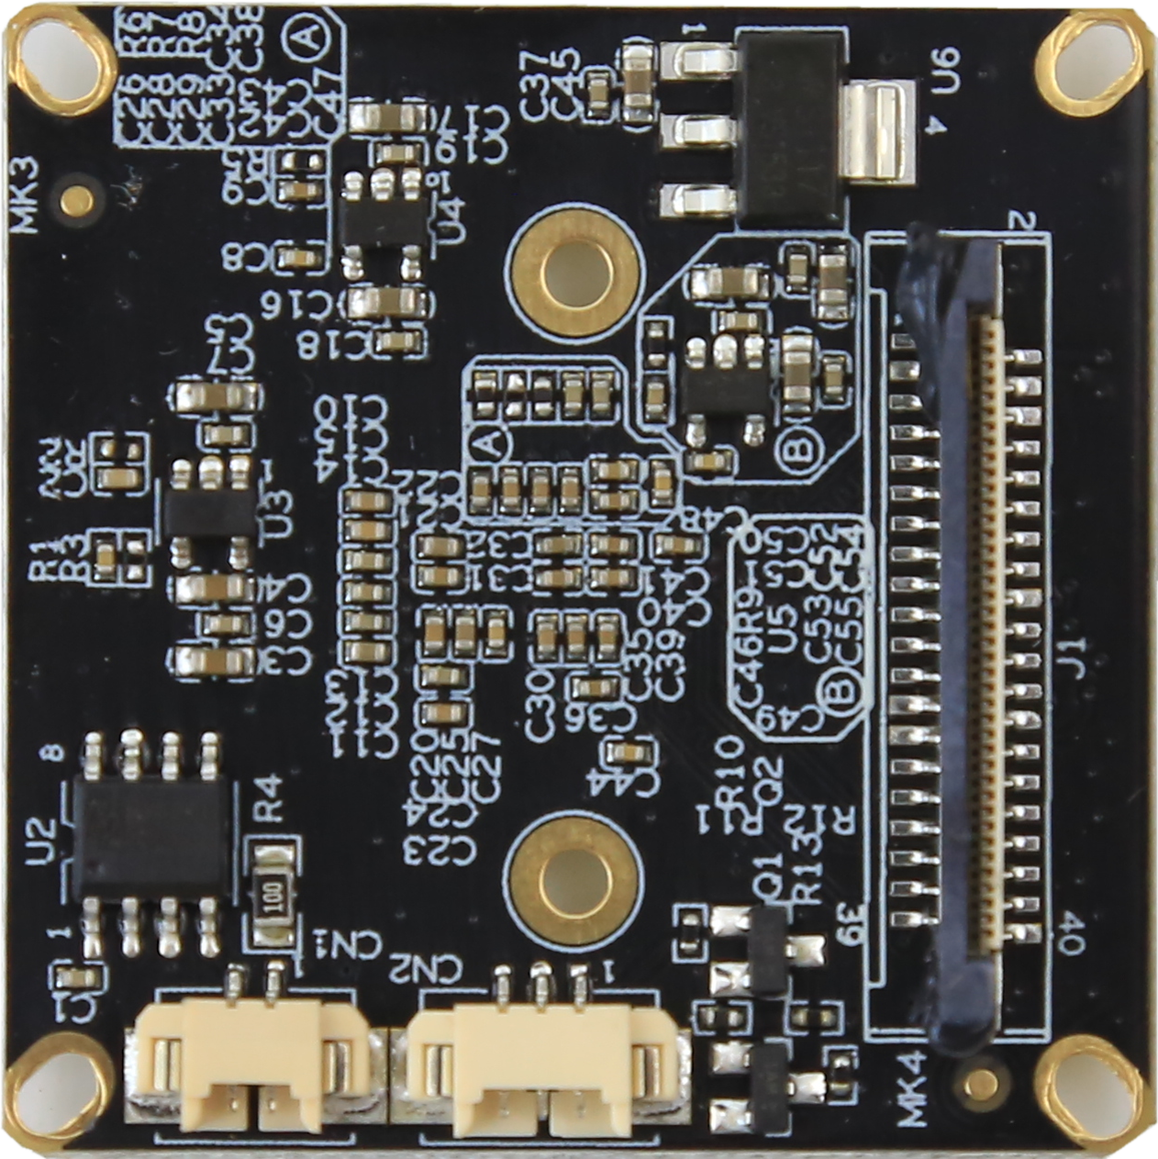
P1 Extension interface

P2 Infrared
P3 IR-CUT

P1 | J4 | 1 | (12v) | 12V DC input
 |  | 2 | (12v) | 12V DC input
 |  | 3 | GND | GND
 |  | 4 | GND | GND
 |  | 5 | (5v) | 5V DC input
 |  | 6 | GND | GND
 |  | 7 | DOUT7 | Video signal output
 |  | 8 | DOUT6 | Video signal output
 |  | 9 | DOUT5 | Video signal output
 |  | 10 | DOUT4 | Video signal output
 |  | 11 | DOUT3 | Video signal output
 |  | 12 | DOUT2 | Video signal output
 |  | 13 | DOUT1 | Video signal output
 |  | 14 | DOUT0 | Video signal output
 |  | 15 | VIDEOIN_HD | VIDEOIN_HD
 |  | 16 | VIDEOIN_PCLK | VIDEOIN_PCLK
 |  | 17 | VIDEOIN_VD | VIDEOIN_VD
 |  | 18 | GND | GND
 |  | 19 | NC | NC
 |  | 20 | SCL | SCL
 |  | 21 | NC | NC
 |  | 22 | MCBSP_DR_SPI1_EN | SPI
 |  | 23 | NC | NC
 |  | 24 | REDCTRL | REDCTRL
 |  | 25 | GND | GND
 |  | 26 | GND | GND
 |  | 27 | GND | GND
 |  | 28 | 1.8V DC input | 1.8V DC input
 |  | 29 | SDA | I2C SDA
 |  | 30 | NC | NC
 |  | 31 | NC | NC
 |  | 32 | NC | NC
 |  | 33 | NC | NC
 |  | 34 | DOUT11 | Video signal output
 |  | 35 | DOUT10 | Video signal output
 |  | 36 | DOUT9 | Video signal output
 |  | 37 | DOUT8 | Video signal output
 |  | 38 | IRCUT | IRCUT
 |  | 39 | IRCUT | IRCU
 |  | 40 | GND | GND
P2 | CN2 | 1 | Led | Led
 |  | 2 | GND | GND
 |  | 3 | NC | NC
P3 | CN1 | 1 | IRCUT | IRCUT input control
 |  | 2 | IRCUT | IRCUT input control
P1 ALARM out
P2 Extension
P4 Auto iris
P3 SD card

sign | Socket | Specific No | Interface Description | Function
P1 | CN7 | 1 | ALARM NO | ALARM output
 |  | 2 | ALARM COM | ALARM COM
 |  | 3 | GND | GND
P2 | J20 | 1 | GND | GND
 |  | 2 | 5V | 5V DC input
 |  | 3 | 3.3V | 3.3V DC input
 |  | 4 | GPIO32 | ALARM output
 |  | 5 | GPIO53 | PWM output
 |  | 6 | - | -
 |  | 7 | SD_CLK | SD_CLK
 |  | 8 | SD_CMD | SD_CMD
 |  | 9 | SD_DATA3 | SD_DATA3
 |  | 10 | SD_DATA2 | SD_DATA2
 |  | 11 | SD_DATA1 | SD_DATA1
 |  | 12 | SD_DATA0 | SD_DATA0
P4 | CN10 | 1 | IRIS_CON- | IRIS_CON-
 |  | 2 | IRIS_CON+ | IRIS_CON+
 |  | 3 | IRIS_DRV | IRIS_DRV
 |  | 4 | GDN | GDN

